Name ___________________________________ Date _____________ Hour _______

Directions: Welcome to your own Snap Circuit! Snap Circuits are a way we can create circuits from experiments and on our own. This packet is required to start working with your Snap Circuits.

A) Your Snap Circuit Group

Who are your group members?

Who will be your Team Leader? The Team Leader is in charge of making sure your Snap Circuit box is returned to your teacher at the last 5 minutes of class to be checked that all the parts are in their proper place. ________________________

What is your Snap Circuit Box Number? ________

- Basics of Snap Circuits

Open up your Snap Circuit Box. You will notice there are a lot of parts that are all in certain places in your box. What can you use in the box to make sure you return all of your parts to the box?

Take out your Experiments 1-101 Guide. This is the instruction manual you will use to create experiments. Turn to Page 1. What does the exclamation (!) symbol mean?

Read the first warning in the yellow box. When you are done creating a circuit, should you leave it running for long periods of time? Why?

Look at Page 2. This has the list of materials in your Snap Circuit kit. Open up your kit. Using the checklist on the next page, check that you have each of the parts in your kit by checking the part under Quantity. Make sure you take out the materials and put them back IN THE SAME SLOT YOU FOUND THEM. Make sure your battery holder has batteries.

- How to Use your Snap Circuit Kit

Read Page 3 and answer the following questions:

Instead of connecting with wires, Snap Circuits use ____________ to build different electronic circuits.

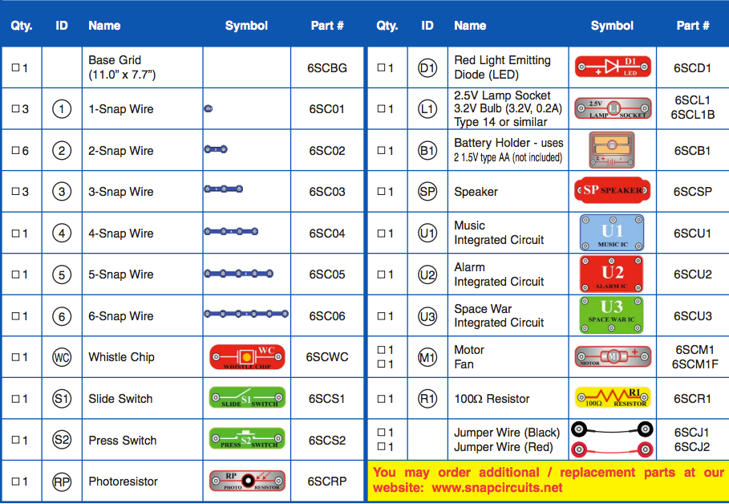
What is the purpose of the switch block?

Why does the wire blocks come in different lengths?

What type of batteries do Snap Circuits use?

What is the purpose of the large clear plastic grid?

What does the small number in black on each of the parts mean?

If the number is 1, which level should it be placed at?

What does the motor (M1) usually connect to?

What is the purpose of the jumper wires?

- About Your Snap Circuits Parts

For each of the parts, write down the basic function and from your kit make a drawing of the part.

Base Grid:

Snap Wires:

Jumper Wires:

Batteries:

Slide Switch:

Press Switch:

Resistor:

Photoresistor:

Lamp:

Motor:

Speaker:

Whistle Chip:

LED:

What does IC stand for?

What are the three IC’s in the kit?

- DO’s and DON’Ts of Building Circuits

What should you be very careful about not creating while you are putting together experiments?

What will a short circuit do to the circuit board?

We will not be creating our own circuits until the end of the unit. What are some of the important guidelines while creating your own circuit?

-

-

-

You are done with Part 1! File this into your binder and get Part 2 from your teacher.

