Kaleidoscope Photogram
Background:
Early attempts at finding suitable compounds that would respond to light in very predictable ways included, what early practitioners called, "photogenic drawings". These camera-less images were produced by coating a support (leather, glass, metal, paper) with a light sensitive compound of silver-salts and placing objects such as botanical specimens or lace over the light sensitive emulsion and exposing directly to sunlight. The exposure would continue until the area not covered by the object would turn dark (physical development). When sufficient exposure had taken place, the plate was given a treatment in sodium hyposulfate, which made soluble all the unexposed silver-salts and removed them from the support. The image that remained was a perfect silhouette (only light in tone). This technique is not something practiced in the beginnings of photography and then abandoned. Man Ray and Laszlo Moholy-Nagy were significant figures in the art movements of the late 1920’s and 1930’s and made a significant number of photograms and "Rayographs". These artists experimented with various objects placed over light sensitive paper. Experiments with glass objects were intended to discover how the light could be modulated or changed as it passed on its way to the paper. Moving objects from one place to another during the exposure also revealed some interesting results. Contemporary artists continue to make photograms to this day. Today photogram artists like Annie Halliday (see http://anniehalliday.com/gallery.php) are still creating new work in this medium.
Assignment:
You will make your own photograms or photogenic drawings in our darkroom by placing objects directly in contact with photo paper and exposing that paper to light, then processing the paper normally. The objects you use can vary widely. Keep in mind that opaque objects placed directly on the photo paper will produce a high contrast outline of the object while transparent or translucent objects will have varying tones and will show detail.
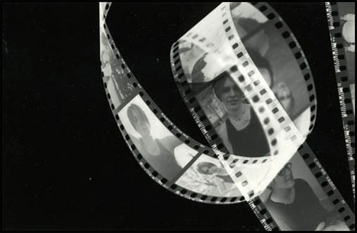

Things You Might Use:
Leaves, seeds, flowers, tools, keys, fabric (including lace), glass (especially textured glass), crumpled up tissue paper, cutouts that you have made yourself, negative strips, toys, your hand, marbles, in other words anything with an interesting shape. You can make a "self portrait personal photogram" using objects that say something about you. You can use printed material like photographs from magazines but keep in mind that any text or pictures on the back of the image will show through also.

How To:
Set the enlarger to a height that will allow the light to cover your paper with some room to spare all around. Cut up some test strips. Place your object on the paper and do a test strip. See which exposure gives you a good rich black ( It may take more than one test). Next, place your objects on a sheet of photo paper, arrange your composition. Expose. Develop the paper normally. Try moving the objects around for a better composition or change your objects and create another photogram. You might also want to try raising the objects off of the photo paper slightly to see what effect you get. To do this you will need a piece of glass larger than the photo paper by a few inches. Place the objects on the glass to see how that changes the edges of the image on the paper. You might want to try moving the object during the exposure.
Please avoid using objects that are messy or juicy.

Make a positive:
Dry the paper well.
1. Set up for a 5x7 exposure using the glass contact easel. Shut off the light.
2. Place the dry photo paper shiny side down on a fresh sheet of photo paper.
3. Expose for about 10 seconds. Process as usual.
Now repeat this process to create two additional photograms. Once all are dry, trim any extra
white border from the paper and tape from the back. Mount on paper with a 1 inch border.

Turn in:
- 2-3 sketches to show how you planned your design
- 5-6 examples that inspired you printed in one document
- 4 photograms mounted on paper.
- Scan one or more of your best photograms and edit it to create a 13 x 19 creation.
- self evaluation form

How you will be graded:
Overall exposure. Try to get an image that has white, 3-6 shades of gray and black tones.
Overall design. Many times simple is the most effective. Try and arrange objects on your paper in an interesting design. Too many objects, and/or too many objects of the same size usually create a "busy" image with no center of attention.
Mounting. Check: The position on the board, if the image securely mounted on the board, trimmed neatly and the board is clean and free from dings.
Good Print quality- no dust or damage

Web Links:

There are many examples of photograms which can give you great ideas to get started.
Man Ray - Rayographs
http://www.geh.org/amico2000/htmlsrc/index.html
Laszlo Moholy-Nagy - Photograms and other work http://www.geh.org/fm/amico99/htmlsrc2/moholy_sld00001.html
Photos and Photograms by Picasso, Miro, Dali and Tapies
http://www.zonezero.com/exposiciones/fotografos/fontcuberta2/index.html
Anne Ferran: Photograms
http://www.abc.net.au/arts/visual/stories/s586494.htm
Many Links to Photogram Artists
http://www.photogram.org/frame.html
http://www.photogram.org/concept/index.htm -- check this site for an excellent pictorial example of how to make truly artistic photograms from simple object.

Your rotated photograms will look something like this.

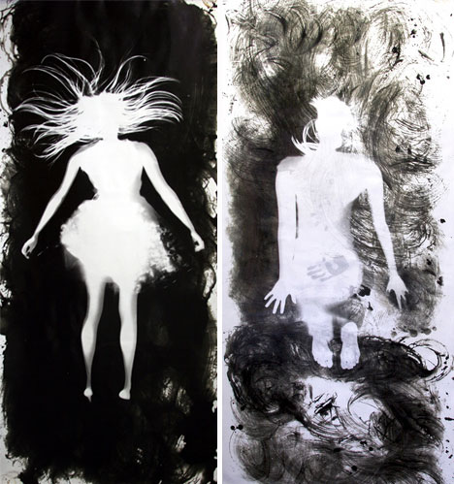
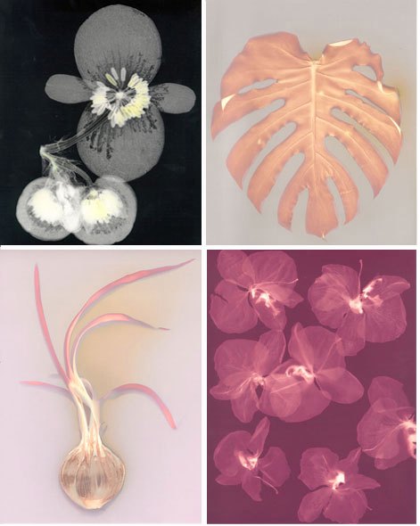
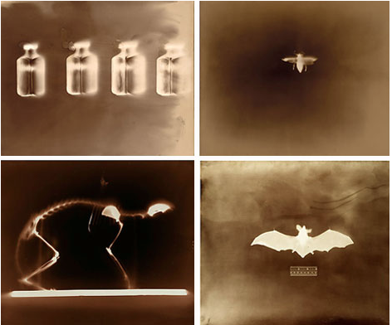
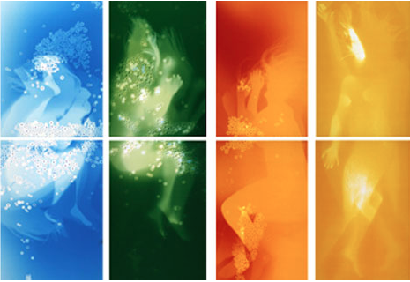
An example of a photogram using a
variety of found objects.

A photogram using a bunch of flowers laid on the photo paper.

