AP Physics – Light’n Them Waves - 1

Hmm?_____________________________________________________________________Per__
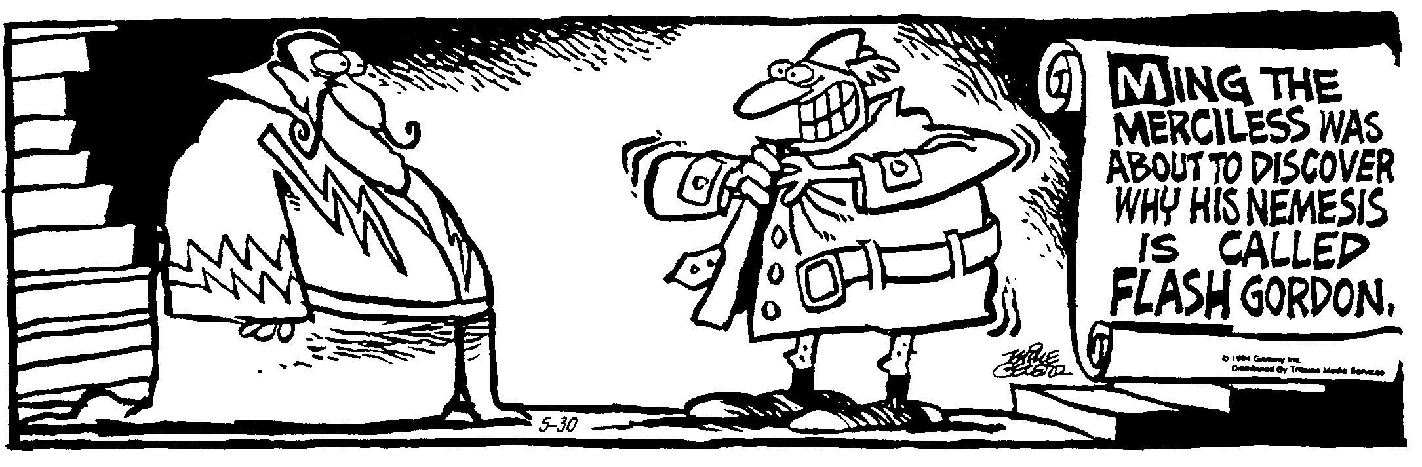
Government is not reason. Government is not eloquence. It is force. And, like fire, it is a
dangerous servant and a fearful master. -- George Washington
- A projectile is fired at an angle of 25.0° to the horizon. Its initial velocity is 312 m/s. What is the range of the thing?

- A beam of light with a wavelength of 575 nm while traveling in air is incident on a slab of material. The angle of incidence is 28.0°. The refracted beam makes an angle of 20.4°. Find (a) the index of refraction for the slab and (b) the wavelength of the light in the slab.

- A beam of laser light, wavelength 678.8 nm in air, is incident on a block of polystyrene at an angle of 29.7°. Find (a) the angle of refraction and (b) the wavelength of the light in the plastic.

- A light wave with a wavelength of 612 nm in a vacuum travels through a bit of fused quartz which has an index of refraction of n =1.458. Find the speed of light in the quartz.

- Find the speed of light in (a) flint glass, (b) water, and (c) zircon.

- Light of wavelength 436 nm in air enters a fishbowl filled with water, then exits through the crown-glass wall of the container. Find the wavelengths of the light in (a) the water and (b) the crown glass.

- A 589nm beam of light is incident on the surface of some clean ice at an angle of 40.0° with the normal. Part of light is reflected and part is refracted. Find the angle between the reflected and refracted light.

- Three charges are arranged as shown. What is the magnitude and direction of the force acting on q₃, the 7.25 μC charge, by the other two charges?

- An electron is fired into the midpoint of a field between two charged plates. The initial velocity of the electron is 4.5 x 10⁶ m/s. The plates are a distance of 2.80 mm apart. The electric field between the plates is 5.357 x 10⁴ N/C. Determine where the electron will hit on the upper plate.

- A 4.0 cm by 6.0 cm rectangular loop of wire is attached to a cart that is moving at a constant speed of 10.0 m/s. It travels through a uniform magnetic field of 3.2 T. (a) What is the induced emf after it has traveled 3.0 cm into the field? (b) What is the direction of the current, clockwise or counterclockwise? If the resistance of the loop is 1.2 Ω, what is the current in the loop?

