AP Physics – Love That Homework – 1

Who you are ___________________________________________________________________Per ___
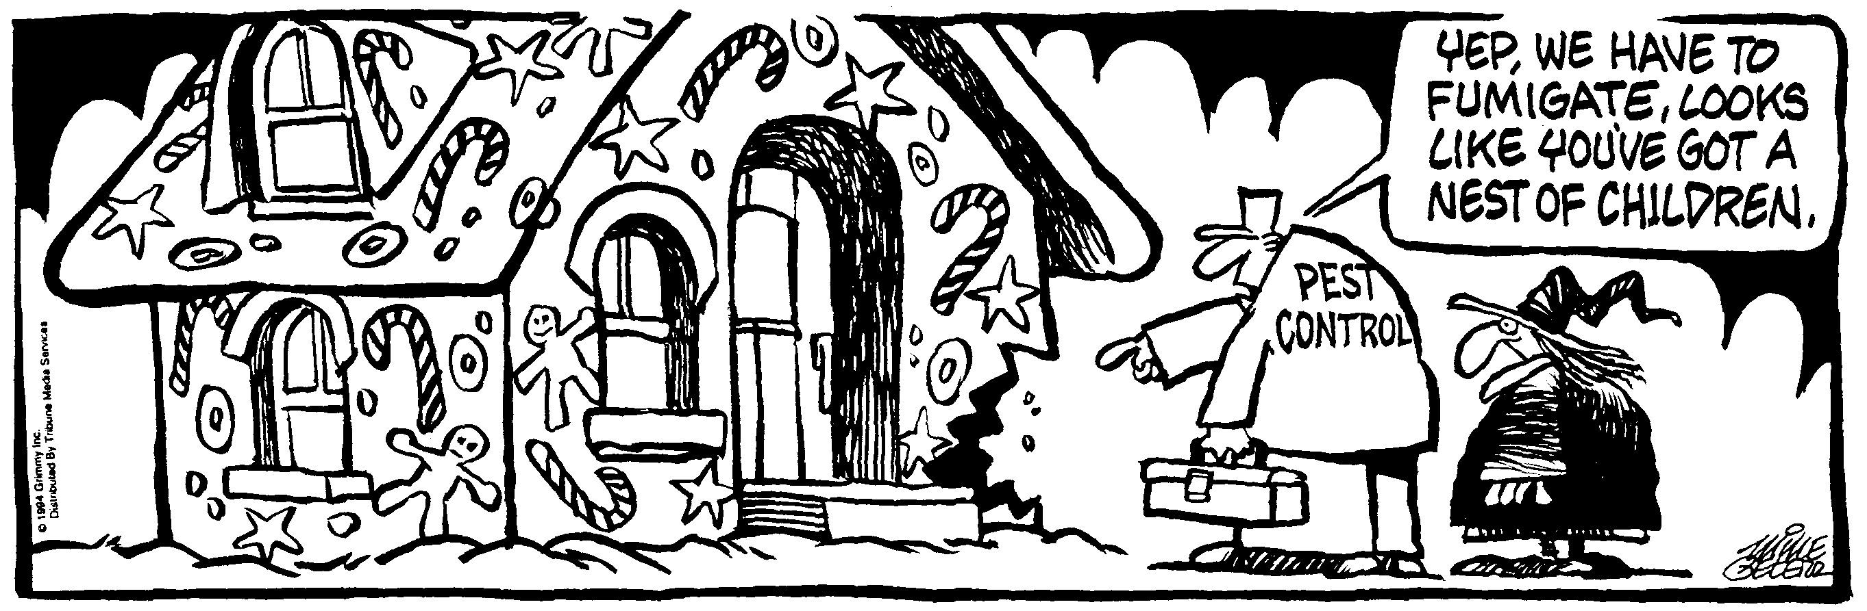
This 'telephone' has too many shortcomings to be seriously considered as a means of communication. The device is inherently of no value to us." -- Western Union internal memo.
- Give an example of two cars that have the same speed but different velocities.

- You are driving down the road at a constant velocity. What are 3 ways you could safely change your velocity?

- You nose out another runner to win the 100.000 m dash. If your total time for the race was 11.800 s and you aced out the other runner by 0.001 s, by how many meters did you win?

- The speed of sound is 344 m/s. You see a flash of lightning and then hear the thunder 1.5 seconds later. How far away from the lightning strike are you?

- A train travels from Denver to Bougainvillea in 5 hours and 37 minutes. If the average speed for the train was 76.5 km/h, how much distance did it cover?

- You travel down the highway, starting from rest. You travel for 2.0 h at a speed of 105 km/h. Then you stop and eat your lunch for 30.0 min. Then you travel for 1.5 h at 75 km h. Make a distance vs time graph of this motion.

- A car travels along a straight section of road. A distance vs time graph illustrating its motion is graphed to the right.
- Indicate every time t for which the cart is at rest.
- Indicate every time interval for which the speed of the cart is increasing.
- What is the velocity from: a – b, b – c. c - d, d – e, and e – f?

