SCHOLARSHIP ANNOUNCEMENT 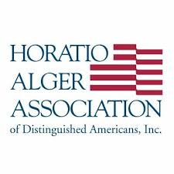

DATE: January, 2022
Juniors: Applications for the Horatio Alger Association Scholarship must be completed online at scholars.horatioalger.org

106 scholarships $10,000 to $25,000
As one of the nation’s largest college financial aid programs in the country, the Horatio Alger National Scholarship Program is one of the major scholarship programs nationally that specifically assists high school students who have faced and overcome great obstacles in their young lives. The scholarships are funded by Horatio Alger Members who, like the Scholars, have experienced challenges but ultimately overcame them to become successful business and civic leaders.
The National Scholarship is awarded to eligible students in all fifty states, the District of Columbia, and Puerto Rico. National Scholars receive an all-expenses paid trip to Washington, D.C., during the spring of their senior year to participate in the National Scholars Conference. Recipients must attend the National Scholars Conference to receive the award.
To be eligible to apply for the Horatio Alger National Scholarship, applicants must meet the following criteria:
- Be enrolled full time as a high school senior in the United States; be progressing normally toward graduation in spring/summer of 2023 with plans to enter a college in the United States no later than the fall following graduation
- Exhibit a strong commitment to pursue and complete a bachelor’s degree at an accredited non-profit public or private institution in the United States (students may start their studies at a two-year institution and then transfer to a four-year institution)
- Demonstrate critical financial need ($55,000 or lower adjusted gross family income is required)
- Be involved in co-curricular and community service activities
- Display integrity and perseverance in overcoming adversity
- Maintain a minimum grade point average (GPA) of 2.0; and
- Be a United States citizen
DEADLINE: March 15th, 2022. CEEB code for FBHS -100460

