Scholarship Announcement
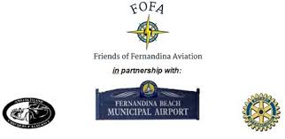
Friends of Fernandina Aviation
Josh Barber Memorial Scholarship

Date: March, 2021

Eligibility Requirements:
Available to any Fernandina Beach graduating senior who is enrolled in the Aviation Technology Program and plans to pursue his/her education. Education pursuits can include attending a 2 or 4 year college/university, technical school or trade school. Please note that further study in the aviation field is not a scholarship requirement.

Scholarship Amount: $1000 awarded in a check payable to both the student and institution of continuing education.

Deadline for Application: Friday April 16 noon (deliver to Guidance Office)
General Information: Student’s Name: Parent or Parents’ Name: Address: Cell/Home Phone #: Questions:

General Information:

Student’s Name:

Parent or Parents’ Name:

Address:

Cell/Home Phone #:

Questions:

1. Why did you decide to enroll in the FBHS Aviation Technology Program?

2. How do you believe the FBHS Aviation Technology Program has benefited you?

3. What are your plans to continue your education after high school graduation? What do you intend to study and what are your career aspirations?

4. What is the first year cost of your further education?

5. What is the source of funds you plan to use to pay for your first year of education? Fill in the dollar amounts in each category below.
a. Parent and /or Extended Family: $
b. Personal Saving: $
c. Education Loans:$
d. Scholarships:$

Please feel free to use the back of this application or add a page to fully answer each question

