Name Date Period

Unit 9, Worksheet 3

Pulses
1. Two students, 5.0 m apart, each hold an end of a long spring. It takes 1.2 seconds for a pulse to travel from the student generating the pulse to the lab partner at the opposite end of the spring.

a. How long will it take for the pulse to return to the “generator”?

b. Explain the motion of the pulse passing through the spring. Calculate the speed of the pulse.

2. The “generator” in Problem 1 repeats the experiment with a pulse of twice the original amplitude. Will the pulse take more time, less time, or the same time to reach the far end of the spring? Explain your answer.

3. The students move so that they are now twice as far apart but use the same spring. How will the speed of the pulse sent now compare to the speed of the pulse sent when they were 5.0 m apart? Explain your answer.

A
B
C
D
E

4. Match the letters below to the corresponding terms which follow:
amplitude_____ equilibrium_____ transverse pulse_____
fixed end_____ pulse length_____

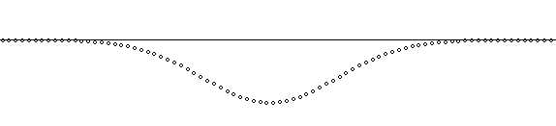
1
2
3
4
5
A
v

5. A pulse of the shape above is moving right toward A (a particle of the spring) with a velocity v. Describe in detail the motion of particle A on the spring as the pulse goes by, causing particle A to move through positions 1-5. For each of the positions, be sure to indicate (1) the direction of the motion of the particle A (up, down or not moving), and (2) state whether the velocity of A is increasing, decreasing, or zero.
Number of position | Direction of Motion | Statement on velocity
1
2
3
4
5

6. The graph below was produced by plotting data for the distance (d) a pulse traveled along a spring in time t. Write the mathematical model for the data graphed below.
d
(m)

