Name
Date___________

Unit IX, Worksheet 2

1. The illustration below shows a series of transverse waves. Label each part in the space provided.
c
e
f
a
b
d
g
a.
b.
c.
d.
e.
f.
g.

2. Below are a number of series of waves. Underneath each diagram write the numbers of waves in the series.
A.
B.
C.
D.

a. Which of the above has the biggest amplitude?
b. Which of the above has the shortest wavelength?
c. Which of the above has the longest wavelength?

3. A wave on Beaver Dam Lake passes by two docks that are 40.0 m apart.
a. If there is a crest at each dock and another three crests between the two docks, determine the wavelength.

b. If 10 waves pass one dock every 16.0 seconds, determine the period and frequency of the wave.

c. What is the speed of the wave?

4. The wave in Problem 3 now has twice the original amplitude. Will the wave take more time, less time, or the same time to pass the two docks? Explain your answer.

5. Wally Wavemaker and Fiona Frequency are 5.0 meters apart from one another creating standing waves in a long spring on the ground. Wally flicks his wrist 3 times a second. As he does this, 5 nodes are produced in the spring.

a. How many antinodes are produced?

b. What is the speed of a given wave in the spring?

c. The students move so that they are now twice as far apart but use the same spring. How will the speed of the pulse sent now compare to the speed of the pulse sent when they were 5.0 m apart? Explain your answer.

d. The students go back to their original position, but Wally begins to flick his wrist twice as fast. What is the resulting speed of a given wave in the spring?

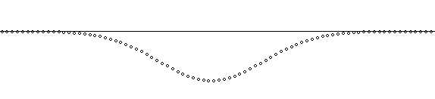
1
2
3
4
5
A
v

6. A pulse of the shape above is moving right toward A (a particle of the spring) with a velocity v. Describe in detail the motion of particle A on the spring as the pulse goes by, causing particle A to move through positions 1-5. For each of the positions, be sure to indicate (1) the direction of the motion of the particle A (up, down or not moving), and (2) state whether the velocity of A is increasing, decreasing, or zero.
Number of position | Direction of Motion | Statement on velocity
1
2
3
4
5

