States of Matter Practice Test

Multiple Choice
Identify the choice that best completes the statement or answers the question.

____ 1. A solid is a state of matter that has a(n)
a. | indefinite volume and an indefinite shape.
b. | definite volume and a definite shape.
c. | definite volume and an indefinite shape.
d. | indefinite volume and a definite shape.

____ 2. In which state of matter are particles packed tightly together in fixed positions?
a. | gas
b. | solid
c. | liquid
d. | compound

____ 3. The state of matter in which particles are arranged in either a crystalline or an amorphous form is
a. | liquid.
b. | gas.
c. | solid.
d. | fluid.

____ 4. Particles of a liquid
a. | are tightly packed together and stay in a fixed position.
b. | have no viscosity.
c. | decrease in volume with increasing temperature.
d. | are free to move in a container but remain in close contact with one another.

____ 5. The surface of water can act like a sort of skin due to a property of liquids called
a. | viscosity.
b. | surface tension.
c. | condensation.
d. | evaporation.

____ 6. In which state of matter do the particles spread apart and fill all the space available to them?
a. | crystal
b. | liquid
c. | gas
d. | solid

____ 7. The change from liquid to solid, or the reverse of melting, is called
a. | condensation.
b. | boiling.
c. | sublimation.
d. | freezing.

____ 8. The freezing point of water is the same as its
a. | melting point.
b. | boiling point.
c. | sublimation point.
d. | evaporation point.

____ 9. What is vaporization?
a. | a gas becoming a liquid
b. | a liquid becoming a solid
c. | a gas becoming a solid
d. | a liquid becoming a gas

____ 10. Which state of matter undergoes changes in volume most easily?
a. | solid
b. | liquid
c. | gas
d. | frozen

____ 11. The greater the speed of gas particles in a container, the
a. | fewer collisions there will be.
b. | lower the temperature.
c. | greater the pressure.
d. | lower the pressure.

____ 12. During the process of sublimation,
a. | a solid turns directly into a gas.
b. | a solid turns into a liquid.
c. | a gas turns directly into a solid.
d. | a liquid turns into a gas.

____ 13. In which of the following pairs of characteristics of an element are the temperatures the same?
a. | boiling point and freezing point
b. | condensation point and melting point
c. | freezing point and condensation point
d. | melting point and freezing point

____ 14. Which of the following will occur as the speed of the molecules in a substance increases?
a. | The substance will become cooler.
b. | The substance will begin to take up less space.
c. | The force of attraction between the molecules will decrease.
d. | The force of attraction that draws objects to Earth will increase.

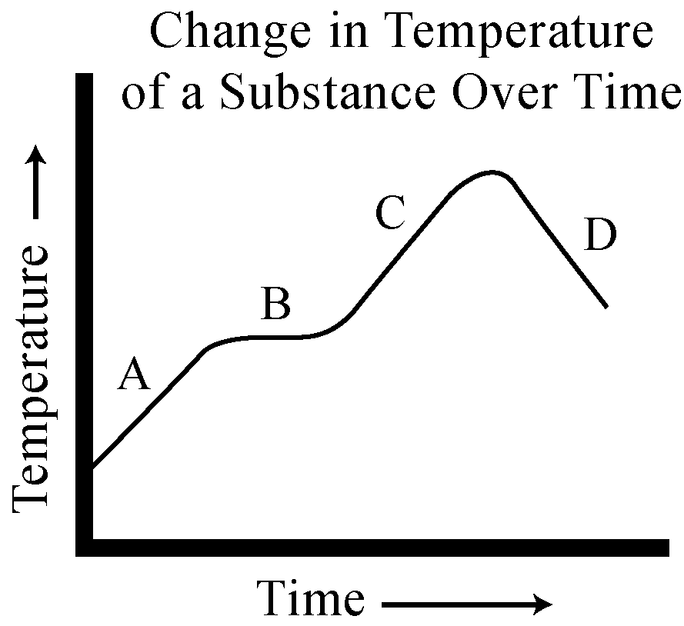
Figure 5

____ 15. Figure 5 shows how the temperature of a substance changed as it was heated. Which segment of the graph indicates that the substance was undergoing a change of state?
a. | A | c. | C
b. | B | d. | D

____ 16. An uncovered pot of soup is simmering on a stove, and there are water droplets on the wall above the back of the stove. What sequence can you infer has occurred?
a. | melting, then boiling
b. | freezing, then thawing
c. | vaporization, then condensation
d. | condensation, then vaporization

____ 17. According to Boyle’s law, when the pressure of a gas increases at constant temperature, its volume
a. | increases.
b. | stays constant.
c. | decreases.
d. | increases, then decreases.

____ 18. When the temperature of a gas decreases at constant volume, its
a. | pressure increases.
b. | mass increases.
c. | pressure decreases.
d. | particles move faster.

____ 19. According to Charles’s law, when the temperature of a gas increases at constant pressure, its
a. | volume increases.
b. | mass increases.
c. | volume decreases.
d. | particles move more slowly.

____ 20. Which of the following examples involves an exothermic change?
a. | ice melting on a warm day
b. | water boiling in a tea kettle
c. | gaseous water particles coming together to form fog
d. | air in a bicycle tire gaining pressure after a long ride

____ 21. Boyle's law states that for a fixed amount of gas at a constant
a. | pressure, the volume increases as the temperature decreases.
b. | temperature, the volume increases as the pressure increases.
c. | temperature, the volume decreases as the pressure increases.
d. | pressure, the volume decreases as the temperature increases.

____ 22. When a person wearing glasses enters a warm house after being outside on a cold day, their glasses fog up because of
a. | vaporization. | c. | sublimation.
b. | condensation. | d. | melting.

____ 23. Which of the following is an endothermic change?
a. | melting | c. | condensation
b. | freezing | d. | all of the above

____ 24. The opposite of vaporization is called
a. | condensation.
b. | sublimation.
c. | evaporation.
d. | freezing.

States of Matter Pretest
Answer Section

MULTIPLE CHOICE

1. ANS: B PTS: 1 BLM: knowledge

2. ANS: B PTS: 1 BLM: comprehension

3. ANS: C PTS: 1 BLM: comprehension

4. ANS: D PTS: 1 BLM: comprehension

5. ANS: B PTS: 1 BLM: comprehension

6. ANS: C PTS: 1 BLM: comprehension

7. ANS: D PTS: 1 BLM: knowledge

8. ANS: A PTS: 1 BLM: knowledge

9. ANS: D PTS: 1 BLM: knowledge

10. ANS: C PTS: 1 BLM: comprehension

11. ANS: C PTS: 1 BLM: comprehension

12. ANS: A PTS: 1 BLM: comprehension

13. ANS: D

 | Feedback
A | What happens when boiling and freezing occur?
B | What happens when condensation and melting occur?
C | No. Try again.
D | That's right!

PTS: 1

14. ANS: C

 | Feedback
A | An object with more speed has more energy.
B | No. That's not correct.
C | You are correct!
D | Earth's gravitational attraction is based on its mass.

PTS: 1

15. ANS: B

 | Feedback
A | The temperature of a substance can change while its state remains the same.
B | Correct!
C | The change of state has already occurred.
D | Try again.

PTS: 1

16. ANS: C PTS: 1 BLM: synthesis

17. ANS: C PTS: 1 BLM: knowledge

18. ANS: C PTS: 1 BLM: comprehension

19. ANS: A PTS: 1 BLM: knowledge

20. ANS: C PTS: 1

21. ANS: C PTS: 1

22. ANS: B PTS: 1

23. ANS: A PTS: 1

24. ANS: A PTS: 1 BLM: comprehension

