8th Grade Westward Expansion Web Quest

This quest will reinforce many of the facts learned during this unit. As you work through this adventure, you will answer questions using given web links and will also need to discover some information on your own. So load up your wagon, cross the plains, and head west!
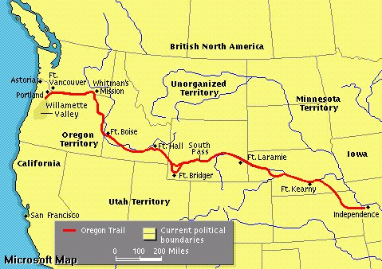
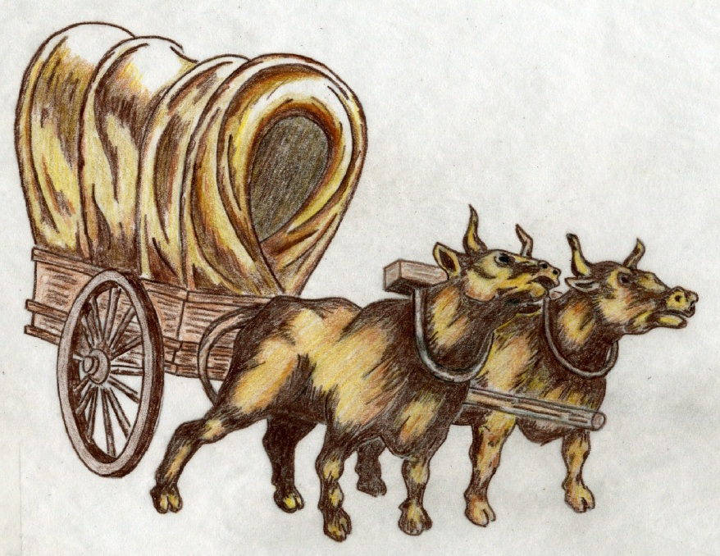
Instructions: Use the web links in each section to help you answer the questions. For each question, circle the keyword and use the Ctrl + F keys to help you locate the keyword on each webpage.
INTRODUCTION
http://www.america101.us/trail/Introduction.html
- Why was the Oregon Trail so important?
Rollin’
Rollin’
Rollin’…..

- When the trail split, what two areas did emigrants travel to?
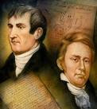
DISCOVERY
http://www.america101.us/trail/Discoverers.html
- Why wasn’t Lewis and Clark’s route used by the emigrants?

- What was Robert Stuart’s incredible discovery, which helped the emigrants?

- What was John Colter accused of lying about?

- Who discovered the Great Salt Lake?
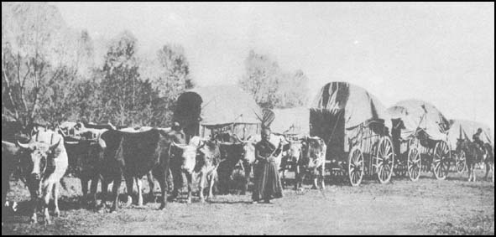
WAGON’S HO
http://www.america101.us/trail/Jumpingoff.html
- In the spring, what were the emigrants waiting for and why?

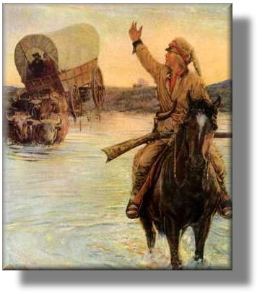
- Describe the amount of food the emigrants would need on their journey and what happened if there was overpacking of the wagons?

ROUGH AND TUMBLE
http://www.america101.us/trail/Hardships.html
Explain how each of the following was a hardship to the pioneers:
- walking
- accidents
- weather
- cholera
- river crossings
A DAY ON THE TRAIL
http://www.america101.us/trail/Camping.html
- Describe a typical day of a pioneer on the trail including camping at night.

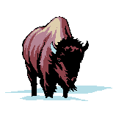
TATONKA
http://www.america101.us/trail/buffalo.html
- How did the buffalo help the emigrants in an unexpected way?
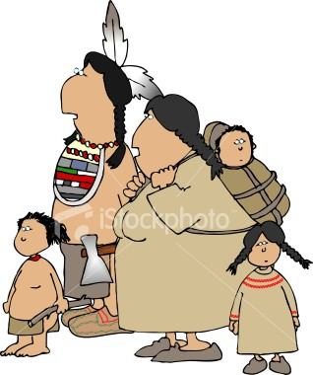

NATIVE AMERICANS
http://www.america101.us/trail/Native.html
Describe Native American and pioneer interactions along the trail at:

- Grattan
- Massacre Rock
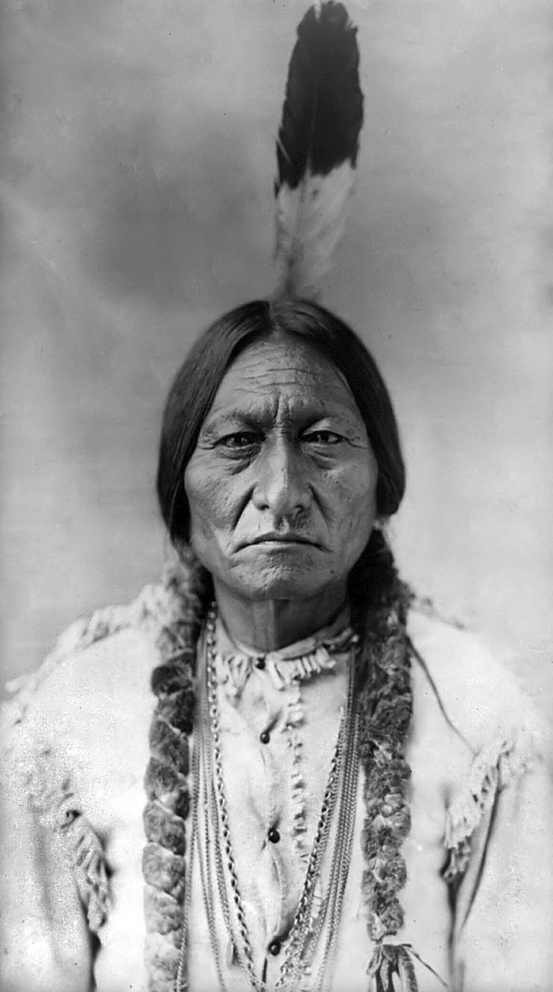
- Bear River
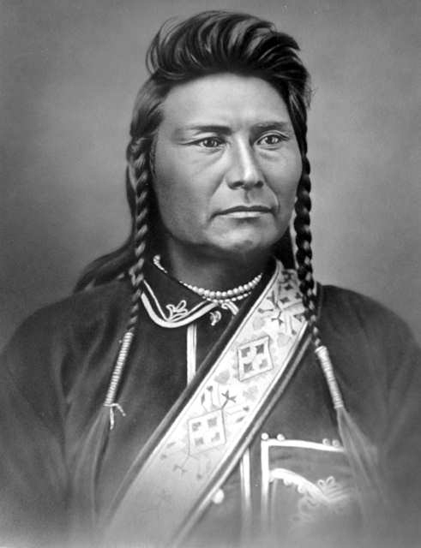

Chief
Joseph
Sitting
Bull

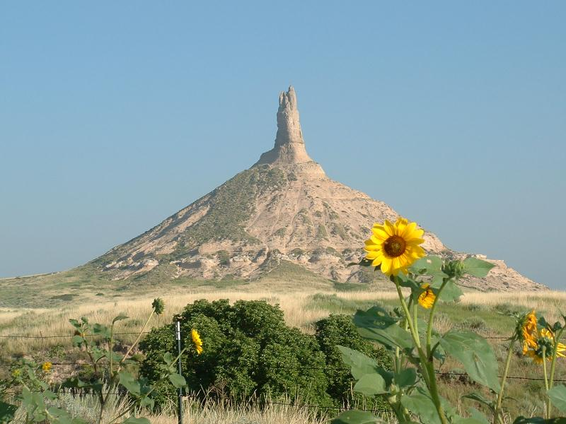
LANDMARKS
http://www.america101.us/trail/Sites.html

Describe the following historic sites:
- Independence, Missouri
- Fort Kearny
- Platte River
- Chimney Rock
- Grande Ronde
- Whitman Mission

Copyright 2008 Donna Preble
http://www.freemansd.org/cms/lib6/WA01000538/Centricity/Domain/83/8th_Grade_CA_Westward_Expansion_Web_Quest.doc.

