
Visual Art Department
High School
Course Title: Visual Art Composition Class
Grade Level: 11-12
Prerequisite: Drawing/Painting 1& 2 or DP 1 and Ceramics 1
Course Length: Yearlong
Instructor: Mrs. Julie Zimmerman
Email: Jmzimmerman@NorthFork.k12.oh.us
Room: 109
Course Overview
This course offers students an extended studio time to work on their visual arts portfolios. Students taking this course are dedicated to the arts and may be extending their focus into college work. The development of student’s portfolios will be explored through several mediums and techniques. Students will have the creative freedom to design projects with the help of the teacher to individualize their projects. Students will create in-depth projects that manage time, resources, the process, self-critiques, and a final product to display. This course will include class critiques and reflections, demonstrations, research, presentations, career building skills, and portfolio basics.

Students should come prepared to class with their Portfolio, Ideas, Sketchbook, Supplies & a Positive Attitude EVERYDAY!
Due to the cost of materials required for this class, each student is required to pay a $30.00 materials fee, which will cover the cost of supplies used in class. Please bring a container of Lysol wipes.

Course objectives
- Students will learn the elements and principles of art and then apply them to create dynamic, balanced compositions.
- Students work on developing a portfolio with well-developed projects capable of college entrance requirements.
- Students will learn to participate in class critiques of their own work for the purpose of evaluation, reflection and improvement. This will stem into class-led discussions about art.
- Students will be encouraged to make their art a meaningful mode of expression by incorporating personal themes and knowledge of the world around them.
- Students will engage in written art statements to fully describe their works.

It is hoped that through this course, students will develop a greater perceptual sensitivity to their surroundings, as well as their inner selves and an attitude of lifelong interest and pleasure in art.

Instructional Methods
Instructor demonstrations, Research, Lecture, Individual Studio work, Projects, Cooperative Learning, and Hands-on experiences.

Textbooks
None

LAB FEE: $30.00

Materials:
- Lab Fee $30.00
- You will need to purchase an artist’s portfolio for this class.
- You will need a writing utensil at all times.
- You will need a sketchbook of paper – preferably 9’’ x 12’’ ( I have some but if you prefer something different, then you will need to purchase this on your own.
- 2 containers of LYSOL WIPES (May be off brand) THIS IS YOUR FIRST PARTICIPATION GRADE!!!!
- Creative Drive, Patience, and Self-Motivation!

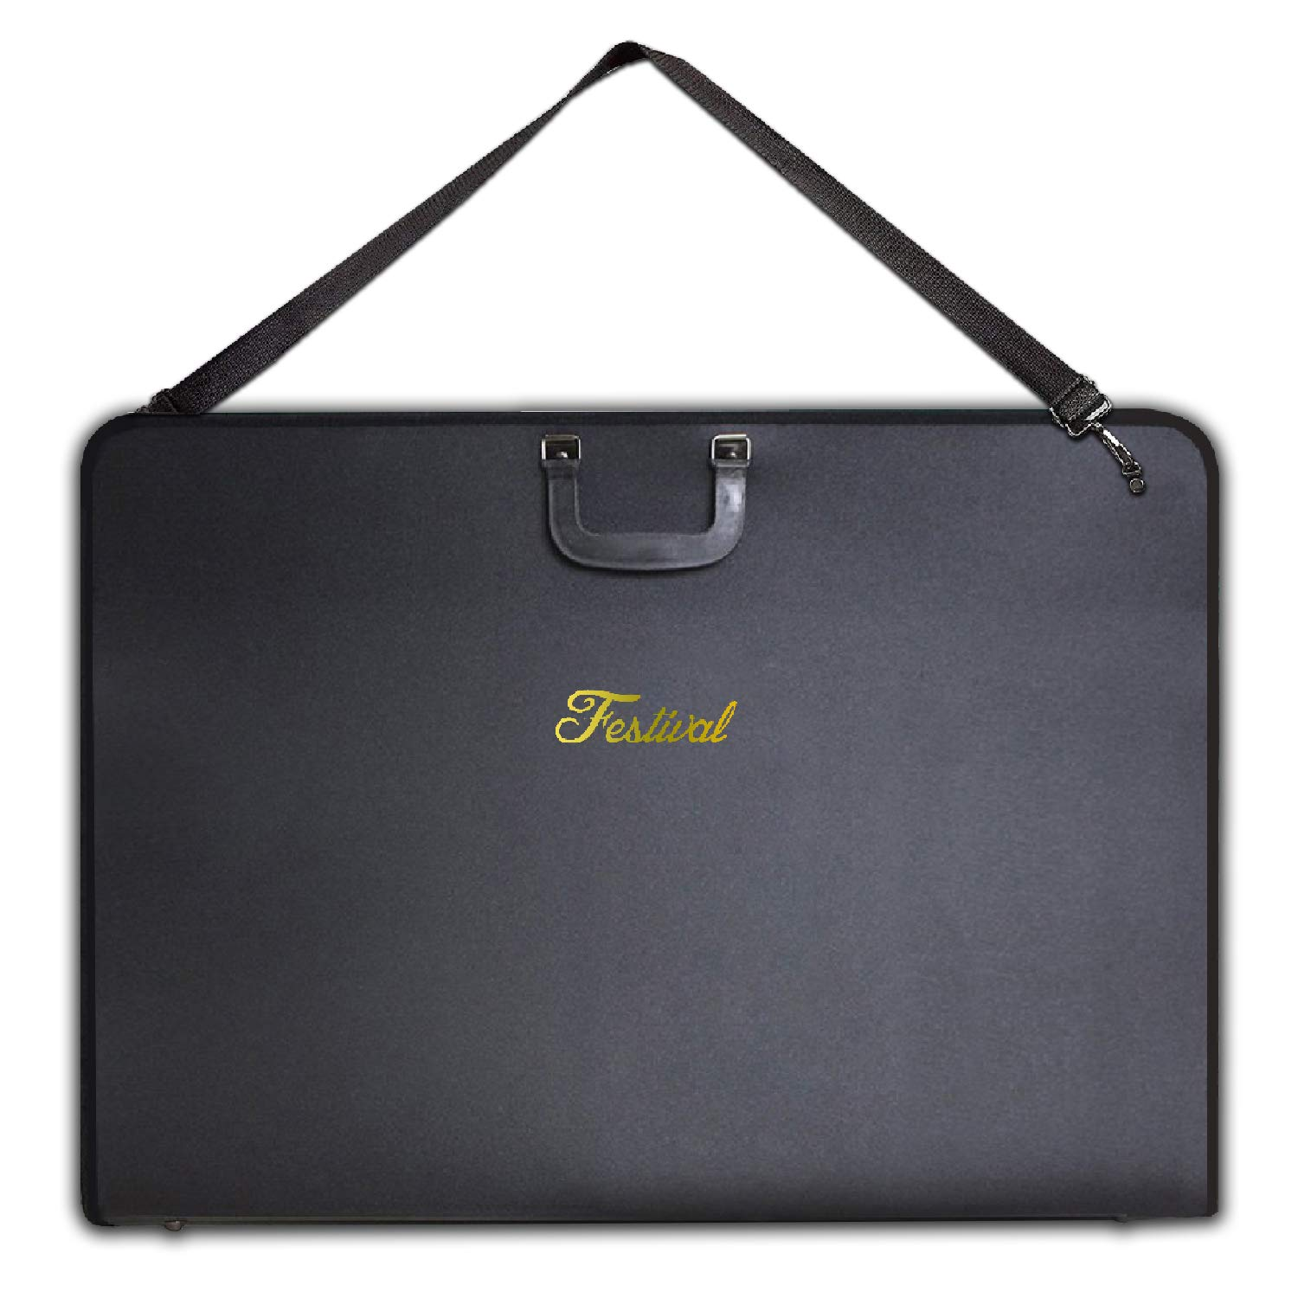
Any larger size or material will work.
This one is waterproof with a zipper.

$25 …
You can also make one out of 2 pieces
of cardboard or thick poster board.

https://www.amazon.com/Portfolio-Carrying-Shoulder-Students-Interviews/dp/B06XQ7SRQH/ref=sr_1_14?keywords=artist+portfolio&qid=1559133513&s=gateway&sr=8-14
ART ROOM EXPECTATIONS:
- Raise your hand if you have a question.
- Stay in your seat unless Mrs. Z asks you to do a job.
- Keep your hands and feet to yourself.
- Share supplies and Ideas.
- Speak in a classroom voice.
- Respect yourself, others, and all materials.
- Clean up properly, every time... every day!
- Artwork takes time & patience… stay positive! ☺
STUDIO TIME: A majority of this class will be spent working on your individual art projects. I will grade you on your progress and participation throughout the project several times. It is extremely important to stay focused and communicate ideas with the teacher and other classmates.

WRITTEN WORK: In Class Work must be done in class. Students should continually work in their sketchbooks/resource files and develop themselves as an artist. Sketchbooks will be graded EVERY FRIDAY!
A place for your reflections, doodles, ideas, drawings, magazine clippings, lyrics that inspire you…etc.

QUIZZES & TESTS: There may be unit quizzes and tests to ensure that you are collectively remembering the material that is being taught. You will always have advance notice of a quiz and should take the time to study outside of class for the best possible grade.

PAPERS / PROJECTS / SHARINGS: There will be an abundance of projects, a slideshow presentation, and critiques, which may or may not include group work and collaboration. Participation is key!

Breakdown of Grading
100-90% A
89-80% B
79-70% C
69-60% D
< 60% F

Projects: 50% (A Criteria sheet will be given at the beginning of every project including: deadlines, total points, and requirements for the project.)
Participation: 25% (Students should actively participate EVERYDAY in class and clean up)
Written Work: 25% (In Class Written Assignments, Critiques, Tests, Quizzes, Etc.)

Attached is a PROJECT LIST of every project we will complete this school year. There are tentative dates attached to each project, although they are subject to change, as the school schedule needs to be flexible with snow days, and other unexpected events. I encourage students to work at their own pace and continually ask questions and talk about how to stretch their creativity. Art is something that is never finished, but we together can agree upon a stopping point.

Students will become familiar with creating a PROJECT PROPOSAL for the listed theme/assignment. Students in this class will need to be self-advocates, creative thinkers, and self-motivated to carry themselves from start to finish of a project/idea.

Each project will be SHARED with the class, and we will run through a CRITIQUING process. This process will help artists develop communication skills, and choose specific advice or opinions that may develop their projects even more.

All projects will be PHOTOGRAPHED with a black or white background. They will be UPLOADED to an online folder. An end of the year project will include all project photographs and a description of the piece. It is important to photograph each piece and upload them, as we will have a final class showcase and move work around the room; don’t wait until the end of the year to complete this task.
1 MANDATORY EVENT for this class

“Composition Night” - Stay after school

* Announcements will come closer to these dates.
*Pending due to Social Distancing guidelines*

*This is a large event that requires student art and participation; this is also a large art of their grade in class.

PLEASE TAKE NOTE – THIS IS A GRADE!

- Brainstorm / Sketch.
- Communicate Ideas.
- Create.
- Ask Questions.
- Develop Ideas.
- Create meaning / story.
- Share.
- Photograph / Upload.
- Reflections / Take notes.

General Class Expectations:

I am committed to providing a quality education to all students in a supportive and challenging environment. I have little or no patience for students who are disruptive, chronically unprepared, rude to me or other students, or otherwise disrespectful. I’m more that happy to help you with any problems you are having in class and I do expect you to do your part and be an advocate for yourself. If you need something, ask!

1. Students are EXPECTED to be in the classroom on time.
* 3 UNEXCUSED tardies will result in a lunch detention the following day.
2. Students are in charge of their grade! Projects have deadlines and will not be accepted late!
Under specific circumstances, if communication is clear between teacher and students, then extensions may be granted.
3. If a student has an Excused Absence, then they will have that number of days to make the project up without penalty.

Classroom Procedures

Entering class:
• Come in class prepared with all needed materials, and sit quietly waiting for instruction.
• An objective will be given at the beginning of each class. *Also noted on criteria sheets.
During class:
• Be a student who:
Watches the teacher
Asks questions
Nods head acknowledging they are listening
Tries to dig deeper into the subject
Succeeds with practice!
To learn!!
• Successful students are active participants
• Complete all assignments given in a timely manner

End of class:
• Write down homework and project due dates for the coming week
• Clean your table with a Lysol wipe (put away paper, personal belongings, push chairs underneath the tables)
EVEN IF IT IS NOT YOURS – PLEASE DO YOUR PART AND CLEAN UP. Participation also includes clean-up!

Food & Drink:
No Food or Drinks will be allowed the art room. We do not want any spills or stinky milk.

IPads:
Students may use IPads for note taking, reference tool. Personal use of the Ipad can only be used after the student is completely finished with the objective / assignments and you must ask the teacher for permission.
PHONES are NOT permitted in school / classes.
Attendance:
Students must be in the room and seated before the bell rings. We will strictly adhere to the school tardy policy.
Students will sign themselves in on a roster as they enter the room each day for attendance.

Instructor Availability:
I am willing to provide you with extra help during in-class studio time, and scheduled before and after school. You must email or talk to me directly to schedule a time, as we all have busy schedules.
Email: jmzimmerman@NorthFork.k12.oh.us *This syllabus is a guide of what should be covered this year and expectations of the student, the instructor reserve the right to make adjustments to this syllabus at any time.*

PRINTED STUDENT NAME: _________________________________________________________
Please circle one:
I DO / DO NOT give permission for my students’ artwork and photo to be used on the UHS sites; as an online gallery.
PRINTED NAME OF PARENT/ GUARDIAN: _____________________________________________
RELATIONSHIP TO STUDENT: ______________________________________________________
SIGNATURE OF PARENT / GUARDIAN: _______________________________________________

PARENT Contact information: EMAIL ________________________________
PHONE ________________________________
I am willing to help with: ______ Donating food for the Spring Art Show if held
______ Donating supplies to the Utica art program

Please read and return to Mrs. Zimmerman

Return signed syllabus and $30.00 by 8-26-2020
Fees will show up on your report card – you can pay the guidance office directly. Do not give money to Mrs. Z or the main office.
Questions? Comments?

Feel free to contact us at any time.

Mrs. Julie Zimmerman JmZimmerman@NorthFork.k12.oh.us

-- -- -- -- -- -- -- -- -- -- -- -- -- -- -- --
Your student will need the following materials for Composition Class this year:
Materials:
- Lab Fee $30.00
- You will need to purchase an artist’s portfolio for this class. Any larger size or material will work. This one is waterproof with a zipper. I have some paper ones that can be a temporary hold over until one is purchased.
- You will need a writing utensil at all times. You may want to purchase a drawing pencil set (2H – HB – 8B)
- A small packet of paintbrushes to keep in your cubby.
- You will need a sketchbook of paper – preferably 9’’ x 12’’
- 2 containers of LYSOL WIPES (May be off brand)
THIS IS THE FIRST PARTICIPATION GRADE!!!!
- Creative Drive, Patience, and Self-Motivation! Approx. $25
https://www.amazon.com/Portfolio-Carrying-Shoulder-Students-Interviews/dp/B06XQ7SRQH/ref=sr_1_14?keywords=artist+portfolio&qid=1559133513&s=gateway&sr=8-14
Visual Arts Composition Class
2020-2021
Artist: _______________________________________
PROJECTS DEADLINES

- Myself as an Artist / My Art Process (Pre-Test)
- Project Proposal _______
- Progress Ck./Sharing _______
- Reflection of artwork/ time* _______
- Photograph/Upload________
- Final Grade/Comments_______
*Skills learned, challenges, and future goals will be identified in the reflection section.
- Represent a song
- Project Proposal _______
- Progress Ck./Sharing _______
- Reflection of artwork/ time* _______
- Photograph/Upload________
- Final Grade/Comments_______
*Skills learned, challenges, and future goals will be identified in the reflection section.

- Phobia(s)
- Project Proposal _______
- Progress Ck./Sharing _______
- Reflection of artwork/ time* _______
- Photograph/Upload________
- Final Grade/Comments_______
*Skills learned, challenges, and future goals will be identified in the reflection section.

- At least 3 mediums
- Project Proposal _______
- Progress Ck./Sharing _______
- Reflection of artwork/ time* _______
- Photograph/Upload________
- Final Grade/Comments_______
*Skills learned, challenges, and future goals will be identified in the reflection section.

- Repetition or Pattern
- Project Proposal ______
- Progress Ck./Sharing _______
- Reflection of artwork/ time* _______
- Photograph/Upload________
- Final Grade/Comments_______
*Skills learned, challenges, and future goals will be identified in the reflection section.

- Abstract
- Project Proposal _______
- Progress Ck./Sharing _______
- Reflection of artwork/ time* _______
- Photograph/Upload________
- Final Grade/Comments_______
*Skills learned, challenges, and future goals will be identified in the reflection section.

- Small & in a Series (At least 3)
- Project Proposal _______
- Progress Ck./Sharing _______
- Reflection of artwork/ time* _______
- Photograph/Upload________
- Final Grade/Comments_______
*Skills learned, challenges, and future goals will be identified in the reflection section.

- Portrait / Person
- Project Proposal _______
- Progress Ck./Sharing _______
- Reflection of artwork/ time* _______
- Photograph/Upload________
- Final Grade/Comments_______
*Skills learned, challenges, and future goals will be identified in the reflection section.

- CONTRAST (Dark vs. Light) (Black & White) ____________________
- Project Proposal _______
- Progress Ck./Sharing _______
- Reflection of artwork/ time* _______
- Photograph/Upload________
- Final Grade/Comments_______
*Skills learned, challenges, and future goals will be identified in the reflection section.

- A New Medium (Something your haven’t tried in class yet)
- Project Proposal _______
- Progress Ck./Sharing _______
- Reflection of artwork/ time* _______
- Photograph/Upload________
- Final Grade/Comments_______
*Skills learned, challenges, and future goals will be identified in the reflection section.

- Something larger than 9x12’’
- Project Proposal _______
- Progress Ck./Sharing _______
- Reflection of artwork/ time* _______
- Photograph/Upload________
- Final Grade/Comments_______
*Skills learned, challenges, and future goals will be identified in the reflection section.

- Free Choice
- Project Proposal _______
- Progress Ck./Sharing _______
- Reflection of artwork/ time* _______
- Photograph/Upload________
- Final Grade/Comments_______
*Skills learned, challenges, and future goals will be identified in the reflection section.

- Art History
- Project Proposal _______
- Progress Ck./Sharing _______
- Reflection of artwork/ time* _______
- Photograph/Upload________
- Final Grade/Comments_______
*Skills learned, challenges, and future goals will be identified in the reflection section.

- My Style (Post – Test)
- Project Proposal _______
- Progress Ck./Sharing _______
- Reflection of artwork/ time* _______
- Photograph/Upload________
- Final Grade/Comments_______
*Skills learned, challenges, and future goals will be identified in the reflection section

ALL Portfolio Works are ready for Composition Night: Spring 2021 (Date TBA)
- Touched Up & Completed
- Matted / Framed / Looking Professional
- Sketchbook marked with tabs on favorite pages.
- Label : Title and Description on labels provided (paper clipped to the artwork)
- Portfolio left with Mrs. Z

COMPOSITION NIGHT – YOU MUST ATTEND THIS EVENT!

Extra Projects:

15.
16.
17.
18.
19.
20.

EXAM
Part 1: Composition Night / Spring Arts Show (if held)

Part 2:
Exam will include a PowerPoint presentation of your projects. You will need to take professional photos on a black or white background, measure the size of each piece, materials used, and explanation of your piece/theme.

Throughout this year you will need to choose at least 8 different mediums.
Of course you may concentrate in a medium of your choice, but I am looking for variety in your works/ styles to showcase you as a growing artist and student.

1. Please check off the medium chosen when your project is completed.
2. Write the project name next to each medium for your records.

- Watercolors:
- Acrylic Paint:
- Graphite:
- Collage:
- Colored Pencil:
- Oil Pastels:
- Chalk:
- Clay:
- Wire / Metal:
- Pen & Ink:
- Photography:
- Charcoal:
- Mixed Media:
- Digital Printing:
- Paper:
- Cardboard:
- Plastic:
- Cloth:
- Recycled Materials:
- Food:
- _________________________
- ___________________________

