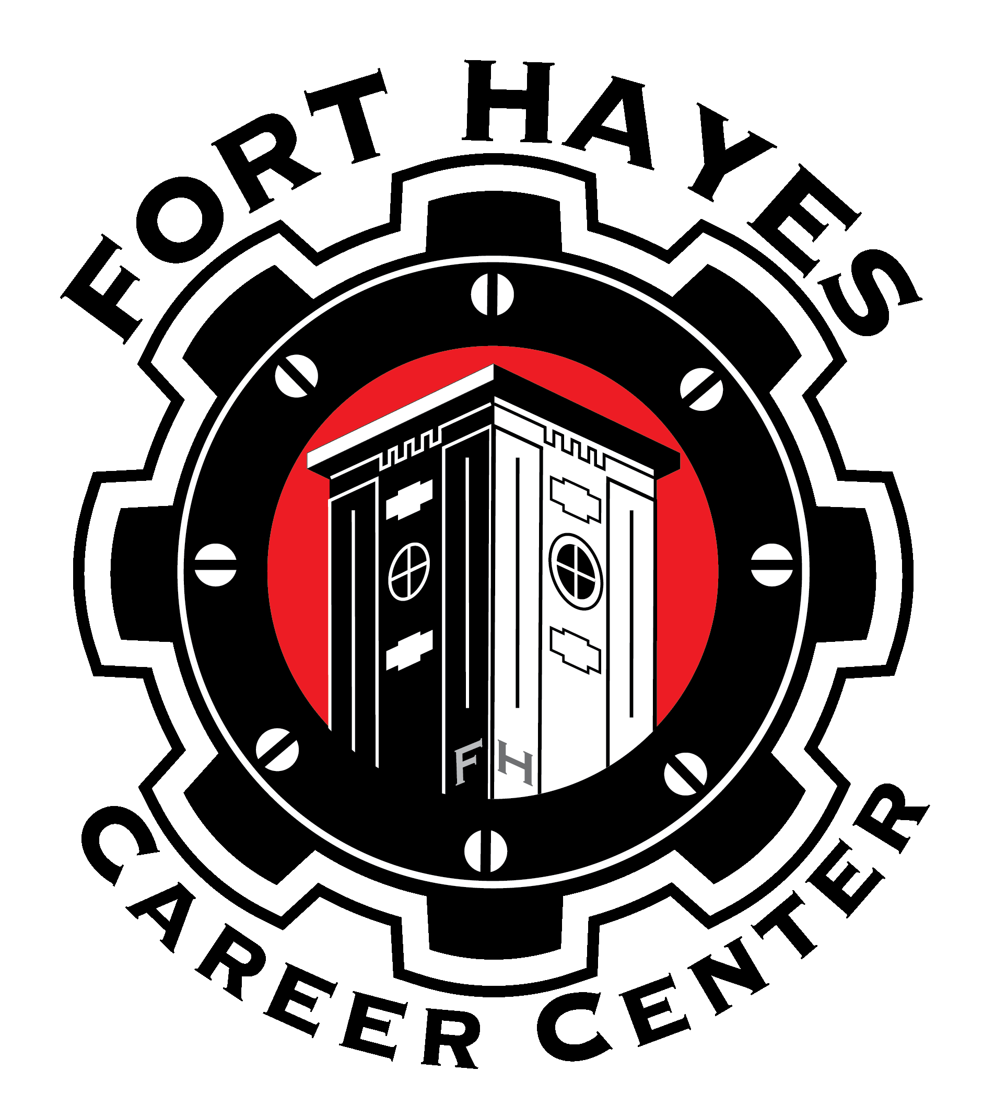
 Fort Hayes Career Center

Construction Arts & Transportation Systems
Program Bldg. /Room Instructor
Automotive Collision Repair | CA / 101 | Robert Parker
Automotive Technology | CA / 105 | William Caspole/Terry Smeck
Bricklaying & Concrete Systems | CA / 111 | Adam Viney
Carpentry | CA / 113 | Alton Smith
Construction Electricity | CA / 117 | Ceron Williamson
Heating, Ventilation & Air Conditioning | CA / 119 | Horn In
Welding | CA / 102 | Andrew Taylor
NCCER | CA /122 | Bob Knecht

Health Science
Program Bldg./Room Instructor
BioScience Technology | H/213 | Dr. Becky Graham
Dental Assisting | H/112 | Ebony Hale
Fitness & Wellness | H/111 | Vicky Pate
Medical Assisting | H/206 | Kelly Tabor
Medical Laboratory Technician | H-202 | Gerald Collins
Pathway to Nursing | H/101 | Julie Clark/Carla Toles-Anthony
Pathway to Surgical Technology/Sterilization | H/201 | Michael Vail

Performing Arts
Program Bldg./Room Instructor
Audio Production | 110 / 105A | Ryan Van Bibber
Dance Performance | PA / 123 | China White
Filmmaking & Television Production | PA / 124 | Julie Kindinger
Music Performance | CA / 124 | Jeff McCargish
Theatre Performance | PA / 114 | David Bahgat

Visual Arts
Program Bldg./Room Instructor
Art Portfolio | ST / 202 | Anna Bory-Ackers
Graphic Arts & Design | 110 / A005 | Keith Morefield
Photography | ST / 213 | Corrie Witt

SEE SEPARATE MAP FOR BUILDING LOCATIONS ON CAMPUS
CA – Construction Arts Building PA – Performing Arts Building ST – Shot Tower
110 – Building 110 H – Health Building

