Arts Commission
Of the

City of Rio Rancho
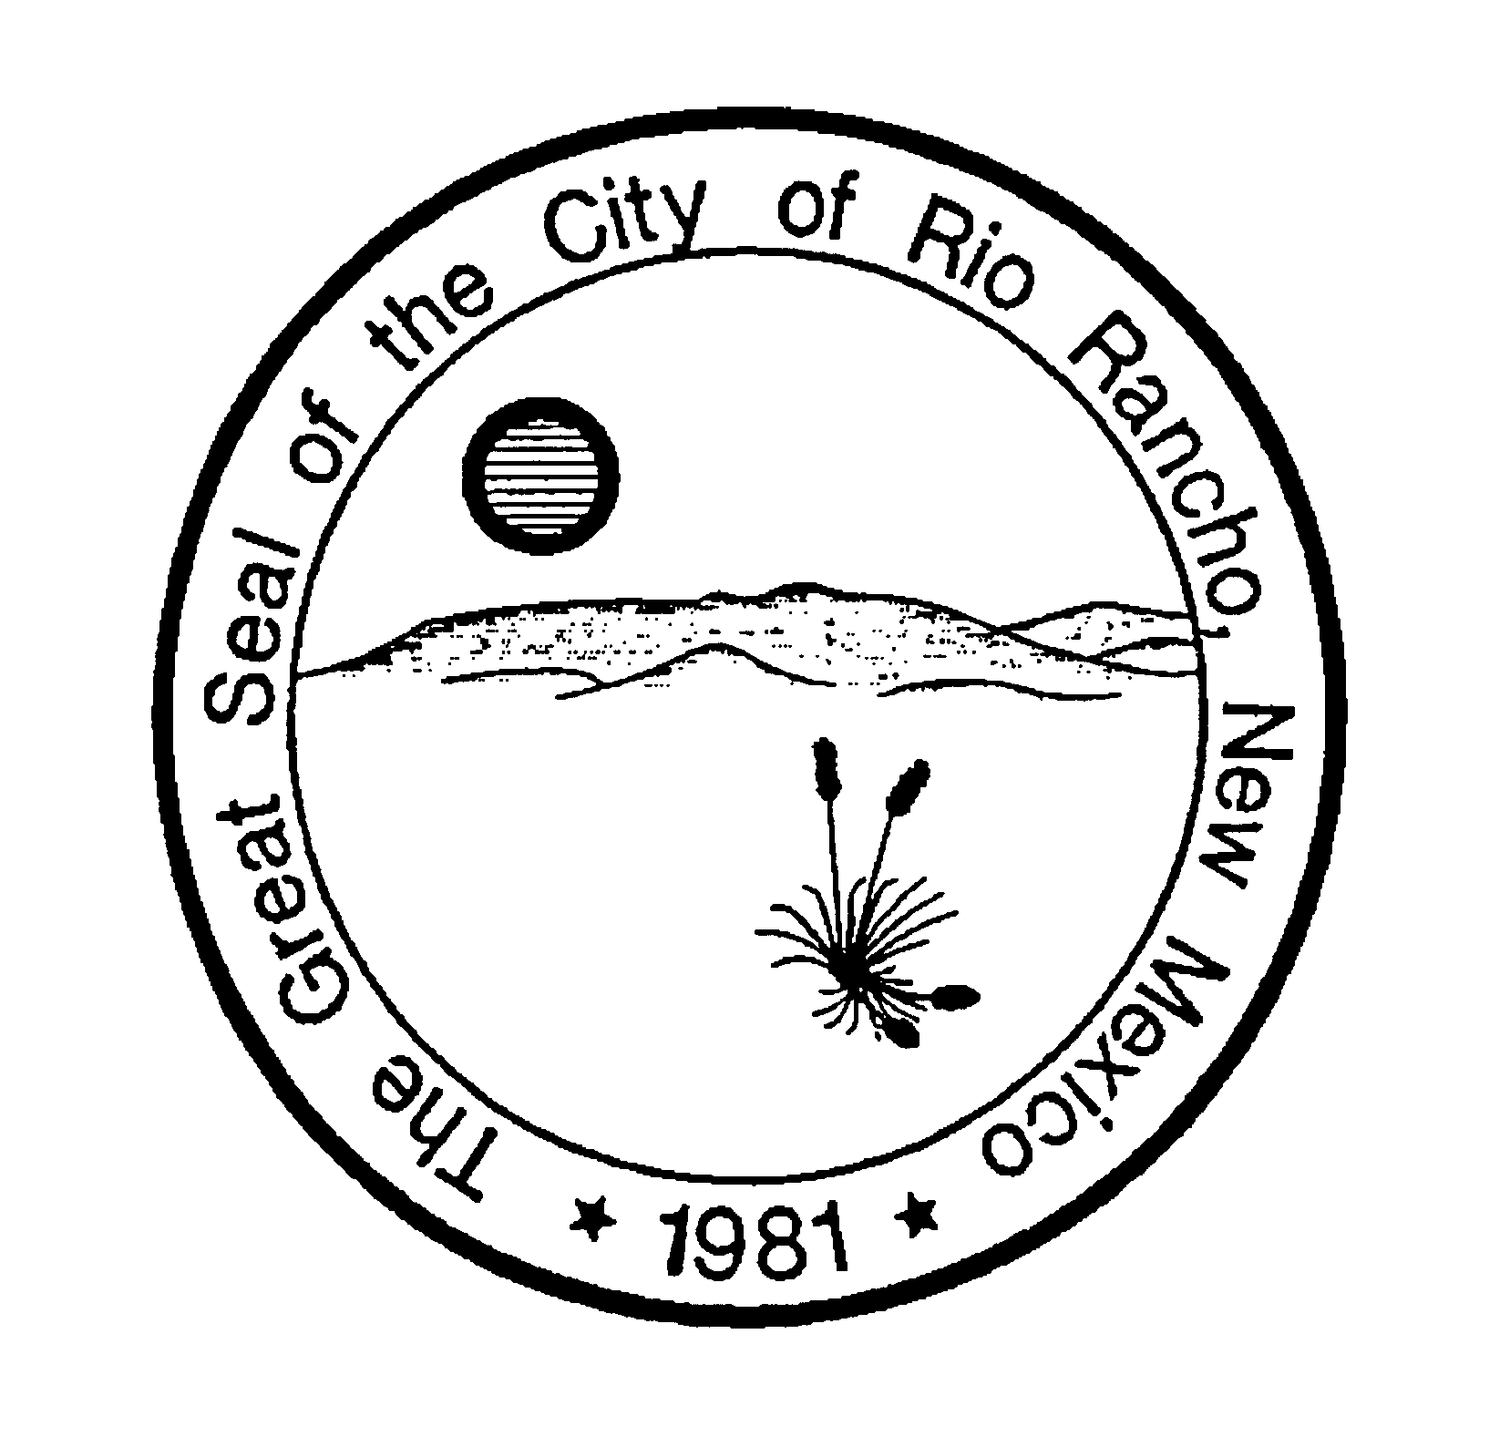

MINUTES

June 12, 2014
6:00 P.M.
CITY COUNCIL CHAMBERS

members present: staff present:
Darryle Bass Dyane Sonier
Daniel Chamberlain
Jaymes Dudding
Debbie Fleming
Joseph McDonnell
Paula Scott
Theresa Surette-Fowinkle

CALL TO ORDER

Daniel Chamberlain, Chairperson called the meeting to order at 6:06 p.m.

APPROVAL OF MINUTES: Daniel Chamberlain asked if there was a motion to approve the minutes of April 4, 2014. Joe McDonnell motioned for approval. Seconded by Darryle Bass. There was no additional discussion among the members.

The motion passed by a vote 7 for and none against.
Yes: Bass, Chamberlain, Dudding, Fleming, McDonnell, Scott, Surette-Fowinkle
No: None

COMMENTS FROM THE PUBLIC (3 MINUTES EACH)
None

PRESENTATIONS
None

REPORTS
- City of Rio Rancho/UNM Architecture Collaboration – Daniel Chamberlain said that he had met with the new Mayor to give him an overview of what the RRAC is doing and summarize the meeting with the UNM School of Architecture and Planning. On June 25th he, the Mayor and Geraldine Forbes will meet to discuss the collaborative project and how UNM is planning to offer a graduate studio this fall to do the arroyos plan – maybe SSCAFCA, the County or others will have funding. They also wish to create curriculum for UNM West.

- Renaissance Fair Research – Joe McDonnell: Joe informed the group that everything is in place, people, music, activities, while a few other things are still in the works. He said that Peter Wells approved the RRAC PR piece for event advertising. Joe would really like to get the handouts, posters, etc. in the works/printed and distributed asap. Paula would like to make sure the information will also be on the Library’s Facebook page. Joe said he will speak with Lynette with the Libraries about this. Terri will ask the woman playing madrigal music for the library activities if it is okay for Paula to film her to place on You Tube.
Joe thanked everyone for their help in pulling this project together to this point. Daniel said this was a good experience for everyone to get to reach out and introduce themselves to people, to make connections needed to bring the event and activities together. Terri said she went to the Celtic Fair at the Albuquerque Balloon Fiesta Park and networked with people there. She listed some of the people whom she met that would like to be more involved with art and music in Rio rancho. Daniel said it is great that the Commissioners are building these relationships. Joe felt it was a great opportunity to pair the Celtic Festival people and the Oktoberfest Planners in the future (instead of just the SCA people), and the event could possibly gain support of the CVB and its staff. Daniel said it is possible to do something really big, but if the RRAC wishes to partner with or approach the Santa Ana Star Center about partnering or supporting such an event, that the RRAC members may need to generate a Performa to demonstrate the effectiveness (funding, revenue) of the proposed event.

- Outreach Subcommittee – Daniel Chamberlain met with the Mayor as mentioned above. The Mayor may have a mission for the RRAC.
- Newspaper Article Review/General Discussion – Paula said that the latest article had been reviewed and approved by Peter Wells and the RRAC members and was ready to go. The article is about the Gateway Park / Flood Wall artwork and the process followed to bring it all together.
- Communications – Paula Scott said that Alise has been continuing to post new information on the various sites for the RRAC, totally on a volunteer basis, and has been doing a great job. The next task is to try to track how many views/likes, etc. the sites are getting.

DISCUSSION AND DELIBERATION

- Commission Presentation to City Council (tentatively June 25, 2014) – Daniel Chamberlain: Daniel provided the one-page handout that will be given to the Governing Body at the June 25th meeting and asked for feedback. Debbie said that she really wants to say that there is currently a lack of coordination of local arts groups (not just visual arts, but also performing arts, etc.) and there is value in addressing this issue. Daniel said he would add that as the first bullet. The group also discussed better defining “Arts” to include “visual and performing arts.” The group then discussed the current HP Art Project, its location and tentative installation dates. At this time the RRAC will not provide any specifics on that art project in the presentation. Daniel will provide a one-page handout, updated with Commissioner feedback, to Dyane who will then provide it to Jay Hart to take to the City Manager prior to the Council Meeting.

APPROVAL OF MINUTES: Daniel Chamberlain asked if there was a motion to approve the proposed one-sheet handout to the Council as adjusted in the meeting. Debbie Flemming motioned for approval. Seconded by Jaymes Dudding. There was no additional discussion among the members.

The motion passed by a vote 7 for and none against.
Yes: Bass, Chamberlain, Dudding, Fleming, McDonnell, Scott, Surette-Fowinkle
No: None

2) New Policy Development – Daniel Chamberlain:
Dyane will continue to work with the City Attorney’s Office to get the latest policy document for Donation/Display of public art approved by City Management. She will advise the City that the RRAC supports the use of the existing State AIPP contract as well.

For new policy development, Daniel would like other Commissioners, especially the newer members, to have the opportunity to consider two things and their related policies:
- Murals in public (city or business buildings) spaces/on buildings. He would recommend that members working on this policy read the City’s existing Sign Ordinance, research what other cities follow this practice - have as far as programs, policies, ordinances, to see what is successful for all parties, then to write a framework for it. Debbie noted that this would need to be done with integrity. Terri and Jaymes agreed to work on this policy.
- An Overlay Plan for the placement of public artwork throughout the City. Last time this was reviewed, they looked at each of the Council Districts and for public spaces in each. This needs to be more clearly defined/ recommended by the RRAC so that when opportunities arise, the RRAC is ready with a recommendation. So this subcommittee will work on determining where there are public spaces, and which are appropriate for which types of art (parks, schools, rights-of-way, SSCAFCA, etc.). Debbie and Daniel – and the rest of the RRAC will work on this policy.

OTHER BUSINESS
- Darryle informed the group that she would be working on forming a local selection committee for the A Park Above project, following the same processes used to form the LSC for the UNM and NM AIPP projects (including the call for members, application forms, etc.). She said that they would need a representative from District 5 where the park is located. Jaymes said he would help with this process. RRAC will convene a standing LSC for A Park Above, mirroring AIPP membership, to choose and direct art installations and activities at the park going forward.
- Everyone needs business cards. Dyane will see if Melanie in PRCS can print some.
- Paula encouraged the other members to try to sit in on the City of Albuquerque’s Art Commission meetings. They meet the 3rd Wednesday of the month at 4:00 p.m. in room 7026 DMD on the 7th floor of the City County Center.
- Next Regular Meeting July 10, 2014 – Will be in the Council Overflow room.

ADJOURNMENT
Daniel Chamberlain adjourned the meeting.

There being no further business to come before the Commission, the meeting adjourned at 7:50 P.M.

APPROVED THIS 10th DAY OF JULY, 2014
______________________________

Daniel Chamberlain, Chairperson

ATTEST:

_______________________________
Dyane Sonier, Resource Development Manager

