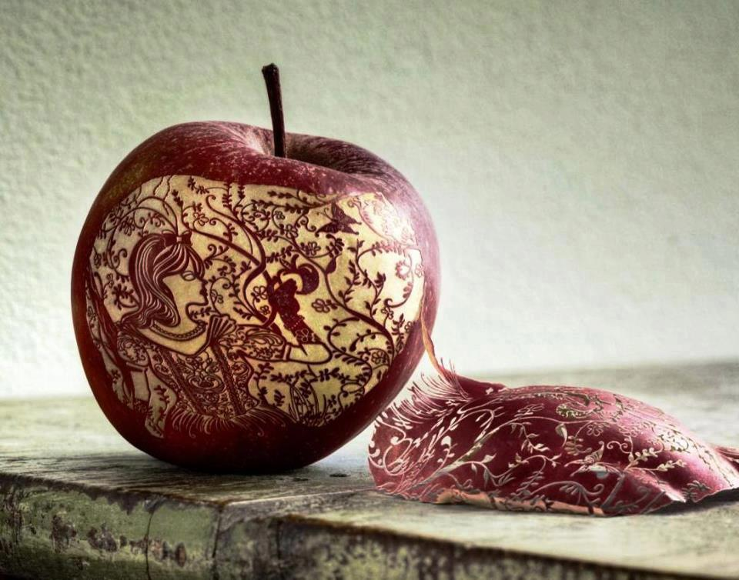
Art 4
Advanced Art- Honors
Krystin McPhail, Instructor
krystinm@sampson.k12.nc.us

Course Description: Art 4 Advanced Art is the highest level art study. As an advanced art student, you will be expected to use art vocabulary in art critiques, as well as analyzing compositions and communicating effectively the language of visual arts. This semester you are required to develop a body of work that encompasses a thesis statement that you have developed. Your body of work will be a minimum of 8 pieces, along with a verbal presentation at the end of the semester that will be presented before a panel of judges. You will also be required to create a website that displays your portfolio along with your artist statement and thesis. You will learn to apply creative and critical thinking skills to artistic expression. You will be asked to create art using a variety of tools, media, and processes. You will be expected to understand the global, historical, societal, and cultural contexts of visual arts. You will need to understand the interdisciplinary connections and life applications of the visual arts. It should be your goal, by the end of the semester you have a firm grasp of your artistic style and how to communicate effectively in every aspect of the visual arts. As an Advanced art student, it is my goal for you to strive to learn what you do not know, and achieve mastery for those particular skills.
What does all that really mean??? What can you expect?
Well, first I want you to understand that we will work every single day. Yes, EVERY day. This is because you have quite a bit that you are responsible for and that we need to cover this semester. There will be tests, lectures, art critiques and discussions, independent studies, and prompts given during this course. This course will be a study of your own abilities and talents. I am expecting you to push your self harder than you have in the past. I will be grading you based on your effort and perseverance through a project. It is key that you work the entire class time and use this time wisely. I have very high expectations for you as a developing artist, and have higher standards for you as Art 3 students and hope that you set high goals for yourself to achieve by the end of the year. We will be working to develop your sense of personal style, by studying Artist, works of art, particular time periods, and specific styles.
I do expect you to respect everyone and their opinions and to address everyone in a positive manner. Having an open mind is one of the necessities of learning about others and their artwork; therefore, it is important that you come to class with a willingness to learn new things about new places and new people. I strive for this classroom to be a safe and open environment where all students work comfortably within the creative environment – in other words, everyone accepts everyone else and no one is left out for any reason. Think of yourself as an advanced learner, and no matter what it is that you think you know, there is always something to learn.
There are NO multiple-choice tests – I use matching, fill in the blank, short answer and essay. I like to find out what you KNOW, not what you guessed!
The materials we use are bought with limited funding and cannot be wasted, proper care & cleaning of materials is necessary. Willful and/or repeated misuse and damage will result in disciplinary action.
Make-Up Work:
It is your responsibility to ask me about make up work. If you have an absence, and you missed material, I can give you the notes. If you were absent, and we had a test, you will be required to make it up. If you missed an assignment or class work, you will have 3 days to get that to me, after that, I will not accept it. If you are absent a day that a project is due, you will be required to turn it in the day that you return. If you do not, IT WILL NOT BE ACCEPTED.
Conference Times:
If you are struggling or need longer studio time on a particular assignment, you will need to meet with me to schedule a time to work extra on your assignment or stay after school to finish.
Class Policies and Procedures:
- Come to class every day on time with all your materials. *A tardy in my class is defined as NOT being in your seat WHEN THE BELL RINGS.*
- The teacher will dismiss the class – NOT the bell. Class will not be dismissed until the room is clean, in order, and everyone is in their SEAT.
- Use the bathroom before class.
- Any missed assignments, including homework, due to absences you will have 3 days to make up work. Late work, not due to absences, WILL NOT BE ACCEPTED!!!
- If you project requires extra time to be completed, you have to make arrangements with me prior the due date. This is your responsibility.
- Even though Art can be subjective, grading your art projects it totally objective: each project has a rubric with specific requirements and guidelines. Just follow them.
- When you enter the classroom, look at the board for instructions for the class period.
- You must actively participate in class work or you will be sent out.
- Stay off/out of the teacher’s desk, please.
- The supplies are not to leave the art classroom for any reason! Please ask permission before you use any of the supplies!

Class Rules:
- RESPECT! I expect respect in every aspect! Respect others and their opinions, the teacher, the classroom and the supplies!
- Use appropriate conduct and language! At ALL times. You will receive one warning, and then further disciplinary actions will be taken.
- Use YOUR brain, NOT some one else’s. I have a ZERO tolerance for cheating. There will be NO warnings! 1st offense will result in disciplinary action. NO EXCUSES!
- Sleeping is to be done at home, NOT in class. If I see that you are having trouble staying awake in class, I will have you stand to complete your work. If you continue to sleep, further diciplinary actions will be taken.
- HAVE FUN and BE CREATIVE!
- CELL PHONES are not to be used in class AT ALL, FOR ANY REASON! If I see or hear your phone I will take it, no exceptions.

Grading:

Critiques 20%
Participation(Website, HW, etc.) 40%
Projects 40%
Total 100%

Your exam at the end of the semester is mandatory. You will present your artwork before a panel of judges, and the cumulative scores will be averaged to give you your exam grade. This particular grade will be 20% of your total semester grade.

Required Materials:
- Art Sketch Book (Not the spiral bound, and a larger book would be best)
- Paint Brushes
- #2 Pencils (If you would like, please purchase a set of drawing pencils with a variety of B and H pencils)
- Erasers (no pink erasers please)
- Personal Pencil Sharpener
- An old, unimportant t-shirt or Apron to keep in class. The materials we paint with will NOT come out of clothes!
Spiral down the side – YES!
Spiral down the side – Yes!

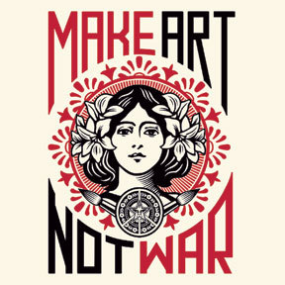

We love donations and are ALWAYS in need of:
soap
paper towels and paper plates and plastic cups
tissue
hand sanitizer
small, plastic containers like those used for yogurt, fruit, etc (clean, please)
brushes of any kind
magazines
glue sticks and tape
cardboard
decorative paper
copy paper
white erasers
#2 pencils
Ziploc bags, saran wrap, and tin foil

Please return this page only to Mrs. McPhail

Notes:
- I grade on the effort, neatness, and work ethic you put into your projects, not talent. I take art seriously and
expect my students to do the same.
- I DO NOT tolerate any misbehavior or disrespect.
- I hope that you will take pride in the art that you create, and be proud of your unique abilities.

Parents, please review this syllabus with your student, sign and return.
By signing this form you are stating that you have read and understood all material presented in this syllabus and agree to comply. Feel free to contact me at work,
or by email, krystinm@sampson.k12.nc.us

Thank you.

__________________________________________________ _____________
Parent’s Signature Date

__________________________________________________ _____________
Student’s Signature Date

Please fill in the student information below:

Student’s Name _____________________________________________________________________________

Name of Parents/Guardians ___________________________________________________________________

Work Number of Parent: (please list who) ________________________________________________________

______________________________________________________

Home number of Parent (please list who) _________________________________________________________

_________________________________________________________

Email Address: __________________________________________________________________________________________

Emergency Contact (and relationship to student): __________________________________________________________________________________________
__________________________________________________________________________________________

Please list any allergies or medical conditions you feel I may need to know about:
______________________________________________________________________________________________________________________________________________________________________________________________________________________________________________________________________________________________________________________________________________________________________________________________________________________________________________________________________________________________________________________________________________________________________________________________________________________________________________________

