Garden City Public Schools
56 Cathedral Avenue
Garden City, NY 11530

Coordinator of Public Information
Catherine Knight, Ed. D.
516 478-1079

June 24, 2019

For Immediate Release:

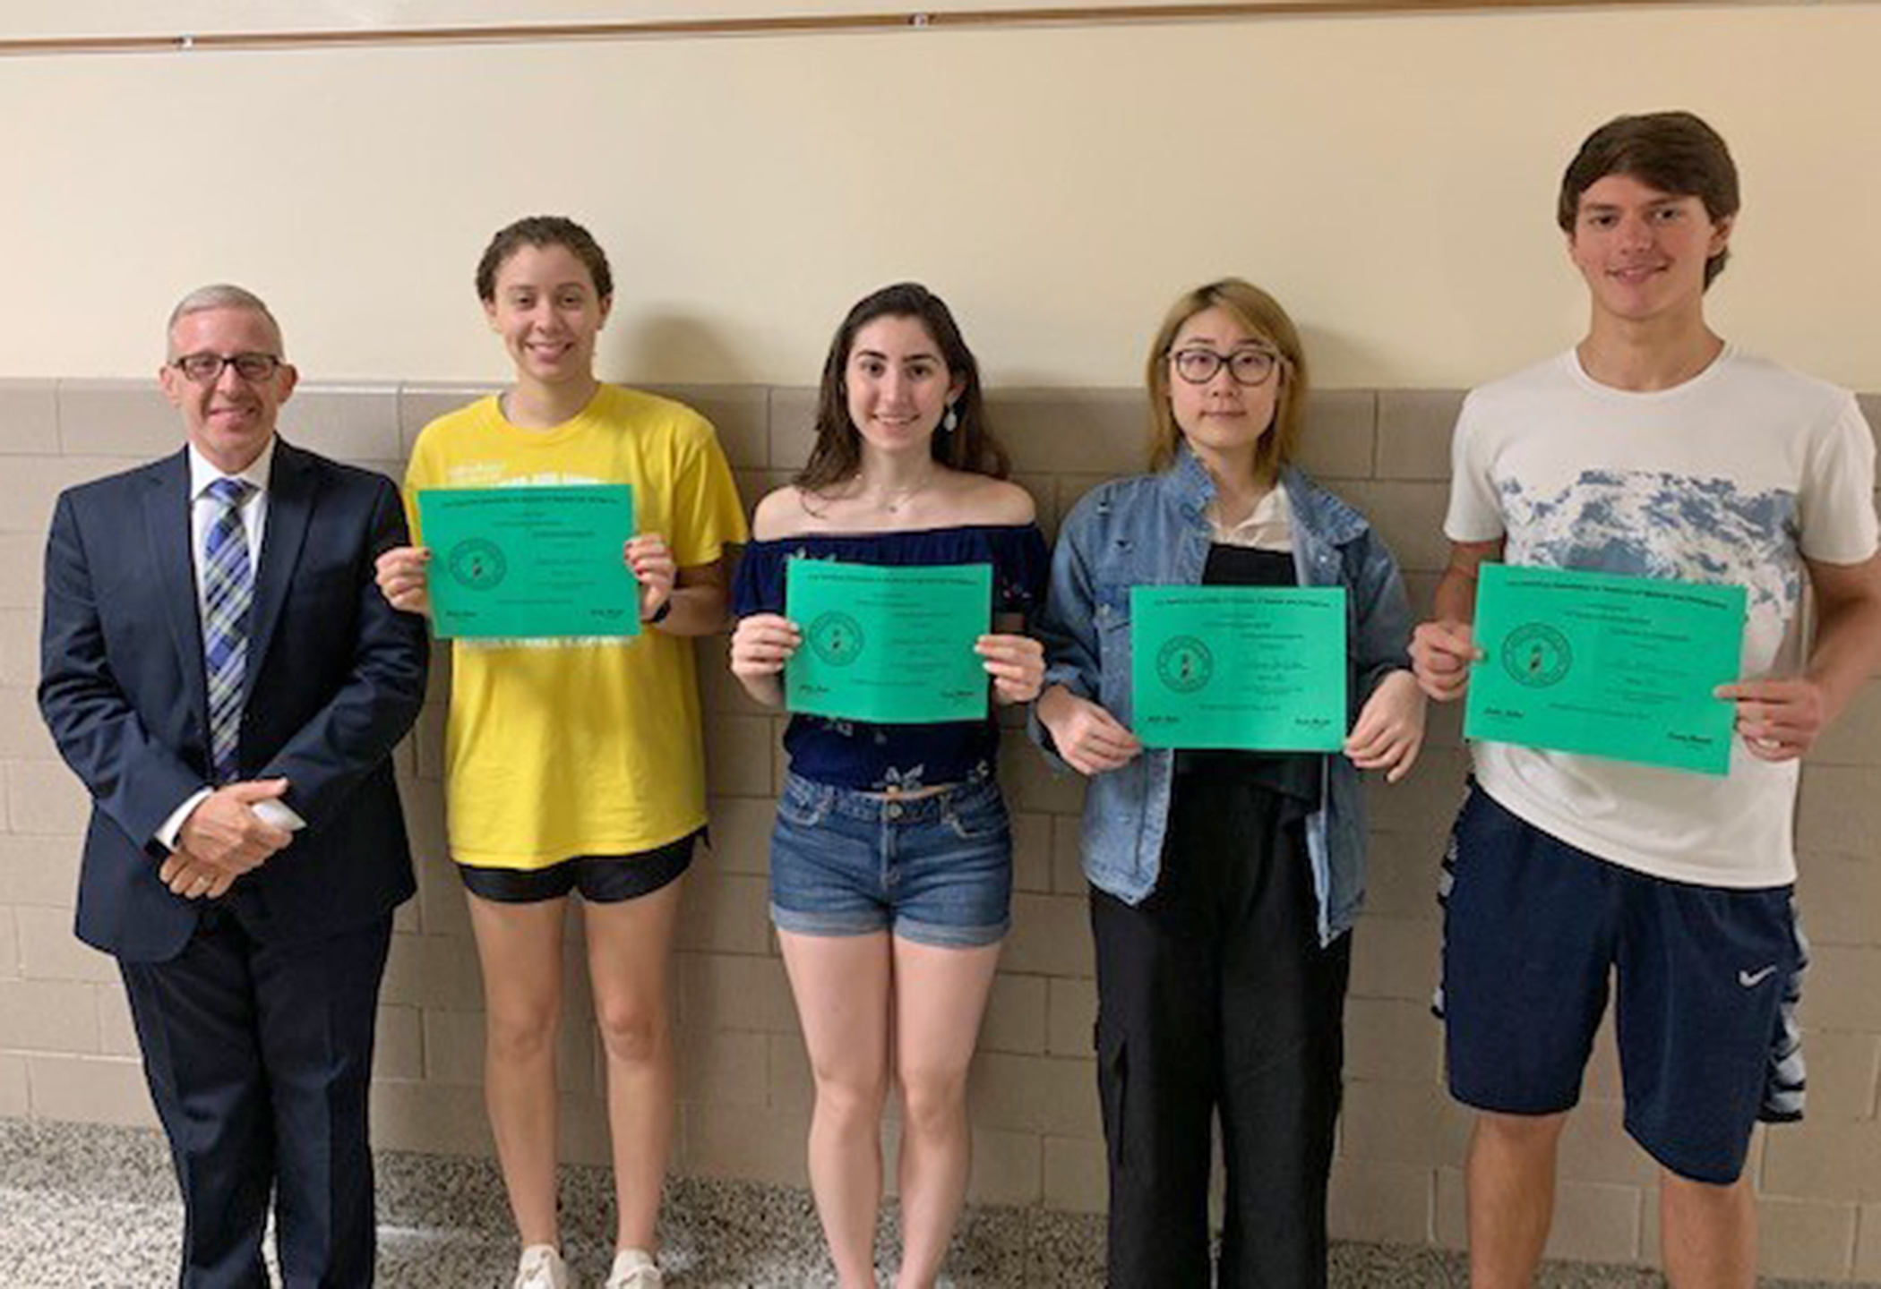

GCHS Students Awarded in Victor Baptiste Essay Contest

Congratulations to Garden City High School seniors in Mr. Giacalone’s College 5 Spanish class who participated in the Victor Baptiste Essay contest sponsored by the Long Island chapter of the American Association of Teachers of Spanish and Portuguese (AATSP). Entrants were required to write a 200- to 250-word essay in Spanish on the topic: “Escriba sobre las contribuciones de la cultura hispana en las artes y la literatura (poesía, música, baile, artes visuales, cine, etc.) - write about the contributions of the Hispanic culture in the arts and literature (poetry, music, dance, visual arts, film, etc.).” Although 24 students participated, the requirements of the organization are that only five essays may be chosen per school. Pictured here the students whose essays were recognized with Mr. Peter Giacalone (left to right): Yasmine Worrell, Alexandra Michael, Jenny Ban, and John Kenny. Absent from photo - Jamie Derkasch.

