JACOB’S LADDER
Summer Enrichment Camp
July, 2014
St. Margaret’s School
The minds of our Jacob’s Ladder Climbers were stretched through the academic enrichment classes offered during camp. Climbers had three different classes weekly for a total of 12 exciting learning opportunities led by amazing teachers. There were classes in the visual arts, including Treasure Hunt in Art History, Tangling in Silk and Glass, and Creative Critters. Climbers explored the performing arts through theatre classes and the production of Beauty and the Beast. French, Japanese, and sign language classes increased Climbers’ language knowledge. There were a variety of writing classes and a class to prepare students for different oral communication situations. Math and science classes included Cracking the Code, Mathletics, Clue Finders and Problem Solvers, and Water, Water Everywhere. How many drops to drink? Climbers also increased their self-awareness and social skills in classes such as Walk a Mile, Welcome Change, Welcome a New World, and How Many Ways Are You Smart? Curious about ancient empires, Mardi Gras, or forensics? Just ask a JL Climber! Academic enrichment also involved several informative and inspiring speakers, field trips to the Virginia Museum of Fine Arts and the Virginia Holocaust Museum, and lots of time devoted to reading. Climbers enjoyed an assortment of experiences to expand and enhance their education. The theme for summer camp was “Greatness Comes from Within”.

JACOB’S LADDER
Performing Arts


JACOB’S LADDER
Marine Science
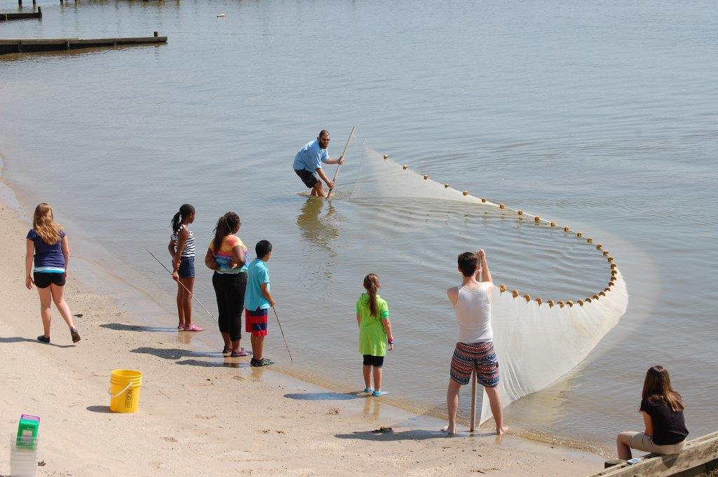

JACOB’S LADDER
Senior Climber Leadership Week
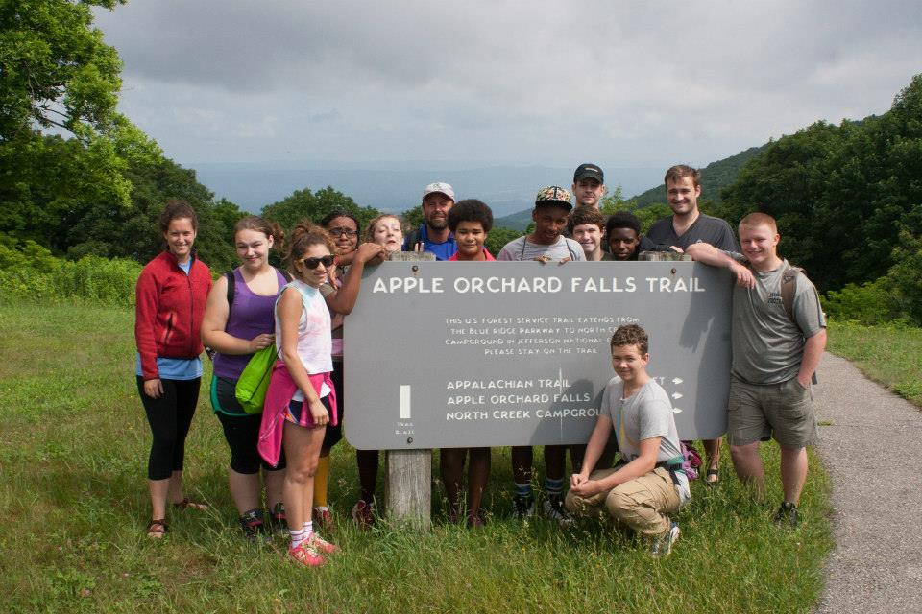

Climbers hiked the George Washington National Forest near Roanoke and the Appalachian Trail. They enjoyed the outdoor adventure while bonding as leaders for the upcoming summer enrichment camp.

JACOB’S LADDER
Alumni Climbers Crop Gleaning
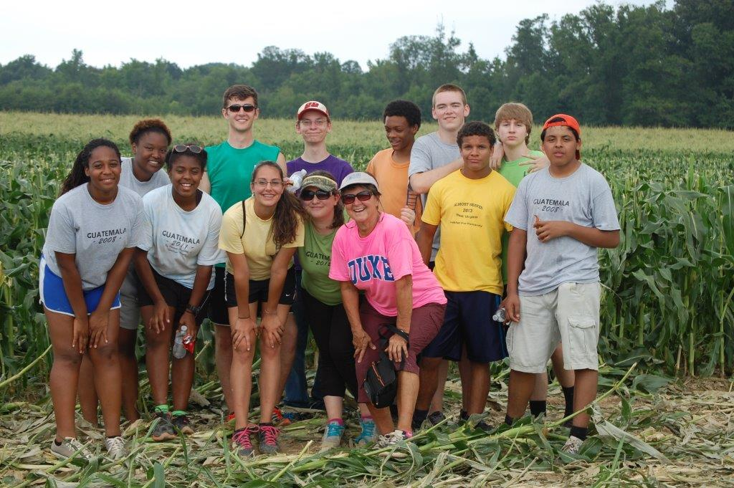
In July twelve Alumni Climbers were involved in a local crop gleaning this year. Fresh corn was picked from the fields at Parker Farm in Leedstown, VA on the Northern Neck. Food gleaned from the fields is donated by way of the Northern Neck food bank. The team was involved for three days and stayed on dorm at St. Margaret’s School during the night. It was hard, hot work.
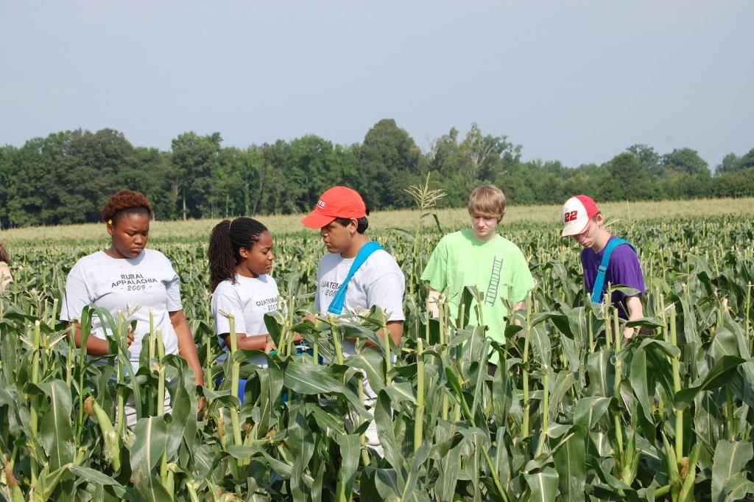

Jacob’s Ladder is a pro-active enrichment program serving children who are gifted and at risk for 23 years.
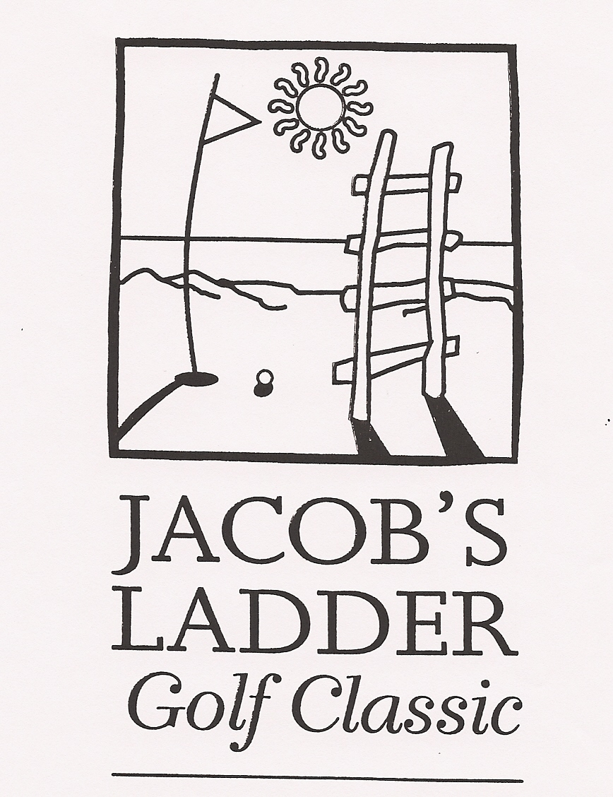 Jacob’s Ladder
21st Annual Golf Classic
Jacob’s Ladder held its 21st annual Golf Classic at the Golden Eagle Golf Course in Irvington, VA on Friday, July 18, 2014. We netted $7700 from this event. ALL proceeds go toward room and board costs for the summer enrichment camp. On behalf of the children of Jacob’s Ladder, we are truly grateful for the partnership and commitment from golfers, sponsors, prize donors, and volunteers over the years. It could not have been a successful fundraiser without you.

 JACOB’S LADDER
Oyster Tasting
September 28, 2014
Rappahannock River Oyster Company hosted the 4th Jacob’s Ladder Annual Oyster Tasting at Merrior Restaurant, Locklies Marina on Sunday, September 28th to benefit the at-risk, intellectually gifted children served by the program. First Tennessee Bank sponsored the event again this year. Good weather, good food, and good supporters made this event an unbeatable combination. “Out On A Limb” provided the music. Thank you, supporters of Jacob’s Ladder. You make good things happen!

Oyster Tasting Good!
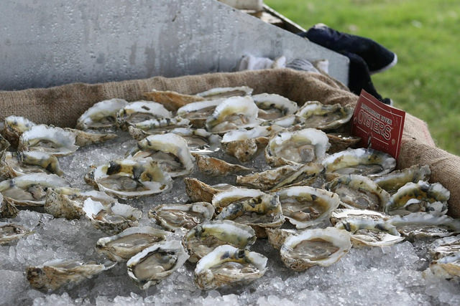

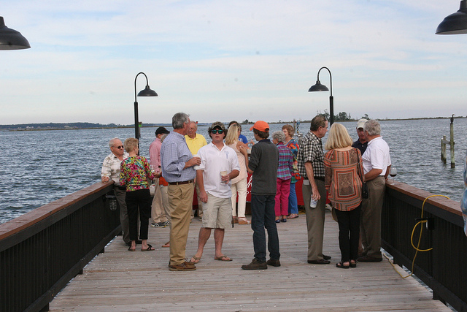
Under the Tent
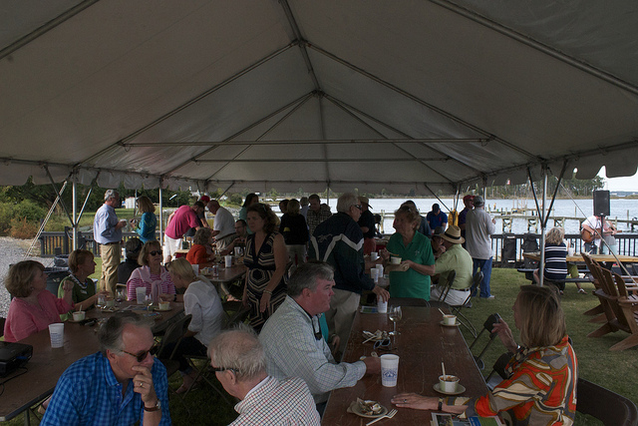

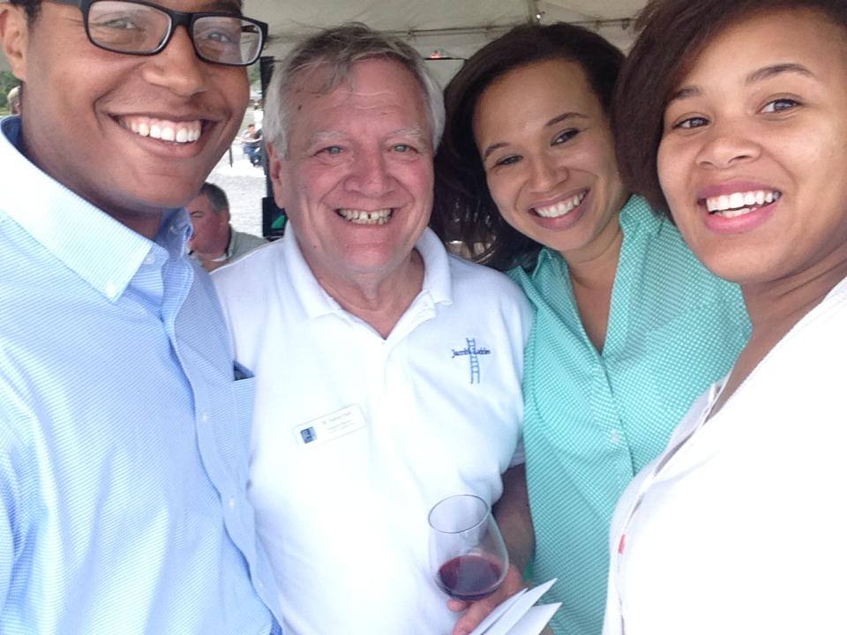

JACOB’S LADDER
Fast Facts – 2014
- Program established in 1991
- 365 students to date
- Gifted, at-risk students in the program are called Climbers
- Climbers are in Jacob’s Ladder from the 4th through 8th grade
- Climbers come from both rural and urban areas of VA and NC
- 94% of Climbers enter college
- 27 Teachers assist with residential enrichment camp
- 4 Weeks of residential camp $2780
- Yr-round advocacy/follow up $1325
- Total cost per child $4105
- $8+ million in scholarships awarded Climbers since inception of JL
Climbers currently attend or are graduates of: Brown, Dartmouth, Duke, Stanford, Yale, University of PA, JMU, University of Chicago, University of Richmond, Georgetown University, University of Texas, College of William & Mary, Mary Washington University, University of North Carolina-Chapel Hill, UVA, Rensselaer Polytechnic Institute, and VaTech.
Climbers graduating high school in 2014 are attending the following schools or universities: ODU, Reynolds Community College, Norfolk State University, Johnson & Wales University, and VCU.
Jacob’s Ladder
22nd Annual Golf Classic
Jacob’s Ladder will hold its 22nd annual Golf Classic at the Golden Eagle Golf Course in Irvington, VA on Friday,
May 15, 2015. Sign up on line at www.jladder.org and bring a friend to support a worthy cause.

“For I know the plans I have for you, says the Lord; plans for good and not for evil, to give you a hope and a future.” – Jeremiah 29:11

FROM THE EXEC’S DESK
As 2014 and the 23rd year of Jacob’s Ladder come to a close, some reflection on the program is appropriate. You who have believed in Jacob’s Ladder and supported the endeavors of the program are due an accounting of the results of your efforts. For some time we have been reporting 100% graduation from secondary school (high school). This past year saw the first Climber not graduating. Also we have proudly reported that 94% of Climbers completing Jacob’s Ladder entered college and the greatest percentage of the remaining entered military service. Our latest statistic is perhaps the most impressive! We find that 69.7% of the Climbers are completing their college and university studies in four years! The national average, stated in the 2013 Digest of Education Statistics, is 39% of white, black, and Hispanic students, and 46.3% of Asian and Pacific Islanders. These Climbers are paying taxes and raising families! All express gratitude to those who supported and encouraged their efforts in Jacob’s Ladder. Take a bow, folks! You have made a difference. We look forward to another great year as you continue to believe in the efforts of Jacob’s Ladder.

Merry Christmas!

– W. Aubrey Hall, Executive Director

