Study Guide 8th Grade
Unit 8

Translations

Key Ideas:
When moving:
Right → x +
Left → x –
Up → y +
Down → y –

Describe the following translations

1) 1 unit right, 2) 8 units left,
4 units up 3 units down

Graph the figure, then find the coordinates of the image and graph the image.

3) Triangle ABC has vertices A(-4,2), B(-1,4) and
C(-2,6) and is translated (x,y)→(x+5, y–4)
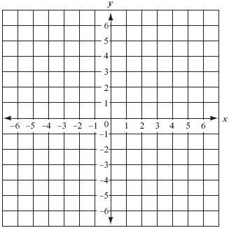

Reflections

Key Ideas:
Line of reflection – line a figure is reflected over

When reflecting:
Over the x-axis – (x,y) → (x,-y)
Over the y-axis – (x,y) → (-x,y)

Graph the figure, then find the coordinates of the image and graph the image.

1) Triangle DEF has vertices D(-5,-1), E(-4,-4) and
F(-1,-2) and is reflected over the y-axis.

2) Triangle GHI has vertices G(1,-1), H(2,-1) and
I(5,-5) and is reflected over the x-axis

Rotations

Key Ideas:

Rotations:
90º clockwise - (x,y)→ (y, -x)
180º – (x,y) → (-x, -y)
270º clockwise - (x,y) → (-y, x)

Remember:
90º counterclockwise = 270º clockwise
270º counterclockwise = 90º clockwise

Graph the figure, then find the coordinates of the image and graph the image.

1) Triangle JKL has vertices J(-4,5), K(-3,1) and
L(-1,1) and is rotated 270º counterclockwise
around the origin

2) Triangle MNP has vertices M(1,1), N(4, 1) and
P( 2,2) and is rotated 180º around the origin

Dilations

Key Ideas:

To dilate a figure, multiply both parts of the ordered pair by the scale factor.
Ex: Dilate by a scale factor of 6
(x,y) → (6x, 6y)

To find a scale factor, compare corresponding sides of the figures in a fraction.
$\frac{\text{Im}\text{age}}{\text{Original}}$

Graph the figure, then find the coordinates of the image and graph the image.

1) Triangle QRS has vertices of Q(1,2), R(3, 2) and
S(1, 3) and is dilated by a scale factor of 2

2) Triangle TUV has vertices of T(6,6), U(6,3) and
V(3,6) and is dilated by a scale factor of 1/3

Congruency and Transformations

Key Ideas:

Use a set of transformations, translations, reflections or rotations to determine if two figures are congruent

Determine if the two figures are congruent by using transformations. Explain your reasoning

1) 2)

3)

Answers

Translations

1) (x,y) → (x + 1, y + 4)

2) (x,y) → (x – 8, y – 3)

3) A’(1, -2)
B’ (4, 0)
C’ (3, 2)

Reflections

1) D’(5, -1)
E’(4, -4)
F’(1, -2)

2) G’(1, 1)
H’(2, 1)
I’(5, 5)

Rotations

1) J’(5, 4)
K’(1, 3)
L’(1, 1)

2) M’(-1, -1)
N’(-4, -1)
P’(-2, -2)

Dilations

1) Q’(2, 4)
R’(6, 4)
S’(2, 6)

2) T’(2, 2)
U’(2, 1)
V’(1, 2)

Congruency and Transformations

1) Congruent: Reflection then a translation

2) Not Congruent

3) Congruent: Rotation, a reflection then a translation

