Name

Date Pd

Unit X: Worksheet 1

- The drawings below represent “cross-sections” of a neutral iron nail and a neutral plastic rod, nowhere near any excess charge sources. How does the arrangement of the electrically charged particles differ in these two objects? You may use a sketch to aid your explanation.

- Now the nail and the plastic rod are separately brought near (but NOT in contact with) a negatively charged Van de Graaff generator. For each object, explain and sketch the changes in the distribution of the charged particles.

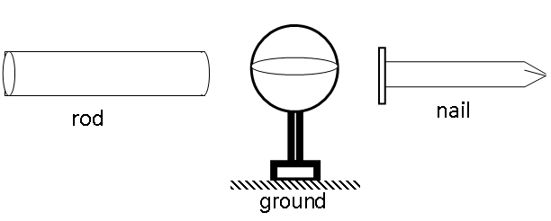

- A pie pan is attached to a negatively charged Van de Graaff generator. Then the pie pan is removed from the area. Describe the state of charge of the pie pan as this process is performed. You may use a sketch to aid your explanation. At the end of the arrow, sketch the excess charge on the pie pan after it has been removed from the area.

- The charged pie pan in the previous question is now brought in contact to a previously uncharged pie pan, and then the two pans are widely separated. Describe the process and the resulting distribution of charge on the new pie pan. What percentage of the charge is transferred between pans?

- A pie pan is brought near (but not touching) a negatively charged Van de Graaff generator. The pie pan is grounded and then removed from the area. Describe the charge on the pie pan as this process is performed. You may use a sketch to aid your explanation.

