The Power of Advertising
Walt Disney’s - THE ROOKIE – Based on a true story!
Type your answers in a different color!
- Who is the manufacturer of the pitcher’s mitt used by Jimmy while pitching in the Florida game?
- What model of car is towing a trailer as the family travels to Texas?
- Identify the rental trailer company.
- Identify the sign on the building as they drive into town.
- What beverage was the domino player drinking?
- When the adult Jimmy is at the oil derrick, what model truck is he driving?
- What brand of pants does the counselor (Jimmy’s wife) grab? (He wears the same brand throughout video.)
- Identify the logo on Jimmy’s cap while he’s pitching in the dark. (He wears it throughout video.)
- Whose backyard do the boys compare the football field to?
- Identify Joel’s catcher’s mitt logo used after regular team practice.
- The wine was bought by which credit card?
- While the men are playing cards, what can of beverage is on the corner of the table?
- What logo is on the right sleeve of the Owl uniforms?
- Identify the long sleeve denim shirt worn by the one man sprinkling hair on the ball field.
- What type of grass is identified by Jimmy on the field?
- What brand glove does Hunter’s grandfather give to him as a birthday gift?
- What brand of cereal were the kids eating at breakfast?
- What team logo was on Dave Brewer’s ball cap?
- In the tryout scene, what equipment brand does the catcher wear?
- What brand peanut butter was visible in the kitchen scene?
- What snack cakes are visible in the kitchen cabinet?
- Identify the department store logo on the TV ball park.
- Identify the brand radar gun used in the rain scene.
- What model truck is in Jimmy’s father’s driveway?
- As Jimmy is on the mound, what logo is visible on the left side of the screen?
- In the night game, what brand name is visible behind the coach?
- What beverage name is visible on the scoreboard in the Durham, NC scene?
- When Jimmy is called to speak to reports, what department store logo is visible?
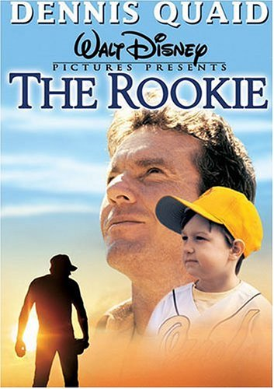
- What news anchor is seen on the TV reporting on Jimmy Morris?
- What brand chips are located next to the Compaq computer?
- As Jimmy’s team drives through town, what vehicle are they in?
- What cab company drops Brooks and Jimmy off at Arlington Ball Park?
- As Jimmy is practicing prior to the game, what quick serve restaurant name is prominent?
- When the camera pans to the outfield, what two brands of beverage names are visible?
- When Jimmy is in the bullpen warming up, what name is visible?
- As Jimmy enters the ball field, what two logos are visible to the left of the doorway?
- On the score board, what beverage brand is visible?
- Also, at the bottom of the scoreboard, what news paper is listed?
- What TV is displayed as Jimmy goes to the mound?
- What airline name is visible in the background?
- What brand ball is Jimmy using?
- What new truck is parked in front of the high school?
- How many years did Jimmy Morris play pro baseball?

