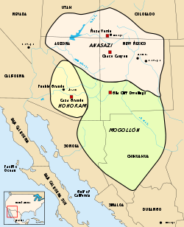
The Anasazi

When the Navajo settled in the Southwest around A.D. 1000, they found the remains of a rich, artistic culture. Sensing the long history that these remains represented, they called the people who left them the Anasazi. Some sources do translate the word Anasazi as 'ancient ones', though it is derived from the Navajo words 'anaa' (enemy) and 'sazi' (ancestors).
The Four Corners region of the Southwest- where Utah, Colorado, New Mexico, and Arizona meet is a beautiful land, where wind has sculpted rocks into spectacular shapes and rivers have carved deep canyons. Rocks heavy with iron shine red in the sun. But this stunning land is also harsh with little rain and long, cold winters.
The Anasazi lived in this harsh environment from about A.D. 100 to about A.D. 1300. The Anasazi began as hunters and gatherers. To collect the food they gathered, they used straw, vines, and other plants to weave beautiful baskets. Some were covered with mud inside so they could hold liquids. The two periods that stretch from the beginning of the Anasazi to about A.D. 700 are called the “Basket Weavers” after this major part of their culture.
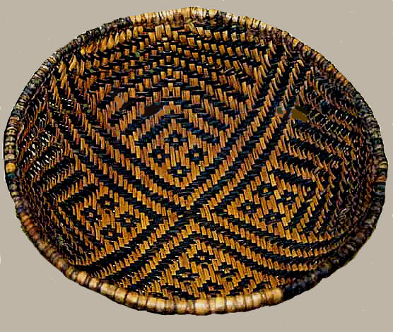
During these centuries, the Anasazi adopted farming, at first raising corn and squash and later adding beans. They lived in round homes made of logs situated over pits dug in the ground. They also adopted pottery making from neighboring groups. Anasazi pots, with their stark, geometric designs, are treasured today.
Around 700, the Anasazi began a new way of life, entering the four “Pueblo” periods of their culture. They continued to use dome structures built over pits, but for spiritual uses, not as homes. These structures came to be called kivas by the Hopi, a group descended from the Anasazi.
For living space, the Anasazi began to make homes above ground. At first their stone and mud buildings housed just one family. Later, they joined rooms and added levels to create towns that held hundreds of people. The wooden roof of one dwelling formed a yard for the unit on the next level.
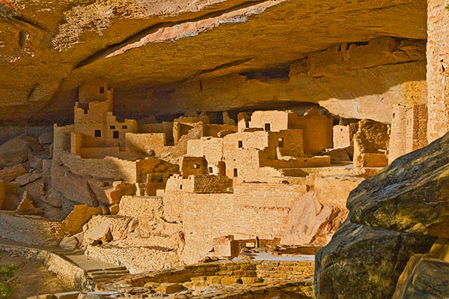
The first towns were built atop flat mesas, such as Pueblo Bonito in Chaco Culture National Historic Park, in New Mexico, which had about 800 rooms. From 1000 to 1300, Anasazi culture was at its peak. Some towns were still built on mesas; Mesa Verde National Park in Colorado is one. More, however, were built in hard-to-reach cliffs high about canyon walls, as seen at Canyon de Chelly National Monument in Arizona. Experts think that the Anasazi built these cliff towns to protect themselves from nomadic groups threatening them at the time.

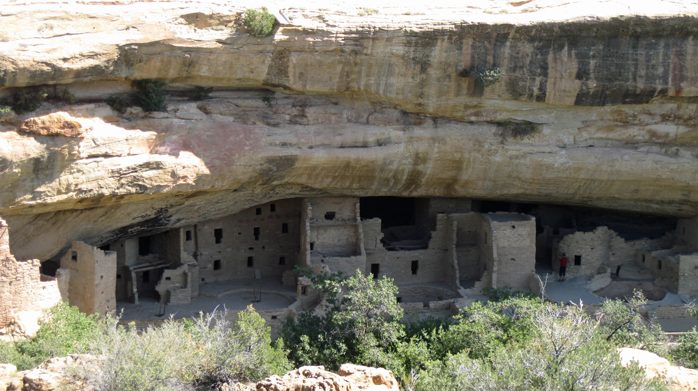
Anasazi society had unique features. Other Native American cultures with intensive farming and large-scale building had centralized governments. The Anasazi did not. Each town had its own power, although larger centers had spiritual importance. Anasazi women enjoyed higher status than was the case with women in many other Native American cultures. As the people began settling in pueblos, they clustered in clans that joined mothers of their married daughters in nearby homes.
Around 1300, the Anasazi drifted away from their settlements. Studying tree rings from the time, scientists have found that severe drought struck the area for more than a decade in the late 1200’s. Groups newly arrived on the scene posed a threat and strained the area’s meager resource. Although they departed from the scene, the “ancient” ones had an impact. Their style of building homes was adopted by their Pueblo descendants. When the Spanish came to the Southwest, they named these peoples “pueblo” after their word for town.

Questions:

- What caused the Anasazi to leave their area?

- What provides evidence of the interest in Anasazi culture today?

