TEAAS 10.02.0000 Release Notes

- County numbers have been incremented by 1, now ranging between 1 and 100. For example, the number for Wake County is now 92 (versus 91 previously)
- Boundary IDs have been changed from an 8-digit number to an 8-character long alphanumeric value with one of the prefixes BM (municipal boundary) , BC(county boundary), or BS(state boundary). For example, boundary ID for Wake County is now BC000092 (versus 70000091 previously). The numeric part of the State boundary ID has also been changed:
  - Georgia – BS000901 (versus 80000006 previously)
  - South Carolina – BS000902 (versus 80000007 previously)
  - Tennessee – BS000903 (versus 80000008 previously)
  - Virginia – BS000904 (versus 80000009 previously)
- ROME municipality codes are now part of TEAAS. The city population table now has a column that holds the ROME codes corresponding to the existing TEAAS municipality codes.
- TEAAS Client shortcut installer
- Fixed the popup
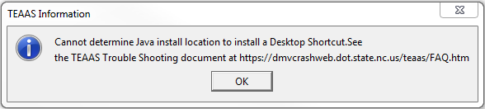
- Proper cleanup of older shortcuts.
- Support for stronger TLS encryption with Java Version 8 Update 51 or higher.

