WONDERFUL WEBSITES & WORKBOOKS (WWW)
(worldwide web TAKS resources for parents and students)

This handout provides a list of websites/online resources for parents and students to use in their quest for TAKS support. In addition there are other sites for classes that are not TAKS tested but may be of help to parents and/or students.

All of this information is also on the DMS website under the heading TAKS!

Please feel free to check daily the DMS website for any updates and important school information.

The main sources for information on students and TAKS is the Texas Education Agency (TEA) website

http://www.tea.state.tx.us/

Additional information and brochure is also available on the TEA website (Resources section) for parents. The brochure is called:

Prepare for Success-A Parent Guide to the Student Success Initiative Grade 8 English (PDF)

Prepare for Success-A Parent Guide to the Student Success Initiative Grade 8 Spanish (PDF

TAKS SUPPORT ONLINE

TAKS Study Guides from the Texas Education Agency
www.tea.state.tx.us/student.assessment/resources/guides/study/index.html

TAKS Released Tests from the Texas Education Agency-work with your child!
www.tea.state.tx.us/student.assessment/resources/release/index.html

TEA TAKS Math Help - Questions and Answers!
This site includes explanations, sample questions and answers!
http://www.escweb.net/tx_bm/math

TEA TAKS Help for Science
This site includes explanations, sample questions and answers!
www.escweb.net/tx_bm/science/
TAKS Science - Parents can help!
Help your child prepare for the TAKS Science Test. This test is given to 8th graders
http://classroom.springisd.org/webs/cms.campus/upload/parents_science.pdf

TAKS Science Test -- Grade 8
http://classroom.springisd.org/webs/cms.campus/upload/gr8taksbook.pdf

TAKS Science Information Booklet
http://classroom.springisd.org/webs/cms.campus/upload/sci_8_info.pdf

TEA TAKS Help for Social Studies
http://www.escweb.net/tx_bm/social/

AAA Math Help
AAA Math features a comprehensive set of interactive arithmetic lessons. Unlimited practice is available on each topic which allows thorough mastery of the concepts. A wide range of lessons (Kindergarten through Eighth grade level) enables learning or review to occur at each individual's current level.
Immediate feedback prevents practicing and learning incorrect methods, which is a common result of traditional homework and worksheets. Practice can continue as long as desired in a non-threatening format which helps build self-esteem and confidence.
The topics are sorted by subject on the left. Parents may also choose to purchase the CD for their child.

HOW TO USE TAKS STUDY GUIDES

The Texas Education Agency has developed TAKS Study Guides to help students strengthen the TEKS-based skills that are taught in class and tested on TAKS. The Guides are designed for students to use on their own or for students and families to work through together. Concepts are presented in a variety of ways that will help students review the information and skills they need to be successful on the TAKS.

What Is This Book?
This is a study guide to help you strengthen the skills tested on the Grade 8 Texas Assessment of Knowledge and Skills (TAKS). TAKS is a state developed test administered with no time limit. It is designed to provide an accurate measure of learning in Texas schools. By acquiring all the skills taught in eighth grade, you will be better prepared to succeed on the Grade 8 TAKS and during the next school year.

What Are Objectives?
Objectives are goals for the knowledge and skills that students should achieve. The specific goals for instruction in Texas schools were provided
by the Texas Essential Knowledge and Skills (TEKS). The objectives for TAKS were developed based on the TEKS.

How Is This Book Organized?
This study guide is divided into the six objectives tested on TAKS. A statement at the beginning of each objective lists the mathematics skills you need to acquire. The study guide covers a large amount of material. You should not expect to complete it all at once. It may be best to work through one objective at a time. Each objective is organized into review sections and a practice section. The review sections present examples and explanations of the mathematics skills for each objective. The practice sections feature mathematics problems that are similar to the ones used on the TAKS test.

How Can I Use This Book?
First look at your Confidential Student Report. This is the report the school gave you that shows your TAKS scores. This report will tell you which TAKS subject-area test(s) you passed and which one(s) you did not pass. Use your report to determine which skills need improvement. Once you know which skills need to be improved, you can read through the instructions and examples that support those skills. You may also choose to work through all the sections. Pace yourself as you work through the study guide. Work in short sessions. If you become frustrated, stop and start again later.

What Are the Helpful Features of This Study Guide?
● There are several words in this study guide that are important for you to understand. These words are boldfaced in the text and are defined when they are introduced. Locate the boldfaced words and review the definitions.

● Examples are contained inside shaded boxes.

● Each objective has “Try It” problems based on the examples in the review sections.

● A Grade 8 Mathematics Chart is included on pages 8–9 and also as a tear-out page in the back of the book. This chart includes useful mathematics information. The tear-out Mathematics Chart in the back of the book also provides both a metric and a customary ruler to help solve problems requiring measurement of length.

● Look for the following features in the margin:

Ms. Mathematics 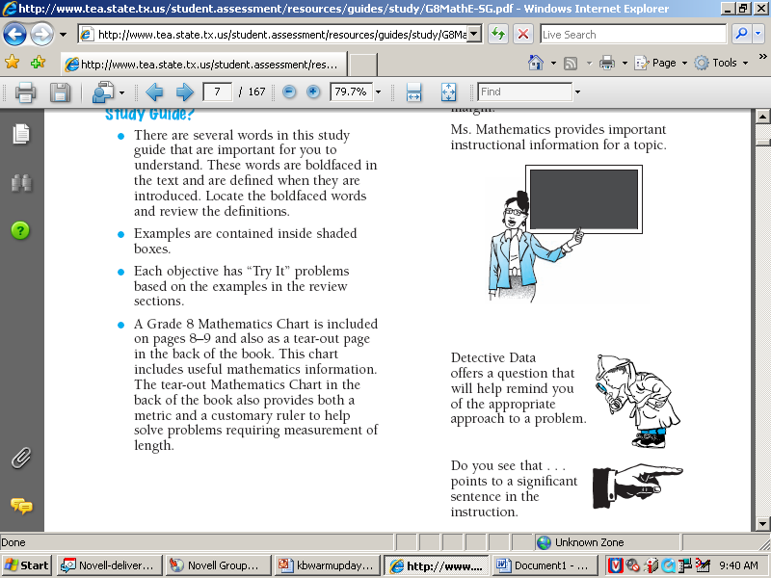
provides important instructional information for a topic.

Detective Data
offers a question that will help remind you of the appropriate approach to a problem.

Do you see that ...
points to a significant sentence in the instruction.

INFORMATION -- 6TH GRADE ONLY

6TH GRADE -- TAKS STUDY GUIDES
6th Grade TAKS Study Guide -- Reading
6th Grade TAKS Study Guide -- Reading -- Spanish Version
6th Grade TAKS Study Guide -- Math
6th Grade TAKS Study Guide -- Math -- Spanish Version

6TH GRADE -- TAKS RELEASED TESTS
6th Grade TAKS Released Test -- Reading
6th Grade TAKS Released Test -- Math

MISCELLANOUS 6TH GRADE RESOURCES
TEA TAKS Help -- Reading
TAKS Information Booklet -- Reading
TAKS Information Booklet -- Reading -- Spanish Version
TEA TAKS Help -- Math
TAKS Information Booklet -- Math

INTERNET LINKS FOR 7TH GRADE TAKS ONLY

7TH GRADE -- TAKS STUDY GUIDES
7th Grade TAKS Study Guide -- Reading
7th Grade TAKS Study Guide -- Math
7th Grade TAKS Study Guide -- Writing

7TH GRADE -- TAKS RELEASED TESTS
7th Grade TAKS Released Test -- Reading
7th Grade TAKS Released Test -- Math
7th Grade TAKS Released Test -- Writing
7th Grade TAKS Released Writing Prompt

MISCELLANOUS 7TH GRADE RESOURCES
TEA TAKS Help -- Reading
TAKS Information Booklet -- Reading
TAKS Information Booklet -- Writing
TEA TAKS Help -- Math
TAKS Information Booklet -- Math
INTERNET LINKS FOR 8TH GRADE TAKS ONLY

8TH GRADE -- TAKS STUDY GUIDES
8th Grade TAKS Study Guide -- Reading
8th Grade TAKS Study Guide -- Math
8th Grade TAKS Study Guide -- Science
8th Grade TAKS Study Guide -- Social Studies

8TH GRADE -- TAKS RELEASED TESTS
8th Grade TAKS Released Test -- Reading
8th Grade TAKS Released Test -- Math
8th Grade TAKS Released Test -- Social Studies
8th Grade TAKS Released Test -- Science
MISCELLANOUS 8TH GRADE RESOURCES
TEA TAKS Help -- Reading
TAKS Information Booklet -- Reading
TEA TAKS Help -- Math
TAKS Information Booklet -- Math
TEA TAKS Help -- Science
TAKS Information Booklet -- Science
20 Tips for Helping Your Child with Science
TEA TAKS Help -- Social Studies
TAKS Information Booklet -- Social Studies
Student Study Guide -- Social Studies

