

Homewood
Summer Program
2021

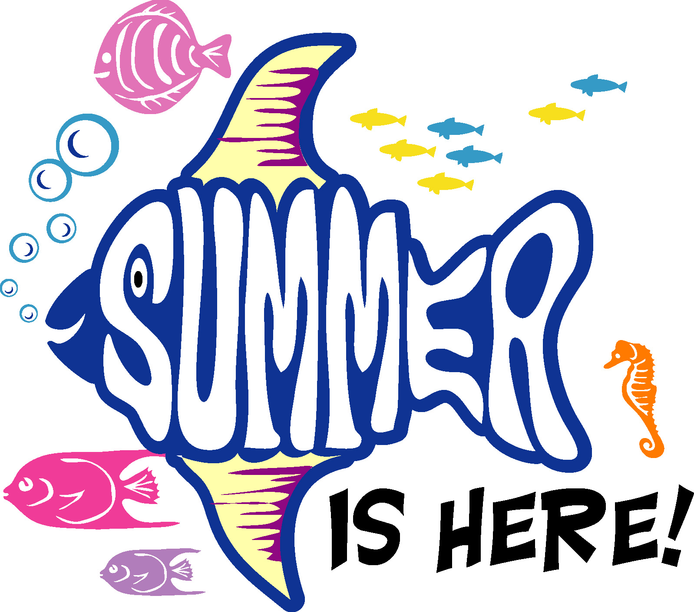

ILLNESS

Parents will be called and informed if their child becomes ill during Summer EDP hours. Children who are ill must be picked up as soon as possible. We may only give medication to children if it is sent from home in accordance to Homewood City School system’s guidelines. Medical Authorization forms are available in the EDP office.

DISCIPLINE

Our discipline will follow the same Code of Conduct established for the regular school day and Extended Day Programs. Failure to comply with these rules will make it necessary for us to do the following:

-Discuss problems with child to help determine causes and ways to resolve
them.
-Time out from activities.
-Restrictions or loss of choices of activities.

If a child’s behavior consistently disrupts the program, physically or emotionally harms others, or otherwise conflicts with program rules and guidelines, a conference with parents will be scheduled. In the event that the problem persists after all reasonable attempts have been made, the child may be suspended from the program for a time. Remember that we are here to provide a pleasant, enjoyable experience for all, so don’t hesitate to discuss any concerns or helpful suggestions that will help to achieve this goal.

ADDITIONAL INFORMATION

For further information, please contact your EDP directors:
Edgewood: Valerie Patton: 205 423-2405 or vpatton@homewood.k12.al.us
Hall-Kent: Teresa Harris: 205 423-2435 or tharris@homewood.k12.al.us
ShadesCahaba: Leslee Bridgmon: 205 870-8854 lbridgmon@homewood.k12.al.us

2021 Summer Contact Information:
Shades Cahaba Elementary School: (205) 870-8854
3001 Independence Dr. Homewood, AL 35209

SUMMER PROGRAM GOALS

• To provide a proper environment for fun, exercise, adventure
and enrichment.
• To develop relationships with others and work together in a
cooperative group.
• To develop self-confidence and self-esteem.
• To better utilize our school facilities for the benefit of our
students; providing a safe, caring atmosphere for your child
until you are able to pick him/her up.

LOCATIONS & TIMES

The 2021 Homewood Summer Program will begin on June 7 and will end on July 30. We will be closed July 2 – July 5. This year we will offer a four week June Summer Session, from June 7th through July 1st, and a four week July Summer Session, from July 6th through July 30th; as well as the full eight week long Summer Program.

The Summer Program hours are from 8:00 a.m. – 6:00 p.m., with early morning drop-off beginning at 7:30 a.m. each day. (Please do not drop your child off at school before 7:30 a.m.) All children attending Summer EDP must be signed out by 6:00 p.m. by a person authorized for summer pick-up. A late fee will be charged for any child picked up after 6:00 p.m. in the amount of $1.00 for every minute late.

The 2021 Homewood Summer Program will be held at Shades Cahaba Elementary School. Edgewood, Hall-Kent & Shades Cahaba students will all attend Summer EDP at Shades Cahaba Elementary. There will not be a program at Edgewood or Hall Kent this summer.

REGISTRATION

The Homewood Summer Program is available to Homewood City School students who are currently enrolled in grades K-5 and have completed kindergarten. All students must be pre-registered for the 2021 Homewood Summer Program in order to participate in Summer EDP activities. Students with current EDP accounts must be in good standing.

Summer registration can be completed at Edgewood, Hall-Kent, or Shades Cahaba EDP. Payments are due with registration. Credit card payments can be accepted at all three schools. All registrations must be completed by March 19th, 2021. No late registration will be accepted.

COST

Part-time/drop-in rates are not available during the Summer Program. The Summer Program relies on tuition to meet all expenses. Children may not attend the Summer Program unless the required registration paperwork is completed and all summer payments are made. School year balances must be cleared before children may attend the summer program. Tuition is due in accordance to the following payment schedule:

Full Summer Tuition: (June 7th – July 30th, 2021)*
$1000 per child payable as follows:
$625 due with registration by March 19, 2021
$375 balance due by April 30, 2021

June Session Only: (June 7th – July 1st, 2021)
$625 per child, due with registration by March 19, 2021

July Session Only: (July 6th – July 30th, 2021)*
$625 per child, due with registration by March 19, 2021

*(Closed July 2 – July 5, 2021)

Please include your child’s name and your telephone number on your checks. All tuition payments are non-refundable.

PROGRAM

All students will attend academic enrichment sessions from 8:00 a.m. until 11:30 a.m. We will make every effort to make this time fun and enriching.

Free Breakfast and Free Lunch will be provided to all students at no cost to you. If your child prefers they may bring a sack lunch and drink from home every day. (No glass containers, please!) We are unable to heat lunches; please keep this in mind when selecting lunch foods. Please label your child’s lunch box or sack with your child’s name.

Please send in an afternoon snack such as a piece of fruit or chips and a drink for your child each day.

Regular EDP sessions will be conducted in the afternoons from 1:00 p.m. until 6:00 p.m. We will have a menu of activities each day from which the students may choose. Activities will include sports skills, outside play, water play, arts & crafts, reading and many other choices.

Field trips will occasionally be offered throughout the summer for an additional fee. They are available on a first come, first serve basis. Your field trip payment holds your child’s spot. All field trip payments are non-refundable. Field trip information, including dates & costs, will be posted this summer.

All children should wear comfortable outdoor play clothes and appropriate footwear. A swimsuit and towel should be brought every day, as outdoor water play sessions are offered daily, weather permitting. There will also be opportunities to swim.

Please make sure that all personal belongings, including towels, clothing and lunchboxes , are labeled with your child’s name in permanent marker and sent in a backpack or tote bag labeled with their name.

