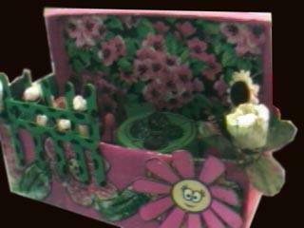
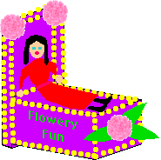
Shoebox Float

You will be creating a shoebox float, also known as a "tableau" or a story about your state. A tableau tells a story visually. The following steps need to be done in order to be considered complete:
Step 1: Plan
First think about exciting, interesting, or fun information you learned about your state. What was the history of your state? Write a short summary about why someone should visit your state. Write the story as if you were telling your friend about your state. After you finish, think about the visual images that were created in your mind as you composed your summary of your state. What are the most vivid or powerful images that you imagine as you think about your state? What do you think are the most important aspects of your state, or part of your state that someone who has never been there should know? What image do you feel would best illustrate your state?
Step 2: Sketch
Next, make a sketch; use a pencil, crayons, or makers to make a plan or design of what your box will look like. You will need to decide (a) If your box will be positioned vertically, horizontally (b) If the lid will be on the top of the box, behind the box, vertically inside the box, etc. (c) If you will need to cut the box or leave it as it is.
Step 3: Create your float
Cover the outside of the box. You can use newspaper, construction paper, old magazines, paint, crayons, or just leave it as it is if it is plain and you can design around it. If you need paper, just see your teacher. Create the inside or contents. You can use all of the following to create the inside or story of your box. Be imaginative. Don’t limit your creativity.
*Draw figures, houses, animals, people, places, and things.
*Make a collage, by using old magazines, newspapers, or photographs.
*Use found objects.
*Transform found objects into buildings, cars, people etc.
*Use recycled materials to create objects to put into your shoe box tableau.
*Make your own clay, glue, or other materials.
*Use preformed patterns to create characters.
*Be sure to attach objects and figures so that they are sturdy.
*Cut and glue pattern attachments onto poster board, and glue so those objects will stay in place.
Step 4: Complete
After you are finished, be sure to write your name, number, and date someplace on the shoe box, and create a placard that tells the viewer the title of the shoebox float and an explanation of your creation and why someone should visit your state.

