Chandler Unified School District
Infinite Campus (IC) Student Portal Grades (7-12)
(Parents access through the Student Portal)
What is it?
It is a logon website “Portal” where you, the student, can access your grade and class attendance. This will help you increase communication with your teachers.
What do you need to do to start using the Infinite Campus (IC) Student Portal?
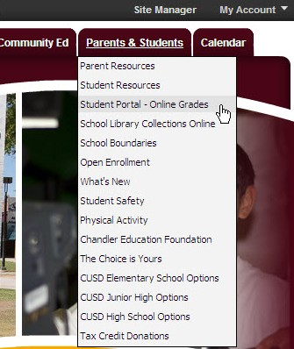
You will need to activate your account. You can logon anywhere you have Internet access (at home, in a school or through your Smartphone). The activation is easy, but specific directions need to be followed.
How to access:
- Go to the Chandler Unified School District Homepage:
Error! Hyperlink reference not valid.
- Click on the Parents & Students Tab
- Choose Student Portal-Online Grades
or
use this URL: https://campus.cusd80.com/campus/portal/chandler.jsp
The Infinite Campus Portal Homepage appears where you will enter your unique username and password. (As a student, you already have a Campus Portal account.)
- The User Name is: Capital S (plus) student number (Example: S78788)
If this is your first time setting up the account, your temporary Password is::
Capital S (plus) student number (plus birthdate in MMDDYY format)
(Example: S78788051898)
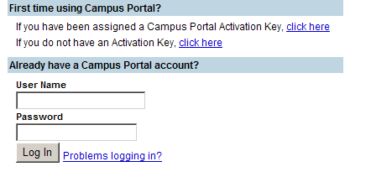
BirthdateMMDDYY
Cap.
S
Student #

Example: S78788

- You will create your own personalized new password: It must be at least 6 characters.
- Change Account Password
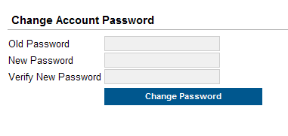
Old Password: is the one you first used (example S78788051898)

New Password is Case Sensitive



NEW DISTRICT ID IS: SSZKYL (upper case)
Download the Infinite Campus Mobile Portal application from any of the following app stores:


Note
- Be sure to keep your password in a safe place and share with your parents.
- If you forget your password, do not try to logon more than twice or the program will be disabled. If your account becomes disabled please contact: Rosie Saenz, 224-2831 to have the password reset.
THANK YOU!

