Getting Started in Edgenuity

Welcome to Edgenuity – a Virtual Classroom!

In this class, we are going to begin using Edgenuity© to help you recover concepts you may be struggling with in your regular Math classes. Edgenuity has created an inviting, interactive learning environment to help guide you toward academic success and recover concepts and credits to help you pass your mathematics classes. With lessons designed to provide you with instructional content and show you how that content correlates to your real world, we hope that you will not only thrive with Edgenuity, but flourish.

The Virtual Classroom is the portal to your lessons; it is also where you can find your Progress Report, Assignment Calendar and other features designed to keep you informed and in control of your own education. This document is intended to help you get started using the Virtual Classroom. Future documents will help you learn to navigate the Virtual Classroom and guide you through everything you need to know to be happy and successful with your Edgenuity program, in your own time and at your own pace. Good luck!

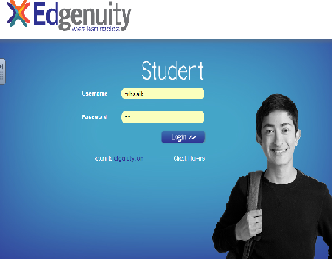
1. Virtual Classroom Login

a. Go to http://learn.education2020.com/student/

b. User name: ________________________

c. Password: _________________________

d. Click the dark grey ENTER button.

Please contact your instructor for username and password.
You can also email him.

2. Working in the Virtual Classroom

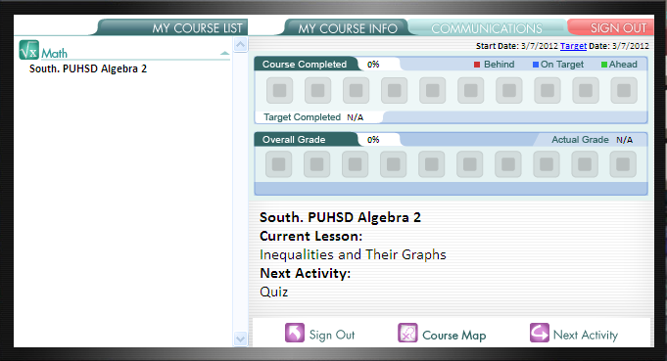
Once logged in, you are now in the Lobby of the Virtual Classroom and can begin working on your course.

a. Click on the name of your course.

b. Click on the Course Map button.

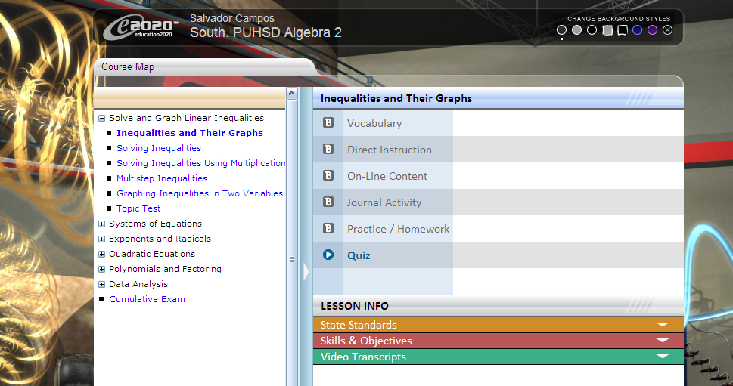
c. You are now viewing your course structure.

While you may view the structure of your courses
in the Course Map, you are not able to participate
in any of the activities beyond the lesson in which
you are currently working. You must finish
activities in the sequence they are listed. You can
always go back to previous lessons and review
information before a quiz, test or cumulative
exam, but you cannot move forward without first
successfully completing each activity in order.

d. Click on the name of the activity to begin.

The activities contained within a lesson are found on the right side of the Course Map.
The activity that you should currently be working on is in blue.
Future activities, which you may not access until you have successfully finished
previous activities, are in gray.

Your course is set up to begin with a pretest, so you will need to click on Quiz to begin.

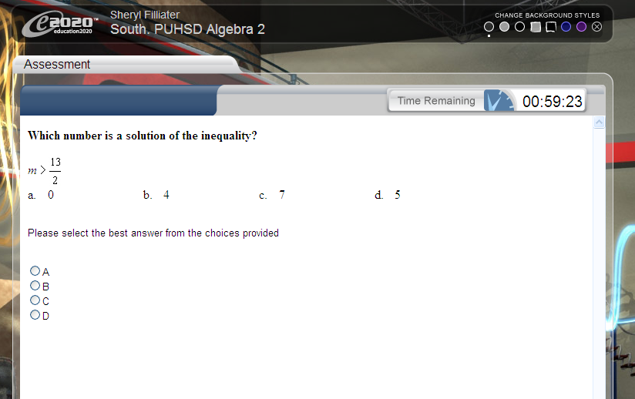
3. Working on the Pretest (Quiz)

a. Notice the time in the upper-right hand portion
of the screen that tells you how much time you
have left to complete the assessment.
(You have one hour to complete it.)

b. Use a piece of paper and a pencil to solve
each problem (when appropriate) in order to
answer the questions.

c. Select your answer by clicking on the radio
button to the left of your response.

d. Move to the next question by clicking:

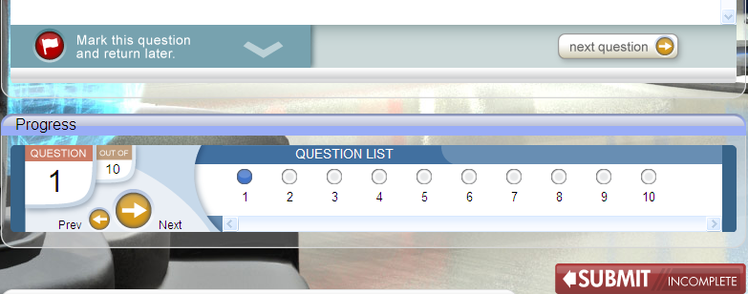
● The Next Question button.

● The Next and Prev arrows in the Progress
section.

● The question bubbles in the Progress section.

e. Click the red flag if you want to skip a question
and come back to it later.

4. Submitting the Assessment
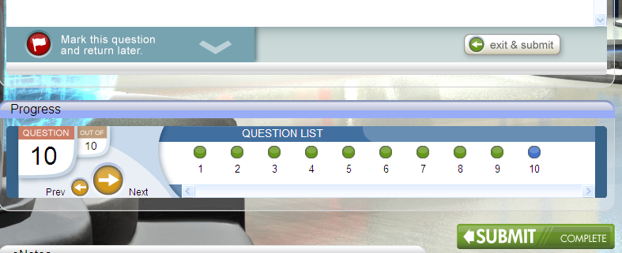
a. If you run out of time before you finish your
assessment, click the Exit and Save button
(if your teacher has enabled this feature).

b. When finished, click the Exit & Submit button
or the green Submit/Complete button.

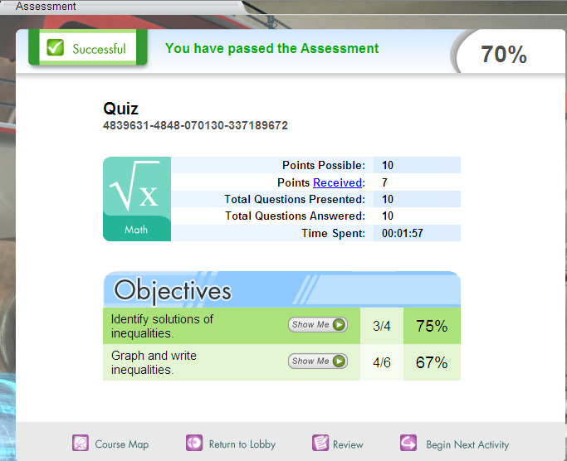
5. Using the Assessment Feedback

a. Use the feedback on the assessment review
screen to determine your next task.

b. If you pass, move on to the next lesson.

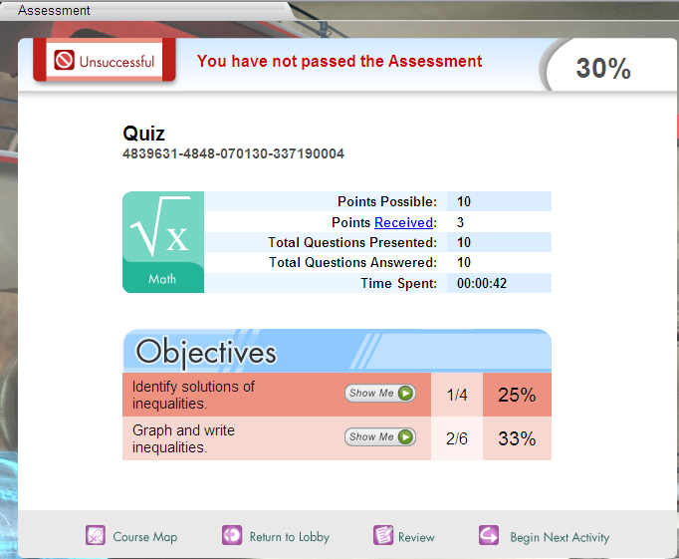
c. If you do not pass:

● Click the Show Me button(s) to view videos
which help explain each objective covered.

● Click Review to go over your answers and
learn what you did incorrectly.

Tips to Help You Succeed with Edgenuity

Focus on 3 Things: Space, Time, Productivity

Space: Make sure you have space in which to work where you can concentrate and focus, without distractions.
Time: Pace yourself to complete your daily assignments at a pace that is most effective for you. Be sure to include time to review course work and eNotes before taking assessments. Your grades will be higher if you take time to review.
Productivity: Stay on task as you work through your course. Do your best to not get distracted or daydream, as you will miss important course information which may lead to lower assessment grades. Staying focused and productive will also help ensure that you complete your course on time.

