

Registration and Login Manual

Version 4.0

Copyright © 2004 Georgia Department of Human Resources, Division of Public Health. All rights reserved

Contents

Registration Procedure 3
Registration Form 3-5
Registration Acknowledgment 6

Forgot Password 6
Requesting a password reminder email 6

Logging In 6-7
First Time Logging in 6
Disclaimer 7

Registration procedure

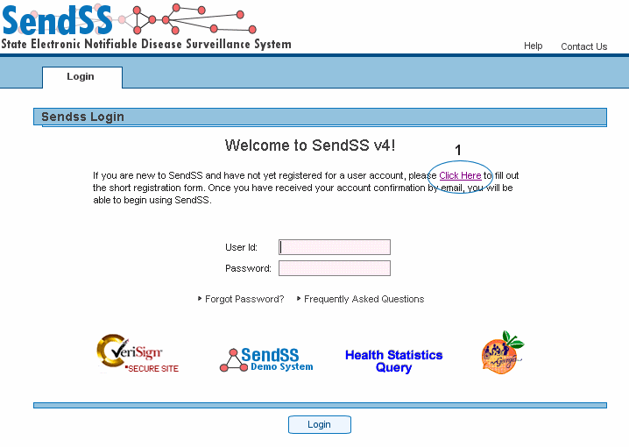

In order to register for access to SENDSS you will first need to fill in a registration form. This can be accessed by pressing “Click Here” as shown above [1].

The home page can be accessed with the following URL and is best viewed using Microsoft Internet Explorer Version 6.x.x. https://sendss.state.ga.us

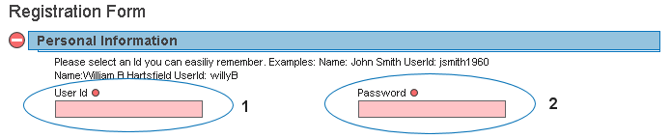

- Remember to use a userid that is easily remembered
- Fill out Password Information

Registration Form (Continued)

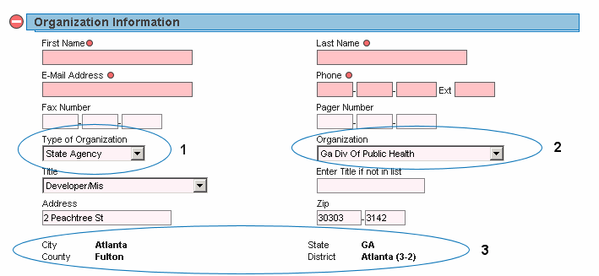

- Select the type of organization you will be entering cases for.
- Select the name of your organization. If you cannot find your organization select “Enter a New Organization” from the select box and the section will change and appear as below.
- City, County, State, and District are not editable once an organization is entered into SendSS. If all the information for this section does not appear when you select an organization, you will be asked to provide it the first time you log in to SendSS.

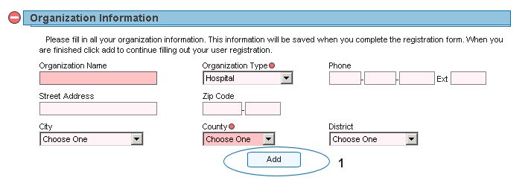

- This section appears if a new user needs to enter an organization for which SendSS does not have a current user. Please fill in all information and press “Add”. Then continue filling out the registration form.

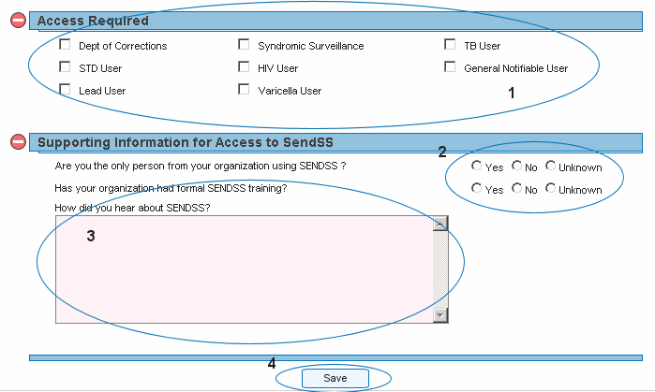

- Select the type of access you will require from SendSS from section 1.
- Please answer the questions in section 2.
- Enter any comments is this section
- Press “Save” to complete your registration.
Signing In

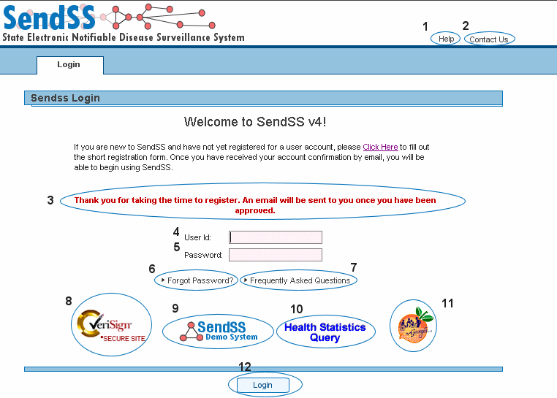

Key to features

Help – A link to documentation and manual for SendSS version 4.0

Contact Us – Send an internal message

Warnings and Messages – Text will appear in red to alert users of failed logins or other relevant messages such as successful registration.
- User Id – Enter the user id you chose when registering
- Password – Enter the password you chose when registering. This password must be reset every 3 months. After 3 months SendSS will allow 3 grace logins before locking your account. You will be prompted to change you password at this time.
- Forgot Password – Click here to request your password
- Frequently Asked Questions –
- VeriSign -- The certificate authority utilized by SENDSS is Verisign. Clicking on the graphic will display the validity of the SSL certificate.
- Sendss Demo System -- Clicking on this image will take you to the Demonstration site. A separate registration is required to access this site
- Health Statistics Query -- This link will take you to the Notifiable Disease Query
- Georgia Peach – Click this image to access the Georgia State Epidemiology Web site.

SENDSS - Disclaimer

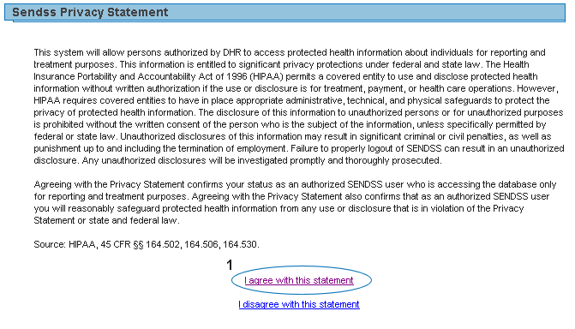

Before you can enter the system, you must accept the Privacy Statement [1]. Selecting “I disagree with this statement” will terminate your login and return you to the login page.

