Data to Monitor Progress in
Hospital Policies and Practices that Support Breastfeeding

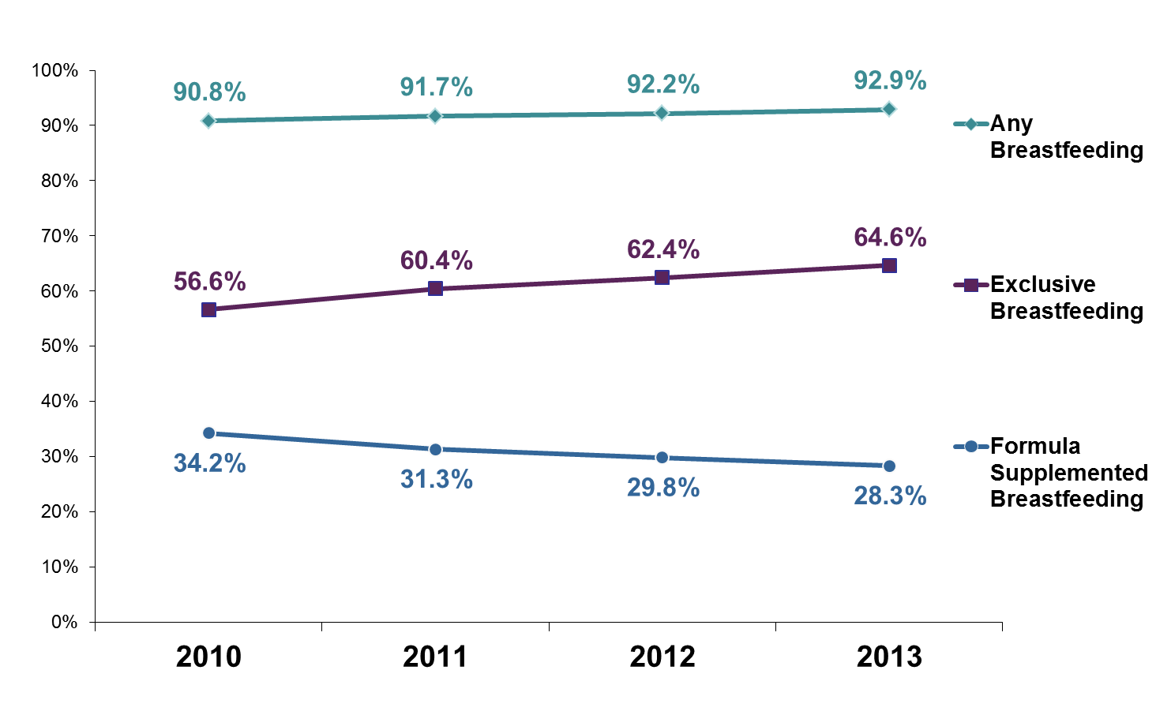
Hospital Breastfeeding Data: The California Department of Public Health (CDPH), Maternal, Child and Adolescent Health (MCAH) Division has released the California 2013 in-hospital breastfeeding initiation rates. These data tables provide hospital level breastfeeding initiation rates overall and by the race/ethnicity of the patient population. Hospital staff and administrators can use this information to examine the percentage of women who initiate breastfeeding at their hospital in comparison to similar hospitals and the state rates.
There has been progress in increasing in-hospital breastfeeding initiation and reducing racial/ethnic differences in California between 2010 and 2013. The rate of any breastfeeding increased from 90.8% to 92.9%, while exclusive breastfeeding rates increased from 56.6% to 64.6%. This translates to an overall decrease in formula supplementation from 34.2% to 28.3% during this time period. Improvements were seen across all racial/ethnic groups narrowing the gap in breastfeeding initiation and exclusivity between whites and other race/ethnic groups.

California In-hospital Breastfeeding Practices, 2010-2013

Data Source: Genetic Disease Screening Program, Newborn Screening Data, 2010-2013

Notes: these data (2010-2013) are not comparable to data published in previous years.

For further details on our methodology, please reference the footnotes section of the 2013 data report available on our Breastfeeding Statistics web-site at: http://cdph.ca.gov/BreastfeedingData.

Maternity Practices in Infant Nutrition and Care (mPINC) Survey: The Centers for Disease Control and Prevention (CDC) will disseminate results of the 2013 Maternity Practices in Infant Nutrition and Care (mPINC) Survey to all participating hospitals and birth centers in the United States later this year. As in previous years, each participating facility will receive a customized mPINC Benchmark Report that addresses barriers to evidence-based maternity care related to breastfeeding. Hospitals are encouraged to utilize their mPINC report to support quality improvement efforts within the maternity care setting. For comparison, state and regional level mPINC benchmark reports have been posted to CDPH’s mPINC Survey web-site at http://cdph.ca.gov/mpincdata. For information about CDC’s mPINC Survey visit www.cdc.gov/mpinc.

Baby Friendly Hospital Initiative:
Number of Baby-Friendly Hospitals in California

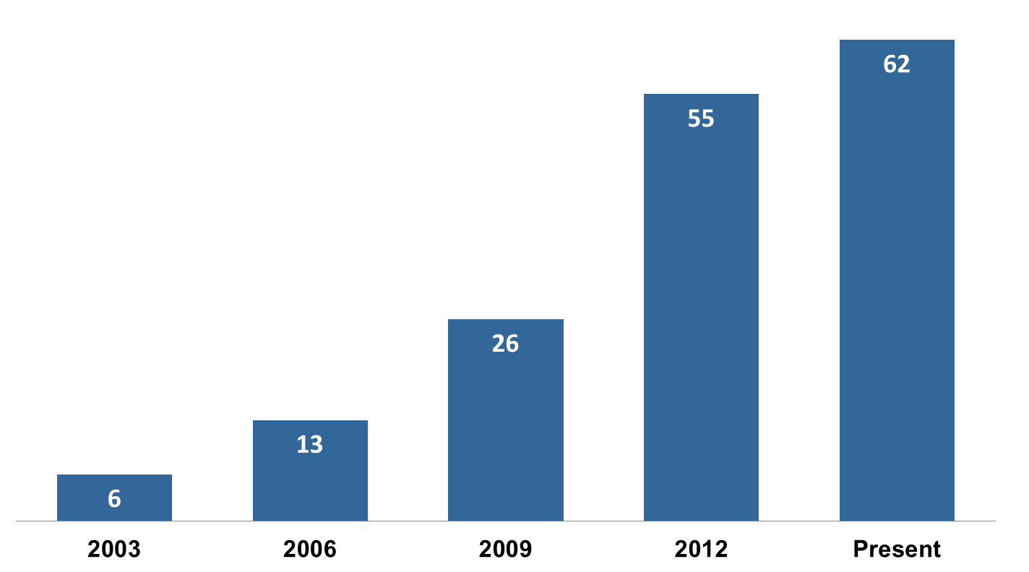
As of July 2014, there are 62 labor and
delivery facilities in California that have
earned the "Baby Friendly" designation
as defined by the United Nations Children's
Fund (UNICEF)'s Baby Friendly Hospital
Initiative (www.babyfriendlyusa.org).
Information and the names of the California
facilities with this prestigious designation
can be found on the California Breastfeeding Coalition website at:
Source: Baby Friendly USA. www.babyfriendlyusa.org
*Present represents Baby-Friendly Hospitals as of July 2014
http://www.californiabreastfeeding.org
New Hospital Infant Feeding and Care Requirements

Hospital Infant Feeding Act: The Hospital Infant Feeding Act (California Health & Safety Code §123366) requires that by January 1, 2014 all California hospitals that have a perinatal unit have an infant feeding policy. Policies need to promote breastfeeding and utilize guidance from the Baby-Friendly Hospital Initiative (www.babyfriendlyusa.org) or the State Department of Public Health Model Hospital Policy Recommendations (http://www.cdph.ca.gov/breastfeeding)and must be clearly posted and routinely communicated to staff.

The Joint Commission’s Perinatal Care Core Measure Set: The Joint Commission has expanded the mandatory performance measure requirements for accredited hospitals with 1,100 or more births per year to include the Perinatal Care Core Measure Set that includes exclusive breast milk feeding, effective January 1, 2014. The United States Breastfeeding Committee (USBC) produced a helpful resource entitled “Implementing the Joint Commission Perinatal Core Measure on Exclusive Breast Milk Feeding” found at www.usbreastfeeding.org/.

California Health & Safety Codes §123367 requires all general acute care hospitals and special hospitals that have a perinatal unit to adopt the "Ten Steps to Successful Breastfeeding" per Baby Friendly USA's Baby-Friendly Hospital Initiative, or an alternate process that includes evidenced-based policies and practices and targeted outcomes, by 2025.

Resources and Technical Assistance for
Developing Hospital Policies that Support Breastfeeding

Hospital Training: The CDPH developed an 8 hour administrator training entitled “Increasing Exclusive Breastfeeding Rates in California’s Hospitals.” The training curriculum is available at: http://cdph.ca.gov/breastfeeding.

CDPH Breastfeeding website / California Model Hospital Policies: The CDPH Breastfeeding and Healthy Living website, http://cdph.ca.gov/Breastfeeding includes a variety of resources. The 2005 California Model Hospital Policy Recommendations and related toolkit lists policies and information to assist hospitals in increasing exclusive breastfeeding rates.

Birth and Beyond California (BBC): In 2012, MCAH released the BBC: A Hospital Breastfeeding Quality Improvement and Staff Training Demonstration Project Report which describes BBC implementation, evaluation and lessons learned. Curricula, trainer notes, evaluation tools, and other materials for hospitals to implement all or portions of this project are posted at http://cdph.ca.gov/BBCProject.

The Regional Perinatal Programs of California (RPPC): RPPC, a network of regional public health consultants that promote access to risk appropriate perinatal care for pregnant women and their infants, can assist hospitals in implementing breastfeeding quality improvement. The contact information for each Region's RPPC Coordinator can be found at: http://cdph.ca.gov/RPPC.

Women, Infants and Children (WIC): Hospitals and local WIC agencies are important partners in increasing exclusive breastfeeding rates for low-income mothers. WIC provides prenatal breastfeeding education and anticipatory guidance, breast pumps when needed, and, in some areas, peer counselors to support breastfeeding mothers. To locate WIC sites in the area of your hospital, use the "Find a Local WIC Agency" search function, located on the WIC Works website: http://www.cdph.ca.gov/Programs/wicworks.

Local Breastfeeding Coalitions and Coordinators: The CDPH urges all labor and delivery facilities to work with their local breastfeeding coalition (http://californiabreastfeeding.org) and/or their local health jurisdiction breastfeeding coordinator (http://cdph.ca.gov/Breastfeeding) to address barriers to women breastfeeding exclusively.

