_____________________________________ Report Guide
Project Approval Statistics
CTE14935
Section 1. Introduction
Purpose of the Report
This report is for DOT use only. DOT is the only project costing agency to configure workflow approval events. If other project costing agencies configure workflow approval events in the future, then this report would be useful for them as well.

The report displays project approval summary data including number of projects approved in selected date range, minimum days for approval, maximum days for approval and average days for approval. This report also provides detail data by project including project ID, project description, date event created, date event approved and number of days between creation and approval. The report can be run for a single event or a range of events. When report is run for single event, it gives the approval statistics for that event for the selected date range. When the report is run for a range of events it gives approval statistics for the days it took to get from the “From Event” to the “To Event”.

The report is used to monitor and review approval statistics data and evaluate the effectiveness of workflow.

 User must specify business unit ANd DATE range
Type of Report
Structured Query Report (SQR); Format - Portable Document Format (PDF) or CSV (MS Excel)
Legacy SAAAS/CAS Reports N/A
Role(s) Needed to Access the Report
CT AGY PC DOT Viewer RPT Maker
Navigation Path to the Report
Project Costing > Core-CT Reports > Project Approval Statistics
Suggested Run Times Ad hoc

Section 2. Report Request Parameters
General Notes:
- Select an existing Run Control ID or enter a new one
- For reports that are run on a regular basis, user should select a Run Control ID naming convention that can be easily identified (e.g., Proj_Approval_Stats)
- An asterisk * preceding the field name indicates input is required
Parameters see screenshots below
In This Field | Enter | Notes
* Business Unit: | type business unit or use the lookup to select | use DOTM1 for DOT reports
* From Date: | type date or use the calendar icon to select | date format mm/dd/yyyy (e.g., 10/22/2008)
* To Date: | type date or use the calendar icon to select | date format mm/dd/yyyy (e.g., 10/22/2008)
Project Event Selection | select radio button | Single – type a single event or use the lookup to select
Project Event Selection | select radio button | Range – type a From Event and To Event or use the lookup to select
Save | push the save button to save report parameters | save reports that you want to run on a regular basis
Run  OK | push the run control button | - click on the select box for report  - select server name (PSNT or PSUNIX) from the dropdown list or leave blank  - select format – PDF and both PDF and CSV (MS Excel) formats will be created. User does not need to run CSV format separately.  - push the OK button

Report Request Parameters (single event)
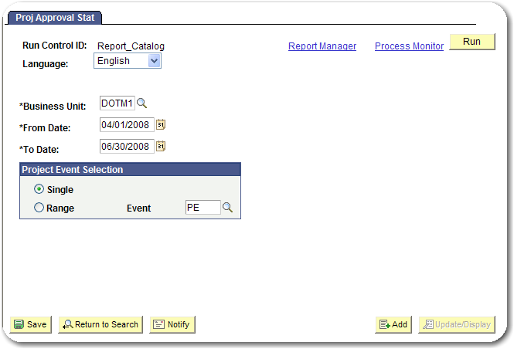
Report Request Parameters (range of events)
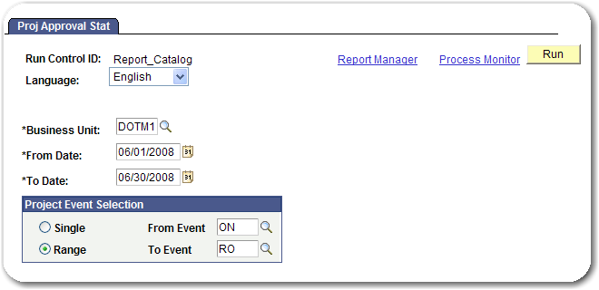
Process Monitor
Process Monitor
In This Field | Enter | Notes
Process Monitor  Refresh | click the Process Monitor link | - to view the processing status of the report  - push the refresh button until the Run Status is “Success” and the Distribution Status is “Posted”  - click the Details link  - click the View Log/Trace link  - click the report name link to display results

Section 3. Example(s) of Report Output
Examples of rows generated for a Projects Approval Statistics report with the suggested parameters.

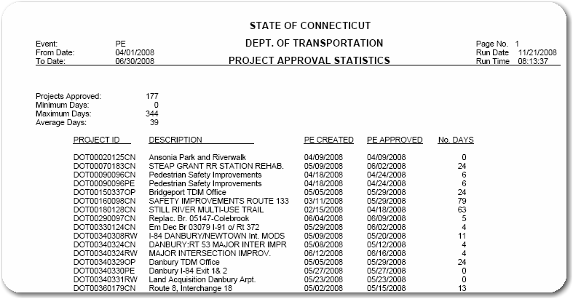
Figure 1 – CTF14935 single event in PDF format

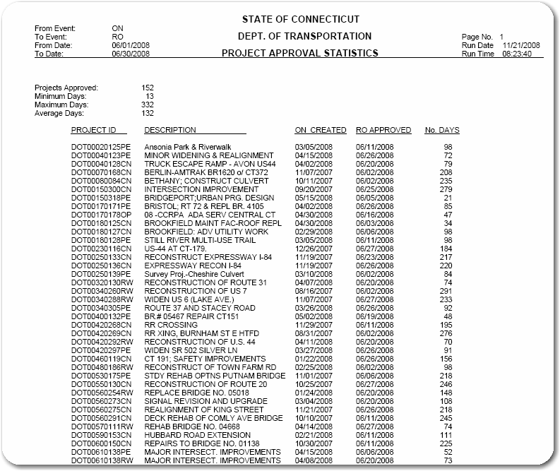

Figure 2– CTF14935 range of events in PDF format

