ONLINE FY2020
ANNUAL REPORT INFORMATION SURVEY (ARIS)
The online ARIS will be available to fill out on July 1, 2019 and will close on Friday, August 16th, 2019.
Please note: The online form and a signature page must be printed out (see directions below), signed in pen, and sent in to the MBLC. The final day to postmark the print copy of the FY2020 ARIS is Friday, August 16, 2019.
Please observe the following:
- Enter data for FY2020, even if it is the same as FY2019 data.
- Enter zero only if the number is actually zero, otherwise leave blank.
- No need to enter N/A, just leave blank.
- Branches and Bookmobiles questions for each of your outlets will appear at the end of the ARIS form.
- Write a note whenever the edit check (variation in data from last year) pop-up appears. We rely on those notes for explanation so we do not have to give you a call.
Questions? Contact Liz Babbitt x 227 or liz.babbitt@state.ma.us

New This Year: New Software

This year, after a lengthy process, we chose a new vendor for ARIS and Financial Report data collection. We moved from Counting Opinions/LibPAS to Baker & Taylor Collect and Connect. Collect is the data input software and Connect is the reporting software.
Instructions for filling out the ARIS online
Login to the survey at:

https://collectconnect.baker-taylor.com/login.aspx

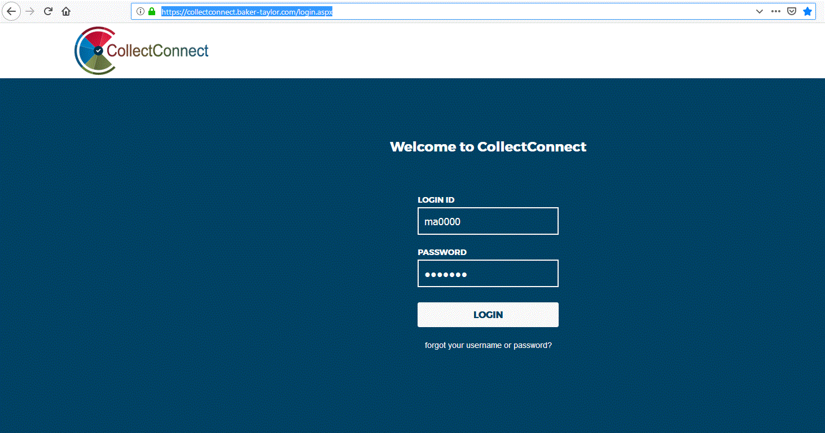 When you reach the login screen enter your username and password—This will be sent to library directors in mid-June. You can also contact Liz Babbitt, Uechi Ng, or Mary Rose Quinn if needed.

Click on “Login”.

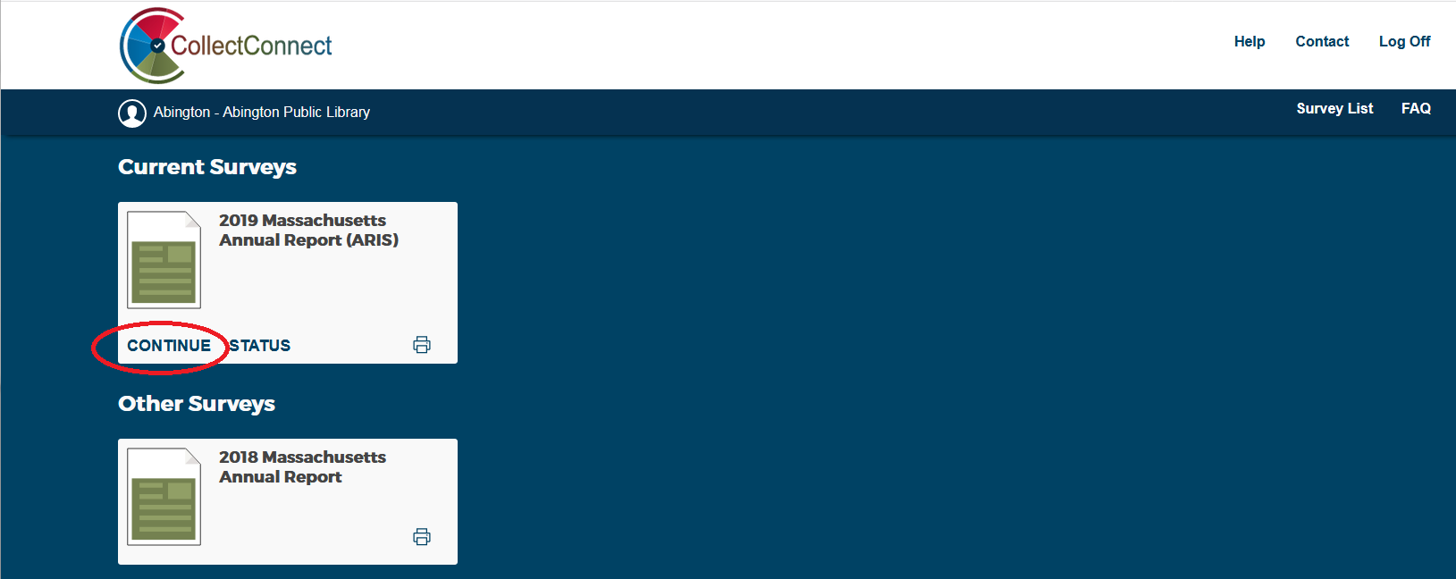

After entering the username and password you will see a set of surveys. Choose the “2019 Massachusetts Annual Report (ARIS)” and click on “Continue”.

- Enter data by using the Survey Navigation sidebar to access the questions section by section. Click on the “Save” button after each section.
- If you have a branch or bookmobile, the questions have been incorporated into the ARIS form and appear at the end.
- When you have finished entering all your data, click on “Show Status”. Show Status checks for any unanswered questions, and edits checks.
- When all of your data has been checked, and you are ready to submit, click on the Submit button.
- If you notice a mistake after you lock and print the form, please to not use white-out to make corrections. Simply put a line in pen through the incorrect information and write the correct information next to it.
- IMPORTANT: Click on "Print" and choose “Show PDF Report” A PDF version of the online form will appear. Print out the form and, sign the signature page, mail it to:
Massachusetts Board of Library Commissioners 98 N. Washington Street, Suite 401 Boston, MA 02114 Attn: Uechi Ng
7. You are done!
Your library will receive a confirmation from Uechi when the signed, print copy is accepted by the MBLC.
Tips & Hints to Fill Out Online Forms:
Navigating the Form:
- Select the section to be filled out from the “Survey Navigation” column on the left side of the screen.
- Use the Next and Previous buttons to move through the form, one section at a time.
- Move from field to field on the form by clicking on a field. Or, you can use the Tab or Enter key to proceed through fields one at a time.
Data Entry
- Greyed out fields automatically total your data.
- A pop up window will prompt you to explain why data may be out of usual range. Edit checks ensure that entered values are within a usual range (i.e. if $500,000,000 is entered instead of $50,000 for book expenditures). Please tell us WHY something has changes not just that the number is correct or that you have checked it.
- Data entry options are in a drop down menu format (e.g. for yes/no questions).
- Information that doesn't change often, such as addresses and phone numbers, will be pre-filled. You only need to correct if there have been changes. If the field is locked, contact the MBLC to make changes for you.
- Previous year's data can be turned on and off using the “Show Last Year’s Data” button.
Add Notes to Questions
- Click on the note pad icon to the right of the question. There are three types of notes: Federal, State, Local
Federal notes are for the questions we send to IMLS to be included in the PLS survey.
State notes are asked for a couple of questions – Changes in NRC reporting or meeting room usage.
Local notes are where you can enter notes that may be helpful in answering that question in the future. For example, these notes might explain who gave you those circulation numbers, or attendance figures, etc. Local notes carry over from the previous year.
- Make as many notes to yourself as needed.
- Notes should be used whenever the data changes significantly from year to year. Using notes to explain data prevents the MBLC from having to contact your library to verify if data is correct.
Submit Data
- After you have completed the form, and have check its status, please click on “Submit” in the upper right hand corner of the input screen.
- Once you click on “Submit”, you will not be able to change any values.
- If a change is required after the data set is Submitted, please contact Liz Babbitt or Uechi Ng at the MBLC to unlock the form to make changes yourself, or to request changes be made for you.

