Stem-changing verbs NOTES – Muchas gracias a Senora A. Lenord a slideshare.net

Boot Verbs!
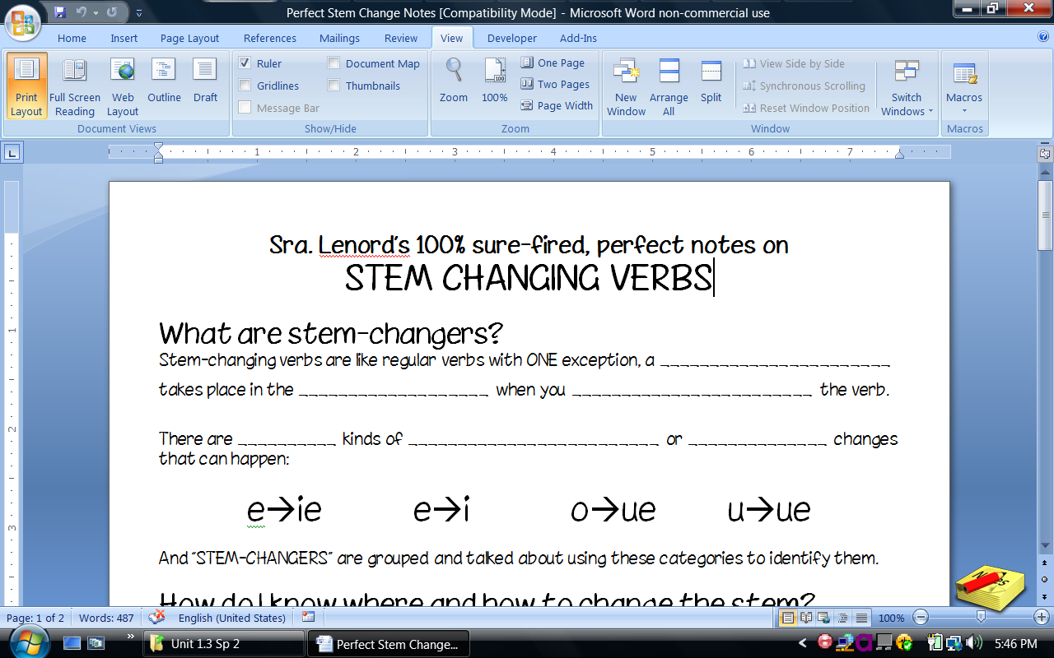


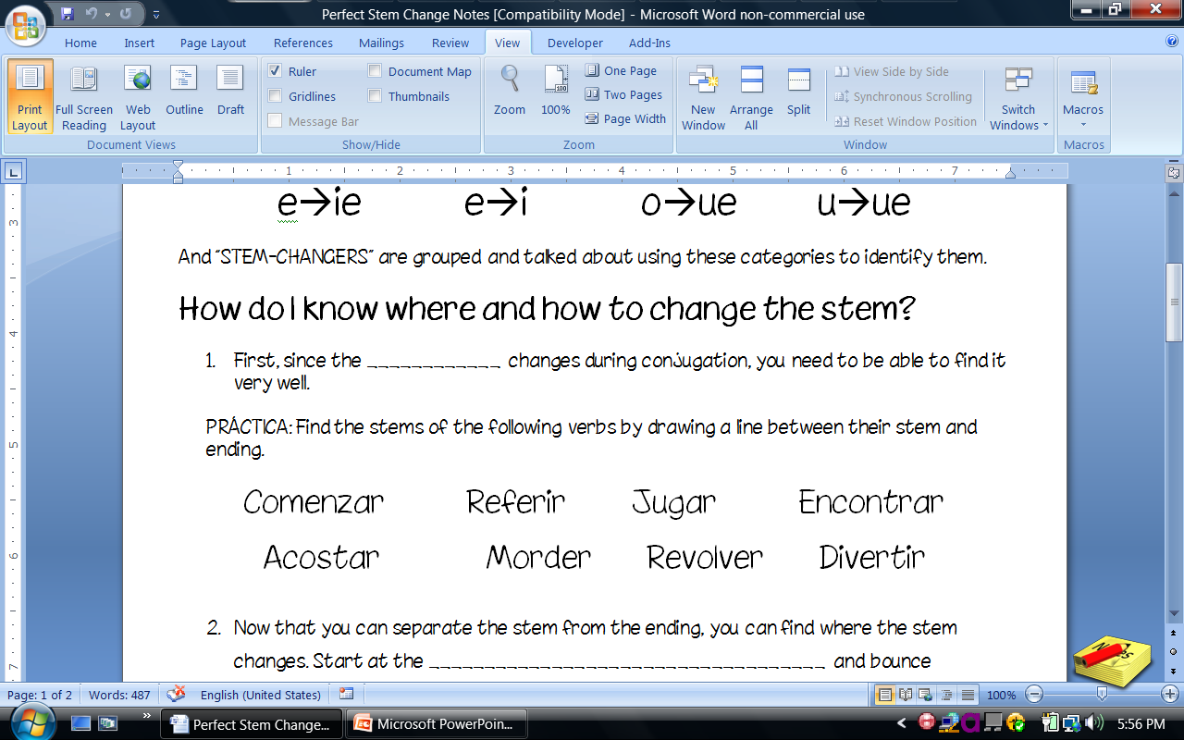

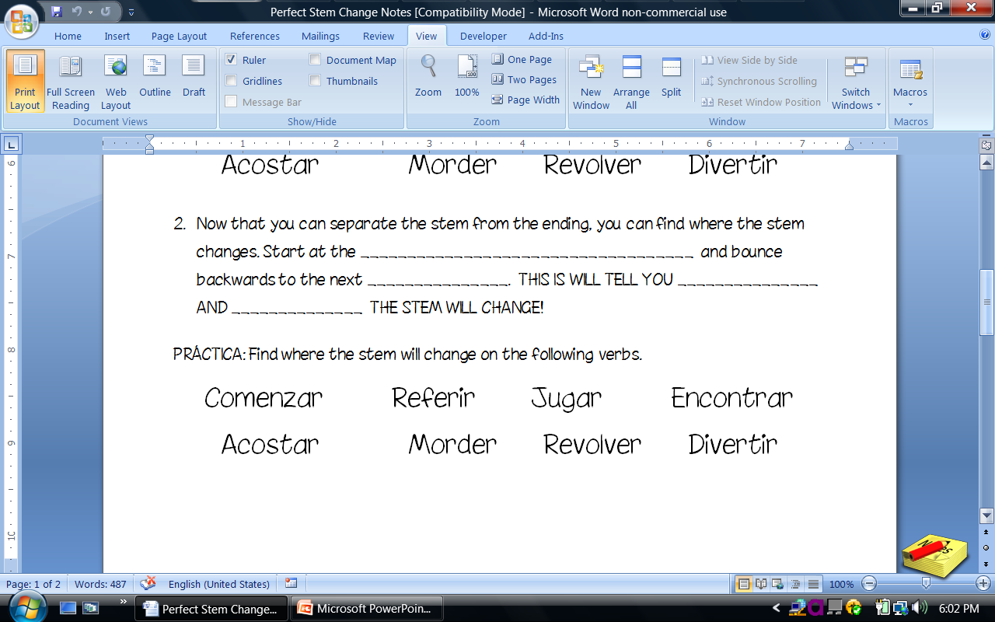
How do I conjugate stem-changers?
- Figure out what kind of change it will be.
- Separate the stem from the verb ending (AR, ER, IR)
- Conjugate with regular endings, then change the endings inside the ‘boot’

Remember – NOSOTROS, VOSOTROS and the INFINITIVE are OUTSIDE the ‘boot’!!!

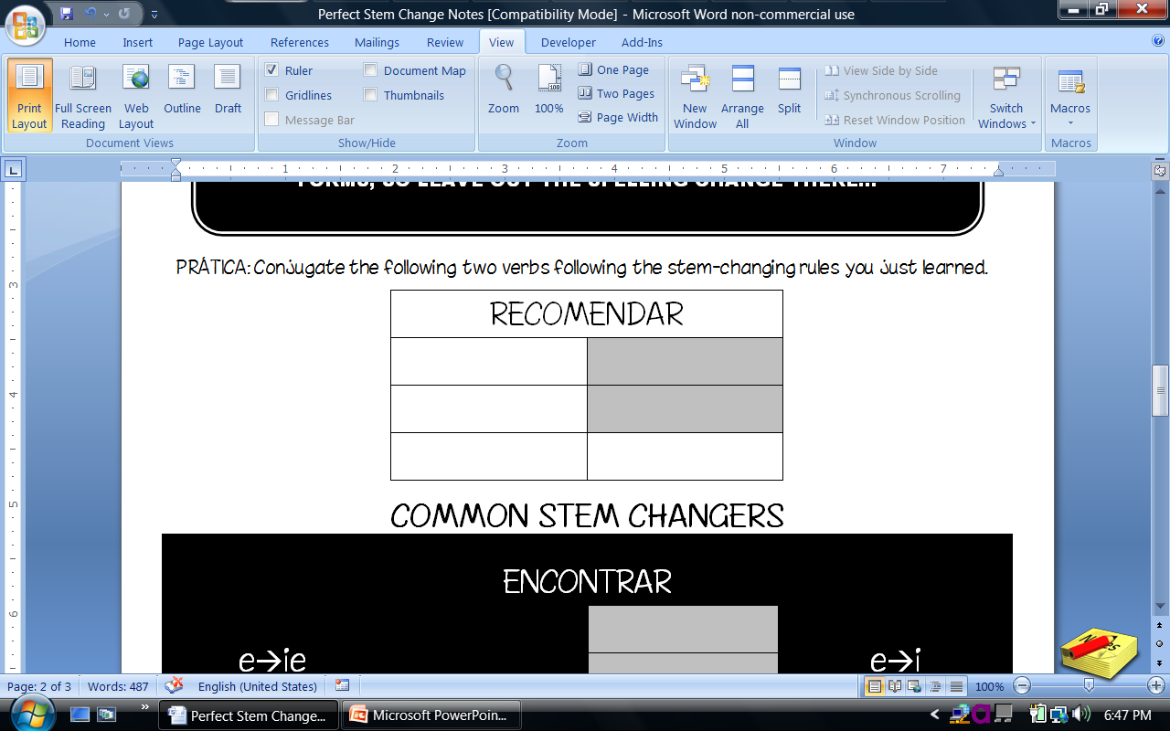

Draw the ‘boot’ around the forms that change

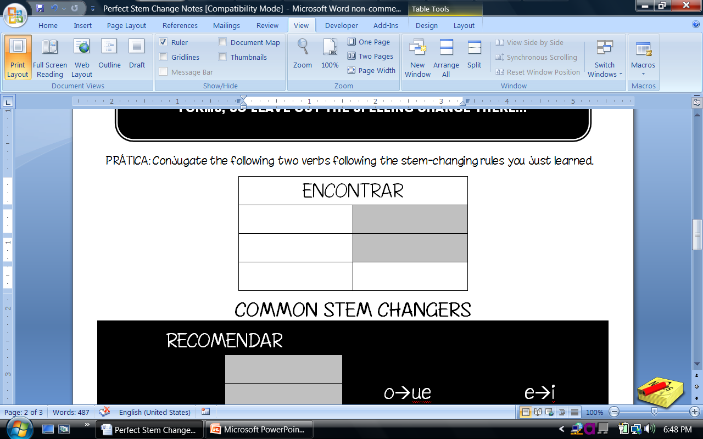

Know:
E →IE O → UE E→ I U → UE

cerrar almorzar pedir jugar
entender contar repetir
pensar dormir servir
preferir mostrar
querer poder
comenzar probar
empezar recorder
volver

