
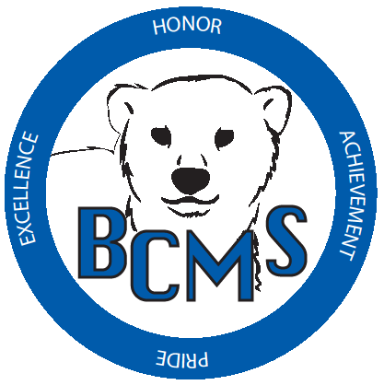
Bracken County Schools
348 West Miami Street

Brooksville, KY 41004
606-735-2523- phone 606-735-3640- fax
“Changing the world, one student at a time.”

Bracken County Schools Gifted & Talented Nomination Forms

Student Name: _____________________________ Teacher Name: ______________________
School: __________________________________ Grade: __________ Date: _______________
SPECIFIC ACADEMIC APTITUDE IN SOCIAL STUDIES

A. Indications (check all that apply):
☐ Nationally normed social studies scores
______________ Date: _________ Social Studies Score: ______%ile

B. Anecdotal notes: Please see below.
C. Student’s work that substantiates giftedness in social studies (Attachment)
D. Additional information that you believe is relevant (Attachment)
E. Social Studies Checklist (Below)

(MUST BE COMPLETED FOR RECOMMENDED STUDENTS)
Please check the characteristics which accurately describe the TYPICAL behavior of this student.
☐ Sensitive to social issues, concerned with moral and ethical questions
☐ Knowledgeable about current events
☐ Reads or watches TV programs dealing with global awareness
☐ Shows interest in learning a foreign language
☐ Has a high interest level in global issues of environment, endangered species, etc.
☐ Enjoys learning about the past, present, and future
☐ Exhibits great desire to earn high grades
☐ Is eager to tell others about discoveries and shows excitement in voice when talking about subject
☐ Usually prefers to work individually
☐ Is eager to complete tasks
☐ Is very alert: supplies rapid answers in subject
☐ Is inquisitive
☐ Enjoys talking with experts in this subject
☐ Enjoys Discovery channel
☐ Understands cause and effect
☐ Can apply knowledge to a variety of social science related issues
☐ Interest in people

Anecdotal Notes

Student Name: _____________________________ Teacher Name: ______________________
Gifted/Talented Area (check which one applies):
- Social Studies

Please comment on the following:

Level of performance:

Special strengths and weaknesses:

Needs caused by giftedness:

Ability to work independently and focus responsibility on specific area:

Additional comments:

