Utilizing Advanced Software Tools in Engineering and Industrial Technology Curricula
(size 22 Times New Roman font, Bold, small caps, centered)
Name of first author, Name of University; Name of second author, Name of Company or Institution (size 9 Times New Roman, centered)
(one line space of size 10 Times New Roman)

Abstract (size 16 Times New Roman, left justified)
(one line space of size 10 Times New Roman)
(Indent each full paragraph 1/8 inch) Engineering and technology software tools are used by professionals and companies worldwide, and in a university setting, students are given the opportunity to familiarize themselves with the (size 10 Times New Roman for text) operation of software packages that they will be using after they join the workforce. (avoid using first-person personal pronouns like “we” and “our”) Many classroom projects in engineering technology curriculum that require the use of advanced software tools has increased in college and universities on both undergraduate and graduate levels. Emerging virtual applications enhance understanding both theoretical and applied experiences of engineering technology students by supporting laboratory experiments. MSC.Easy5, AMESim, SolidWorks, ProE, Matlab, MultiSim and LabViewTM are some of the well-known system modeling, simulation and monitoring software tools that offer solutions to many problems in mechanical, thermal, hydraulics, pneumatics, electrical, electronics, controls, instrumentation and data acquisition areas. These virtual tools also help to improve the learning pace and knowledge level of students in many applied subjects. This paper presents case studies used in applied class projects, laboratory activities, and capstone senior design projects for a B.S. degree program in electrical engineering technology and manufacturing/design technology. Many students have found software tools to be helpful and user friendly in understanding fundamentals of physical phenomena.
(one line space of size 10 Times New Roman )
Introduction (size 16 Times New Roman, left justified)
(one line space of size 10 Times New Roman )
The development of educational and industrial software and simulation tools has been considerably increased by the development of high speed computers. Industrial applications now concentrate on replacing expensive equipment with software and simulations tools, while a number of educational institutions are preferring simulation tools instead of purchasing expensive test equipment for their laboratories. Universities, especially engineering education departments, are incorporating industry standard programming environment tools mainly in laboratory practices, but they are also being used in research and classroom education.

In engineering education, the demonstration of high tech equipment is the most common procedure. Demonstration engages process modeling, testing and simulation, imitates data acquisition and process control. For demonstration purposes, high level graphical user interface is required for providing efficient communication. Virtual applications may enhance both theoretical and hands-on experience for engineering technology students by supporting laboratory experiments as well. Most well-known industrial and educational software packages such as MSC.Easy5, LMS Imagine.Lab AMESim, SolidWorks, ProE, Matlab, MultiSim and LabViewTM are powerful physical system simulation and monitoring software tools that offer solutions to many problems in mechanical, thermal, hydraulics, pneumatics, electrical, electronics, instrumentation and data acquisition areas. These virtual tools also help to develop learning knowledge level of students in many applied subjects. For example, one of the well-known industrial software packages used in engineering education is LabViewTM, is a National Instrument (NI) product [1]. The NI LabViewTM is a user friendly graphical based programming environment mainly developed for data acquisition, instrumentation, and monitoring, besides process control and modeling are also supported.

There are a variety of research attempts to add simulation tools to laboratory experiments in engineering education courses. Virtual Control Workstation Design using Simulink, SimMechanism, and the Virtual Reality Toolbox was conducted in education to teach control theory principles as well as a test station for control algorithm development [2]. Authors used two workstations from Quanser Consulting for their electrical and computer engineering program student projects. Their claim was that incorporating a laboratory support into the engineering courses would enhance learning skills of the students. The discussion of the design and use of a low-cost virtual control workstation has been accomplished in the first undergraduate control theory course. The virtual workstation model from the physical, electrical, and mechanical parameters of a Quanser Consulting electromechanical system was built during the course period. The system has been used in over a dozen student projects and faculty research in the Electrical and Computer Engineering department at Bradley University. A capstone project was distributed to all faculty members. Also the learning curve of Simulink in senior capstone projects was tested by designing a six-week design project for a course that required system modeling using Simulink.

Other research incorporating the use of multimedia tools into a reverse engineering course has been presented by Madara Ogot [3], [4]. The main goal of this study was to use multimedia as initiatives for the students to learn how to use main tools and use them in other academic activities beyond the reverse engineering class. Since a classic mechanical engineering curriculum may not offer instructions on the use of multimedia tools in the areas of computer illustration, animation, and image manipulation, this experience increased the major students’ interest in these topic areas. Instruction on the use of these tools was incorporated into a mechanical engineering course at Ruther University instructors plan to send out follow-up surveys at the end of the each semester to students who have taken the class. It is expected that the results of the surveys should provide an indication as to whether providing formal instruction in the use of multimedia tools actually translates into their common use during the students’ technical, oral and written communications.

Another study has been conducted to increase use of software tools such as PSCAD/EMTDC [2], an electrical power and power electronics transient studies software tool for majors in the Electrical Engineering area. The aim of this study was to familiarize students with the electrical power systems without the cost and safety issues of actual power system simulators. Introduction of the PSCAD is usually introduced in the second week of an undergraduate power systems class and training starts with two basic sessions. For this purpose two case studies were presented on PSCAD that included the simulation of a three-bus system that allowed for independent control of voltage and phase on each bus in a way that clearly illustrates the principles of power flow control [5]. The author’s objective in using digital simulation software tools in power systems is that “modern teaching facilities supported with digital simulation tools and well equipped laboratories have great impact in the development of engineering programs in power systems and energy technologies.”
(one line space of size 10 Times New Roman )
Software Tools in Technology Education
(one line space of size 10 Times New Roman )
Authors of this paper introduce a number of case studies based on the following digital simulation and modeling tools in both mechanical and electrical engineering technology areas.

The AMESim simulation package comes with very helpful demonstration models for a convenient initial start of modeling [6-9]. This digital software tool offers an extensive set of application specific solutions which comprise a dedicated set of application libraries and focus on delivering simulation capabilities to assess the behavior of specific subsystems.

Pro/ENGINEER Wildfire 2.0 and its “Mechanism” simulation application is used to demonstrate an interference problem between parts in the engineering assemblies by simulating the individual parts [7]. Pro/ENGINEER is another standard in 3D product design, featuring industry-leading productivity tools that promote practices in design while ensuring compliance with industry standards.

Another 3D design software is SolidWorks Education Edition, which brings the latest technologies in 3D CAD software, COSMOS Design Analysis software, and comprehensive courseware to the modern design-engineering curriculum [8]. National Instruments MultiSim [10] formerly Electronics Workbench MultiSim software integrates powerful SPICE simulation and schematic entry into a highly intuitive user friendly graphical based electronics labs in digital environments.

LabViewTM is another National Instruments graphical development environment to help create flexible and scalable design, control, and test applications [11-14]. With LabViewTM, engineering and technology students can interface with real-world signals from a variety of physical systems in all engineering areas; analyze data for meaningful information; and share results through intuitive displays, reports, and the Web. Although not covered in this paper due to the length of this paper, Matlab has been one of the strongest mathematical tools in analog and digital signal and control systems design and simulation studies in the program at the University of Northern Iowa.

Case Studies

Six case studies are presented in this section of the paper. In the first case study, the angle of inclination of a plane will be determined for when the object starts moving if it is located on a flat inclined surface with a given static friction of coefficient. The second case study demonstrates how to determine the stopping distance and time of a vehicle model on inclined surfaces. The third case study is to solve interference problems between engineering models created by Pro/Engineer Wildfire based on Mechanism simulation application. The fourth case study describes Solid Works in a capstone design project to model and simulate floating calculations for a solar electric powered fiberglass boat developed at the University of Northern Iowa. The fifth case study is using MultiSim, Electronics Workbench in simple RLC circuits for measurement purposes. A low pass filter study, Bode Plot for stability, and full-wave bridge rectifier simulation studies by MultiSim are also briefly reported. The last digital tool covered in this paper is LabViewTM for data acquisition and instrumentation of a 1.5kW wind-solar power system where AC and DC voltage, current, power, wind speed values are monitored and recorded precisely.

Angle of Inclination Study (for minor headings, use size 14 Times New Roman, also left justified)

Figure 1 depicts a schematic of the simulated system. An object with mass, m, is located on a flat surface. One edge of the surface is lifted to form an angle, α, with the ground. The static friction coefficient, µ_{s}, is given. The purpose of this test is to determine the angle of inclination when the object starts the motion by using a digital simulation tool.
(one line space of size 10 Times New Roman )
α
F_{w} = mg
m = 100 kg
µ_{s} = 0.6

Figure 1. Object on Inclined Surface (size 9 Times New Roman, Bold)
(one line space of size 10 Times New Roman )
LMS.Imagine.Lab 7b is used to simulate the system [15]. In the mechanical library there exists a component called “linear mass with 2 ports and friction”. The user can apply external forces through the ports; for purposes of this study, the external forces are set to zero. Figure 2 illustrates the simulation model where attachments from both sides of the mass represent the zero external forces.

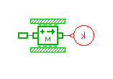
Figure 2. Simulation Model of Object on an Inclined Surface (figure and table captions should be identifying statements, not discussions; use caps as shown, no period)

Parameters of the mass component are populated as demonstrated in Figure 3. The first two parameters are state variables that are calculated internally; the user is supposed to provide only the initial conditions. Initial velocity and displacements are set to zero. As a selected mass of 100 kg starts the motion, initial velocity and displacement values are set to calculated values by the model. Since stiction force is good enough for calculations selected, the other three friction inputs, coefficient of viscous friction, coefficient of windage, and Coulomb friction force are all set to zero values.
The stiction force is given in Equation (1).
(for in-text referencing of a numbered equation, capitalize the word Equation with the equation number in parentheses)
(complex equations or formulas should be placed on a line by themselves with identifying numbers right-justified and in parentheses; use a different number for each formula)
$F_{\text{fs}}=μ_{s}\text{mg}\text{cos}\left(\frac{\text{απ}}{\text{180}}\right)$ (1)
where,
µ_{s} = 0.6 coefficient of friction
m = 100 kg mass
g = 9.81 kgm/s² gravitational coefficient
α (degree) angle of inclination

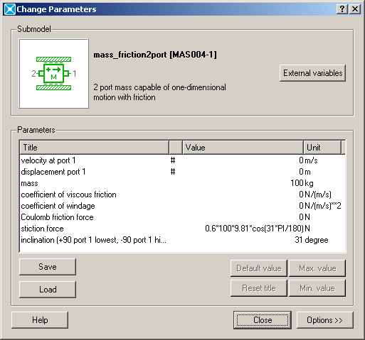
Figure 3. Parameters Input to Mass Component

The angle of inclination in the stiction force formula and the inclination in the following line must be identical. Several runs are conducted with different inclinations for 10 seconds and velocity of the mass has been observed to determine a motion. The results are given in Table 1. According to this study, the angle of inclination is determined as 31 degree.

Table 1. Results of the Simulation Model for the Angle of Inclination
The angle of inclination(degree) | Mass Velocity(m/s)
0 | 0
15 | 0
30 | 0
31 | 5.1
40 | 6.3

An analytical formula to calculate the angle of inclination is given in Equation (2) [16]:

$μ_{s}=\text{tan}α$ or $α=\text{arctan}μ_{s}$ (2)
where,
µ_{s} is the coefficient of friction, and
α (degree) is the angle of inclination

Since µ_{s} = 0.6, the angle of inclination can be calculated as $α=\text{arctan}(0\text{.}6)=\text{30}\text{.}{\text{96}}^{o}$. This result validates the simulation model.

This simple case and several other cases that are introduced in lectures and labs have alleviated the instruction of a complicated engineering software tool (such as AMESim) used students who are taking beginning level of engineering or engineering technology courses. It is observed that the modeling approach has helped students grasp of more advanced engineering subjects.

Vehicle Traveling Distance Study (for minor headings, use size 14 Times New Roman, also left justified)

Because it is an introductory level engineering technology course, the subject of the Power Technology class includes a basic level of mechanical power transmission calculations such as gears, pulleys, inclined plane, etc. Vehicle level design and analysis are generally covered in higher level courses at junior or senior levels. Moreover, testing such vehicles in labs or in the field is always hard to conduct for even an experienced technician and it is expensive to maintain such facilities for a teaching institute. Using software tools may improve instruction of more difficult subjects at lower level courses.

One of the problems presented as part of a computer lab assignment was determining stopping distance and time of a vehicle model on an inclined ground profile. The schematic of the problem is shown in Figure 4. An initial torque profile, as depicted in Figure 5, is applied to vehicle first 22s of the test, and the travel distance and the elapsed time until the vehicle comes to a complete stop must be determined at the given ground slopes of 5% , 10%, 15% and 20% [17-20]. The vehicle model consists of an engine, vehicle, transmission, differential and tire components.
(one line space of size 10 Times New Roman )
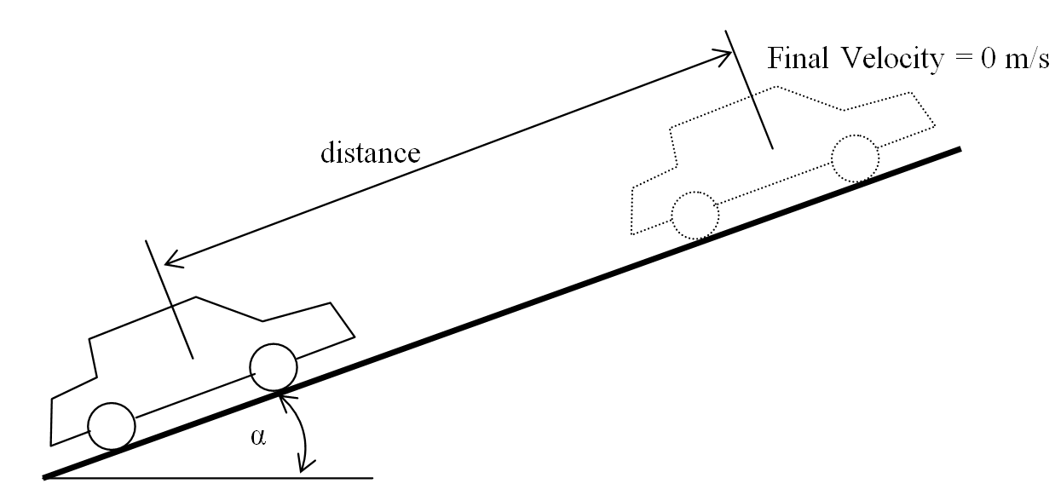
Figure 4. Schematic of vehicle and Ground Profile
The AMESim simulation package offers an extensive set of application specific solutions which comprise a dedicated set of application libraries and focus on delivering simulation capabilities to assess the behavior of specific subsystems. The current portfolio includes solutions for internal combustion engines, transmissions, thermal management systems, vehicle systems dynamics, fluid systems, aircraft ground loads, flight controls, and electrical systems. AMESim comes with very helpful demo models for a convenient initial start of modeling.

“VehicleTire.ame” is a demonstration model in their power train library which consists of differential, vehicle and tire models. While the engine has been represented by a simple torque curve, a transmission model has been completely ignored. For part of the lab work, the students were expected to integrate a transmission model to the demonstration vehicle model. They are instructed to use the variable gear ratio component from AMESim mechanical library for a simplified transmission model. The component allows the user to specify any gear ratio externally. A diagram of the modified vehicle model is demonstrated in Figure 6.

Breaking torque is set to zero for the purpose of this study. The Gear ratio of the transmission has been increased from 0 to 1 by 0.25 increment for each 5 s as depicted in Figure 7. The other parameters except the slope input have been left at the default parameters from the demonstration model. The model is run twice for 5%, 10%, 15% and 20% of ground slopes. The results are shown in Table 2. It is obvious that as the slope increases, the vehicle stops earlier.

Figure 5. Engine Torque Profile

Interestingly, at 20% slope, the vehicle did not move towards up to hill, instead it moved back after the engine torque was released at a time of 22s of the simulation. This gives the student an opportunity to investigate the system capabilities. The model can be used further in a detailed discussion and analysis of the vehicle behavior. For example, the car body longitudinal velocity and acceleration for 5% ground slope (Figure 8). The vehicle is accelerating and reaches to maximum velocity until time 22 second when the engine torque is set to zero as seen in Figure 8.a. The accelerating scheme (Figure 8.b) during this period looks like a step function since gear ratios are suddenly increased at times of 5, 10, and 15 s of simulation. The slight decrease in acceleration through the end of each step is because of the drag losses that were set to nonzero by default.

Solving an Interference Problem with Pro Engineer Wildfire 2.0

Pro Engineer Wildfire 2.0 [21] is an engineering modeling and design program capable of creating solid models, drawings, and assemblies. Pro/Engineer comes with different application program packages to help in the design and modeling process.
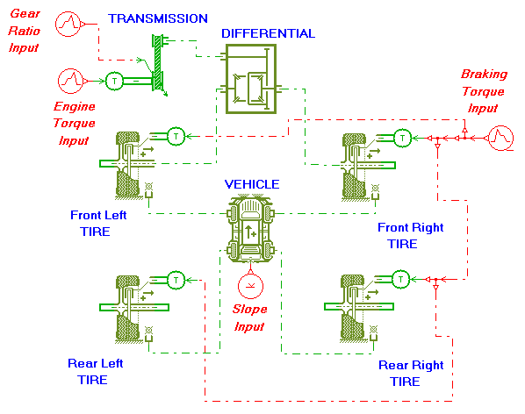
Figure 6. Vehicle Simulation Model

Table 2. Results of the Vehicle Simulation Model
Ground Slope (%) | Stopping Distance (m) | Stopping Time  (s)
5 | 1304 | 85.96
10 | 454 | 47.38
15 | 111 | 32.4
20 | n/a | n/a

Figure 7. Gear Ratio of a Transmission in a Vehicle Simulation Model
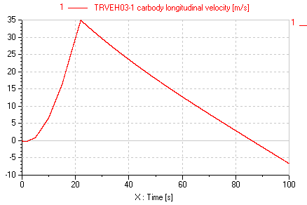
(a) Velocity
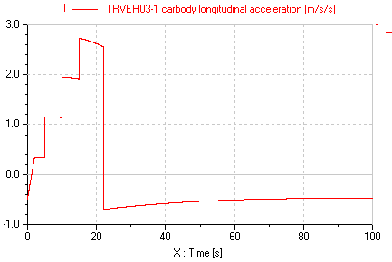
(b) Acceleration

Figure 8. Car Body Longitudinal Velocity and Acceleration (figures or tables with multiple entries should be formatted as shown; same font characteristics as the caption, but centered)

These application programs aid engineers in testing parts, models, and assemblies from early to advanced development stages. Applications include cabling, piping, welding, sheet metal, mechanica, mechanism, animations, plastic advisor, finite element analysis etc. Student groups who are familiar with Pro/Engineer can be divided into small interest groups to make projects using application packages depending on their area of interest. For instance, cabling applications can attract an electrical engineering major student to learn how to design an electrical cabling of the system. The piping application package can be an interesting part of modeling for students who want to model air, gas, hydraulic and fuel pipes and hoses for the automotive industry [15], [22-24]. In fact, learning fundamentals of how to use Pro/Engineer applications definitely enhance students’ knowledge. Fundamentals of each application help students to understand the basic terminology, tasks, and procedures so they can build their own models efficiently and share information, ideas, and processes with other students.

In this case study, a small group of engineering students were required to solve an interference problem between two parts by providing a new design solution. For this purpose, the Pro/Engineer “Mechanism” application was used to find out where the interference occurs. Pro/Engineer Mechanism can define a mechanism, make it move, and analyze its motion. In the Mechanism application, engineering students create connections between parts to build an assembly with the desired degrees of freedom, then apply motors to generate the type of motion the student wants to study. Mechanism Design allows designers to extend the design with cams, slot-followers, and gears. When the movement of the assembly is completed, the students can analyze the movement, observe and record the analysis, or quantify and graph parameters such as position, velocity, acceleration, and force. Mechanism is also capable of creating trace curves and motion envelopes that represent the motion physically. When the movement ready, mechanisms can be brought into “Design Animation” [25] to create an animation sequence. Actual physical systems such as joint connections, cam-follower connections, slot-follower connections, gear pairs, connection limits, servo motors, and joint axis zeros are all supported in “Design Animation.”

Initially, the dimensions of four different parts were provided to the students to model in Pro/Engineer. The parts were named with appropriate explanations to alleviate the modeling process for them [26]. The dimensions of the ball adapter and main structure plate were intentionally changed to cause interference in between when operating in the assembly. In this case, the students used a mechanism application by changing the assembly type and using joint connections to move the parts in the assembly. Figure 9 depicts a Pro/ Engineer assembly of four different parts; ball adapter, connection pin, tightening pin, and main structure plate.

As a result of modeling and assembling the aforementioned parts together, students realized that there was interference between the internal sides of the main plate and the ball adapter. The interference amount was found by making a model clearance analysis with Pro/Engineer (depicted in Figure 10 with red lines). Second interference occurred when testing the ball adapter using the mechanism application. When the ball adapter moved down 65-degree angle there was interference between the narrow edge of the main structure plate and the round shape of the ball adapter.

This was obvious when testing with mechanism only; otherwise the interference was not visible without moving the ball adapter. Second interference diagnosed by mechanism application is shown in Figure 11 with red lines and 65-degree angle. In this example, the 65-degree angle was given initially to indicate that the ball adapter is supposed to move a maximum 65 degree angle to avoid interference of other parts in the assembly.

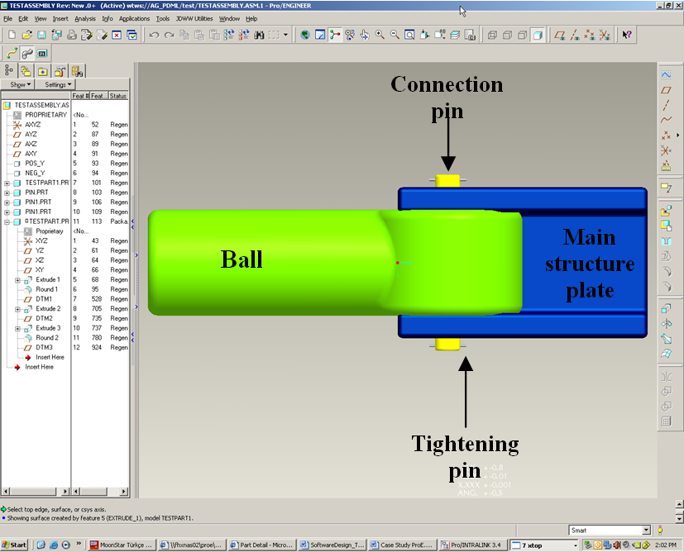
Figure 9. Pro-Engineer Assembly to Test Assembly for Interference Control
(one line space of size 10 Times New Roman )
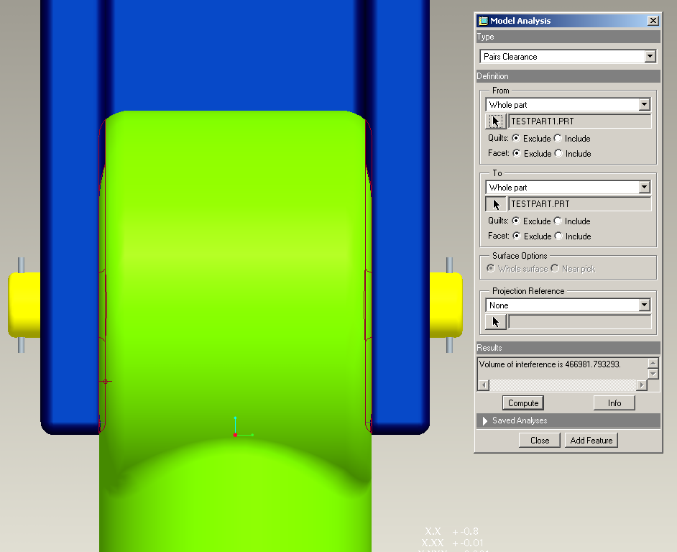
Figure 10. Interference Between Main Plate and Ball Adapter without Moving the Parts
(one line space of size 10 Times New Roman )
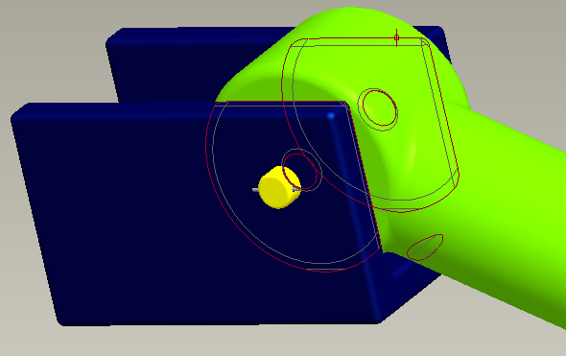
Figure 11. Interference Between Main Plate and Ball Adapter when Moved 65°

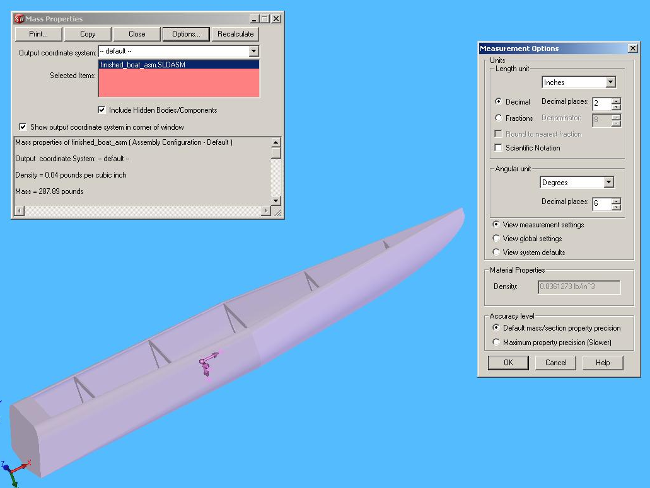
Figure 12. Solid Works Model of UNI Solar-Electric Boat

After diagnosing the interference problems, the thickness of the main structure plate and the diameter of the round shape of the ball adapter were decreased enough to avoid the problems. This case study motivated students to involve more model analysis with other applications of Pro/ Engineer. Students gained skills in how to model, assemble, and analyze their designs with Pro/Engineer and its applications.

Using Solid Works in Solar Electric Boat Design and Floating Calculations

The UNI solar electric boat team used both Solid Works and Pro-E [27-29] to model the new solar electric boat in 2007. With the team’s extensive use of CAD, it was easiest to change the material of the hull to water and have Solid Works automatically to calculate the new mass as shown in Figure 12 by using properties of the assigned materials from library. The following is an example of how to insert a long quote—40 words or more—but in this case is not something Johnston et al. [40] actually said.
(one line space of size 10 Times New Roman )
(indent the long quote 0.5 inches from the left margin )
This is an example of a long quote that is 40 words or more. Note that the reference to the author is made is the previous paragraph but not here. Make certain that you add ONLY the page number from which the quote was taken at the end of the quote like this. (p.38)

Buoyancy is created by the displacement of water. As modeled, the boat displaces 288 pounds of water when submerged. Calculations by Solid Works indicate the weight of the hull composed of foam material to be only 40 pounds. With all other components taken into account, the assembly of the boat weighs approximately 230 pounds in race trim. This yields a safety factor (SF) as follows:

SF = (288 – 230) / 288 = 0.2014 or 20.1 %

These calculations together with SolidWorks modeling show that the UNI solar electric boat, in the event of capsizing, will not sink and has a safety margin of 20.1 %.

Using NI MultiSim in a variety of EET Applications

Although actual hands-on analog laboratories must be included in EET curricula, students may also gain some initial skills without exposing themselves to the higher voltage/current values in the circuits. A number of circuit simulation tools now offer low-cost student versions that may provide user-friendly access from students’ personnel computers. Figure 13 depicts a simple RLC circuit and how to connect appropriate meters to measure voltage, current, and power. Figure 14 shows a simple passive low pass-filter circuit and its frequency response in MultiSim using a cut-off frequency of fc = 2,192 Hz. Similarly, Figure 15 depicts a Notch filter design, its frequency response, and Bode plots in MultiSim.

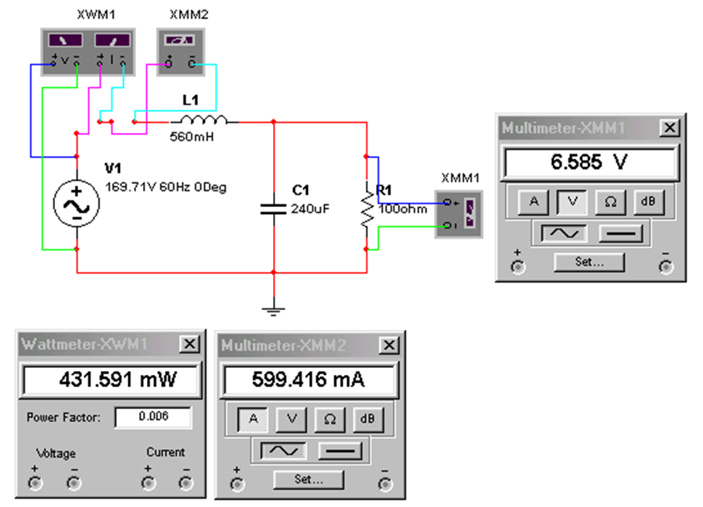
Figure 13. Voltage, Current, and Power Measurements in MultiSim for a Simple RLC Circuit

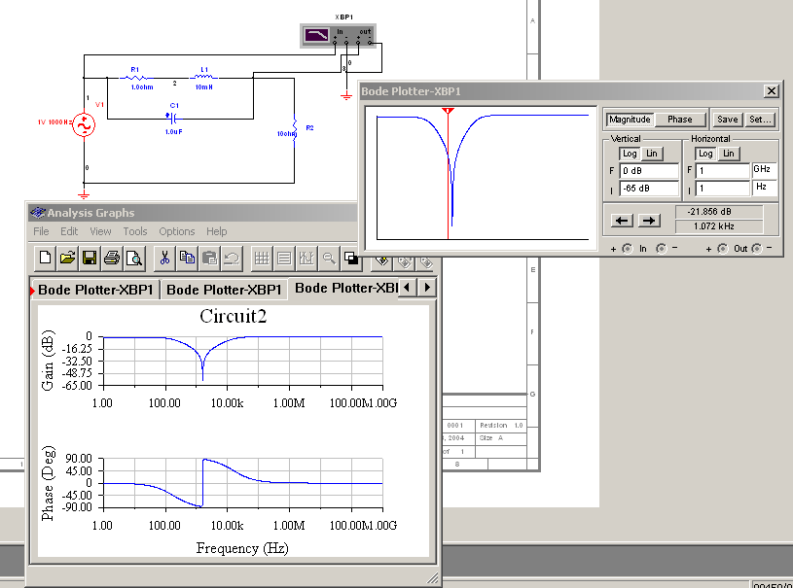
Figure 15. A Notch-Filter Design and its Bode Plots in MultiSim

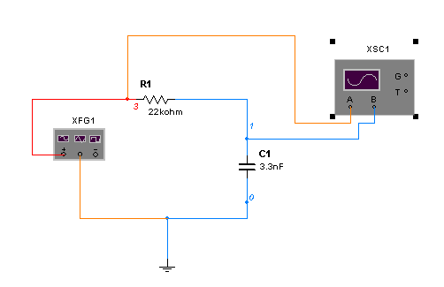
Figure 14. A Simple Passive Low-Pass Filter and its Frequency Response Using MultiSim

Figure 16 indicates another example of MultiSim applied to the simulation of a full-wave bridge rectifier in a power electronics class. Students safely gain in-depth knowledge of a high-power AC/DC converter before ever entering the lab. This also includes instrumentation connections in a virtual environment, waveform monitoring and overall circuit operation in steady-state. Figure 17 depicts a DC waveform output with numerical readings from the same bridge-rectifier circuit shown in Figure 16.

Using LabVIEWTM in Computer-Based Data Acquisition and Instrumentation Classes and Capstone Design Projects

Figures 18 and 19 show a LabViewTM based data-acquisition virtual instrument diagram and graphical outputs, respectively, for a 1.5 kW hybrid wind-solar power system, where AC/DC voltage and current values, wind direction, wind speed and AC/DC power values are measured and monitored precisely. The instrumentation phase of the wind-solar power station includes the following hardware: One CR4110-10 True RMS AC Current Transducer, one CR5210-50 DC Hall-Effect Current Transducer from CR Magnetics, voltage- and current-divider and scaling circuits,

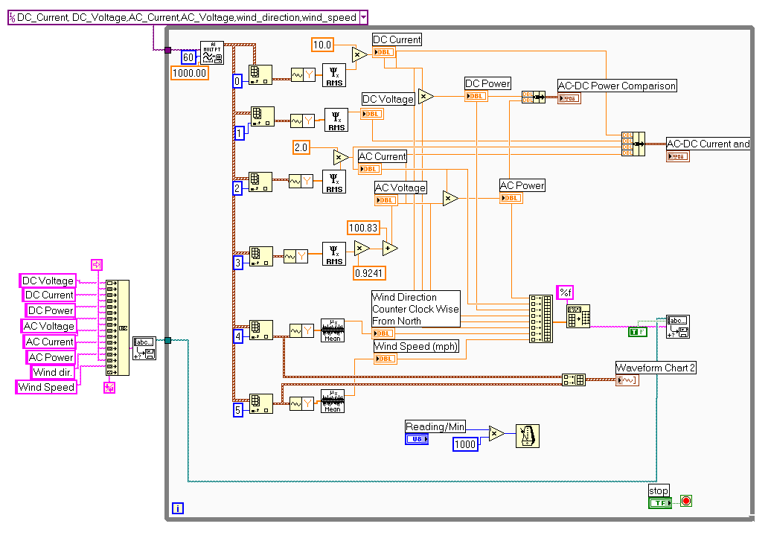
Figure 18. Overall Diagram of the LabVIEWTM Data-Acquisition Virtual Instrument (VI)

one wind-monitoring device called an anemometer, a LabVIEW Professional Development System for Microsoft Windows, one PCI-6071E I/O board, NI-DAQ driver software, one SH 100100 shielded cable, SCSI-II connectors, one NI SCB-100 DAQ (shielded connector block), one isolation amplifier circuit, and a PC.

Figure 16. A Full-Wave Bridge Rectifier in MultiSim

A Young 05103V anemometer provides two voltage signals corresponding to wind speed and wind direction. These wind signals are fed to AD21OAN isolation amplifiers and the output is applied to National Instrument’s SCB-100 data acquisition board (DAQ).

Figure 17. DC Output Waveform of the Bridge-Rectifier Circuit

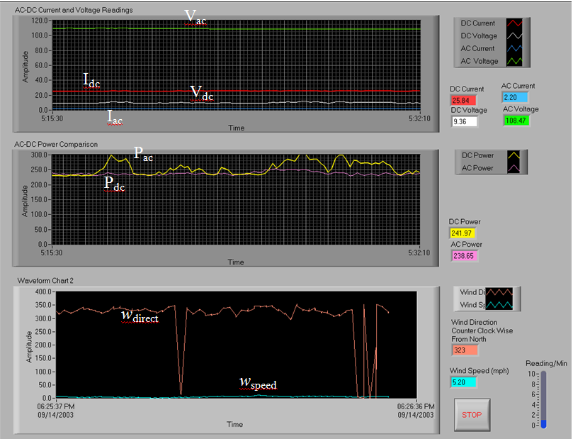

Figure 19. Front Panel of the Data-Acquisition VI for a 1.5 kW Wind-Solar Power System

Conclusion

Computer-aided engineering education is a valuable solution for increasing the quality of laboratory environments of engineering education courses. The classroom education process, similar to laboratory exercises, may be further visualized by introducing more advanced simulation tools. Several case studies have been demonstrated using LMS Imagine.Lab AMESim—a professional grade, integrated platform for 1-D multi-domain system simulation, Pro Engineer Wildfire—a well-known three-dimensional CAD/CAE software tool, SolidWorks—another 3-D digital simulation tool, NI MultiSim—formerly Electronics Workbench software integrating powerful SPICE simulation and schematic entry into a highly intuitive user-friendly graphical-based electronics lab in digital environments, and LabViewTM—another National Instruments graphical development environment to help create flexible and scalable design, control, and test applications in electronics and electromechanical systems.

Many students have found the software tools to be very helpful and user-friendly in understanding the fundamentals of physical phenomena in engineering technology areas. A number of students have increased their knowledge and experience with the aforementioned software tools as a valuable bridge to many internship and part-time student positions in local electronics and machinery manufacturing industries. The industrial advisory board members have repeatedly mentioned their satisfaction with student achievement and the valuable experience with digital modeling and simulation tools.
(one line space of size 10 Times New Roman)
Appendix
(one line space of size 10 Times New Roman)
Appendices, if needed, should appear before the acknowledgements section. Do not, however, use an appendix for tables or figures; these should all be embedded in the body of the document and properly captioned.

Acknowledgements

This work was supported in part by the National Science Foundation, CCLI-Phase I: Exploratory, under grant number DUE-0948152.

References
(Use APA formatting for references. Each of the entries shown below represents the format to be used for the associated type of reference. Also, text must be full-justified with numbers at the left margin and the remaining text indented 3/8 inch, also as shown.)

(Following is a summary of what each entry in this list is referencing.)
1–4 Journal publication
5 Journal publication—six or more authors
6 Journal publication—Internet only
7 Manuscript submitted for publication
8 Unpublished manuscript
9-11 Book
12 Edited book with one or more authors
13 Edited book with no authors
14-15 Chapter of a book
16-17 Website with no author
18 Website with author
19–21 Paper published in conference proceedings
22 Unpublished conference paper
23 Unpublished conference presentation
24 Presentation at a meeting or show
25–26 Wikipedia
27 Master’s thesis (unpublished)
28 Master’s thesis-UMI (published)
29 Master’s thesis-web (published)
30 Doctoral dissertation (unpublished)
31 Doctoral dissertation (published)
32–35 Symposium or report from a private individual or organization
36 Newsletter
37 Newspaper (hard copy)
38 Newspaper (online)
39 Federal agency document—agency as author
40 Federal agency document—personal authors
41 ERIC document
42-43 Article in an online magazine or subscription service

[1] Filho, R. T., Skrivener, K., England, G. L., & Ghavami, K. (2000). Durability of Alkalisensivite Sisal and Coconut Fibers in Cement Mortar Composites. Cement and Concrete Composites, 22(2), 127-143.
[2] Ramakrishna, G., & Sundararajan, T. (2005). Impact Strength of a Few Natural Fibre Reinforced Cement Mortar Slabs: A Comparative Study. Cement and Concrete Composites, 27(5), 547-553.
[3] Elsayed, M. A., & Aissi, C. (2009). Analysis of the Frequency Response Function and Stability in Drillstrings Using Active Circuit Model. Journal of Applied Science and Engineering Technology, 3, 29-38.
[4] Everett, H. (February-April, 1998). Breaking Down the Barriers. Unmanned Vehicles, 3(1), 18-20.
[5] Lin, C., Kang, J., Han, D., Tian, D., Wang, W., Zhang, J., et al. (2003). Electrical properties of Al₂O₃ gate dielectrics. Microelectronic Engineering, 66, 830-834
[6] Hirtle, P. B. (2008, July-August). Copyright renewal, copyright restoration, and the difficulty of determining copyright status. D-Lib Magazine, 14(7), 14-23. doi:10.1045/july2008-hirtle
[7] Roosevelt, F. (1997). Childhood acquisition of Pig Latin by native speakers of English. Manuscript submitted for publication.
[8] Nala, A. (1998). Teaching vocabulary: Evidence from research in Pig Latin. Unpublished manuscript, Brigham Young University, Provo, UT.
[9] Kreyszig, E. (2006). Advanced Engineering Mathematics. (9th ed.). Wiley.
[10] Boylestad, R. (2007). Introductory Circuit Analysis. (11th ed.). Upper Saddle River, NJ: Pearson Education, Inc.
[11] Posamentier, A. S., & Lehmann, I. (2004). Pi: A Biography of the World’s Most Mysterious Number. Prometheus Books.
[12] Adler, A. (1956). The individual psychology of Alfred Adler: A systematic presentation of selections from his writings. (H. L. Ansbacher & R. R. Ansbacher, Eds.). New York: Basic Books.
[13] Atkinson, J. W., & Raynor, J. O. (Eds.). (1974). Motivation and achievement. Washington, DC: McGraw Hill.
[14] Author, A. A., & Author, B. B. (1996). Title of chapter: Subtitle of chapter. In E. E. Editor, & F. F. Editor (Eds.), Title of book: Subtitle of book (edition, pp. first page-last page). City, ST: Publisher.
[15] Booth, C., & Kerns, K. A. (2009). Child-parent attachment relationships, peer relationships, and peer-group functioning. In K. H. Rubin, W. M. Bukowski, & B. Laursen (Eds.), Handbook of peer interactions, relationships, and groups (pp. 490-507). New York, NY: Guilford Press.
[16] Swarm Robotics. (n.d.). Retrieved November 30, 2010, from www.swarm-bots.org.
[17] US Navy Phalanx Close-In Weapons Systems. (n.d.). Retrieved November 30, 2010, from http://www.navy.mil/navydata/fact_display.asp?cid=2100&tid=487&ct=2.
[18] Cipra, B. (2002). Pi in the Sky. [Audio webcast]. Retrieved November 16 from http://news.sciencemag.org/sciencenow/2002/12/16-04.html
[19] Swift, D. G. (1981). Review of Fiber-Cement Research and Development with Particular Reference to Third-World Applications. Final Report of the African Regional Workshop on Natural-Fiber-Cement Construction Materials, (pp. 1-21). Appropriate Technology Center, Kenya.
[20] Cobern, M. E., & Wassell, M. E. (2005). Lab Testing of Active Drilling Vibration Monitoring & Control System. AADE Paper 05-NTCE-25, (pp. 1-14).
[21] Elsayed, M., & Raymond, D. W. (2002). Analysis of Coupling Between Axial and Torsional Vibrations in a Compliant Model of a Drillstring Equipped with a PDC Bit. Proceedings of the ASME, ETCE Conference, Paper # ETCE2002/STRUC-29002, (pp. 1-8). Houston, TX.
[22] Singh, R. (1969). Fibrous Building Materials Produced from Industrial Wastes. Report by the Expert Working Group Meeting, Vienna.
[23] Martins, J. R. (2004, April). Working with the terminally ill: An integrated theoretical model. Paper presented at the American Counseling Association World Conference, San Diego, CA.
[24] Smith, B. (2009, June). The conservative current and Bob Jones University. Paper presented at the American Convention for Contemporary Historical Studies, Boston, MA.
[25] Asbestos. (n.d.). In Wikipedia. Retrieved October 10, 2010, from http://en.wikipedia.org/wiki/Asbestos
[26] Sisal. (n.d.). In Wikipedia. Retrieved October 10, 2010, from http://en.wikipedia.org/wiki/Sisal
[27] Hughey, A. C. (1933). The treatment of the Negro in South Carolina fiction. Unpublished Master's thesis, University of South Carolina.
[28] Highland, P. W. (1989). Limited area and confined space developments in baseline quantum conditions (Master’s thesis). Available from ProQuest Dissertions and Theses Database. (UMI No. AAT986627)
[29] Egland, F. H. (1987). Determinants of upper limits to sub-vectors of non-linear energy flows (Master’s thesis). Retrived from http://proquest.umi.com/pqdweb?did=7755009&Fmt=7&clientid=9077&TYT=905&VName=EFH
[30] Beilke, D. (1997). Cracking up the south: Humor and identity in southern Renaissance fiction. Unpublished doctoral dissertation, University of Wisconsin, Madison.
[31] Cannon, C. (2004). Does moral education increase moral development? A reexamination of the moral reasoning abilities of working adult learners. Dissertation Abstracts International: Section A, 61(12), 4851. (UMI No. 9999321)
[32] Employee Benefit Research Institute. (1994, July). Baby boomers in retirement: What are their prospects? (Issue Brief No. 151). Washington, DC.
[33] Gilles, A. S. (2003, May). Slide presentation and field note summary. In M. L. Irons, (Chair), Storytelling in rural gatherings. Symposium conducted at the meeting of the RGS, Marseilles, France.
[34] Ritz, J. (2008, April). Cultural blindness and language [Slide presentation and data summary]. In M. Ottoman (Chair), Text and perspectives. Symposium conducted at the 55th Annual Meeting of the Archaeological Society, New York, NY.
[35] Toro, P. A., Bokszczanin, A., & Ornelas, J. (2008, June). Prevalence of and public opinion on homelessness in nine nations. Symposium conducted at the Second International Conference on Community Psychology, Lisbon, Portugal.
[36] Dowd, N., O'Donnell, P., & Snoek-Brown, J. (2007, Winter). WeLead and academic libraries: A bright future. Wisconsin Association of Academic Librarians WAAL Newsletter, 24(1). Retrieved from http://www.wla.lib.wi.us/waal/newsletter/241.html#welead
[37] Waldo, S. R., & Danedakar, V. (2011, August 14). Why medical school? New York Times, p. 34.
[38] Waldo, S. R., & Danedakar, V. (2012, January 4). Why medical school? New York Times. Retrieved May 17, 2004, from http://www.nyt.com/med
[39] Federal Aviation Administration. (2004). Seaplane, skiplane, and float/ski equipped helicopter operations handbook (FAA-H-8083-23) (pp.205-216). Washington, DC: Government Printing Office.
[40] Johnston, L. D., O'Malley, P. M., Backman, J. G., & Schulenberg, J. E. (2003). Monitoring the future: National survey results on drug use, 1975 - 2003. (Vols. 1-2). (NIH Publication No. 04-5507). Bethesda, MD: National Institute on Drug Abuse.
[41] Gottfredson, L. S. (1980). How valid are occupational reinforcer pattern scores? (Report No. CSOS--R-92). Baltimore, MD: Johns Hopkins University, Center for Social Organization of Schools. ERIC Document ED182465.
[42] Wills, W., Backett-Milburn, K., Gregory, S., & Lawton, J. (2006, January). Young teenagers' perceptions of their own and others' bodies: A qualitative study of obese, overweight and 'normal' weight young people in Scotland. Social Science & Medicine, 62, 396-406. Retrieved December 19, 2005, from Elsevier ScienceDirect database.
[43] Rowe, M. (2005, November 22). She's no homophobe. The Advocate, (951). Retrieved December 19, 2005, from http://www.advocate.com/

Biographies

FIRST AUTHOR (Indent 1/8” and capitalize the author’s name; size is 10-point TNR BOLD) is an Assistant Professor of Industrial Technology at This State University. He earned his B.S. degree from State University, CA, MS (Computer Science, 2005) from City College of New York, and Ph.D. (Electrical Engineering, 2008) from the University of Northern Michigan. Dr. Last Name is currently teaching at the University of Michigan. His interests are in energy harvesting, conversion, and storage systems for renewable energy sources. Dr. Last Name may be reached at thisemail@school.edu
(one line space of size 10 Times New Roman)
SECOND AUTHOR is ……………..…use the same format as above.
(one line space of size 10 Times New Roman)
THIRD AUTHOR is …………………….use the same format as above.

