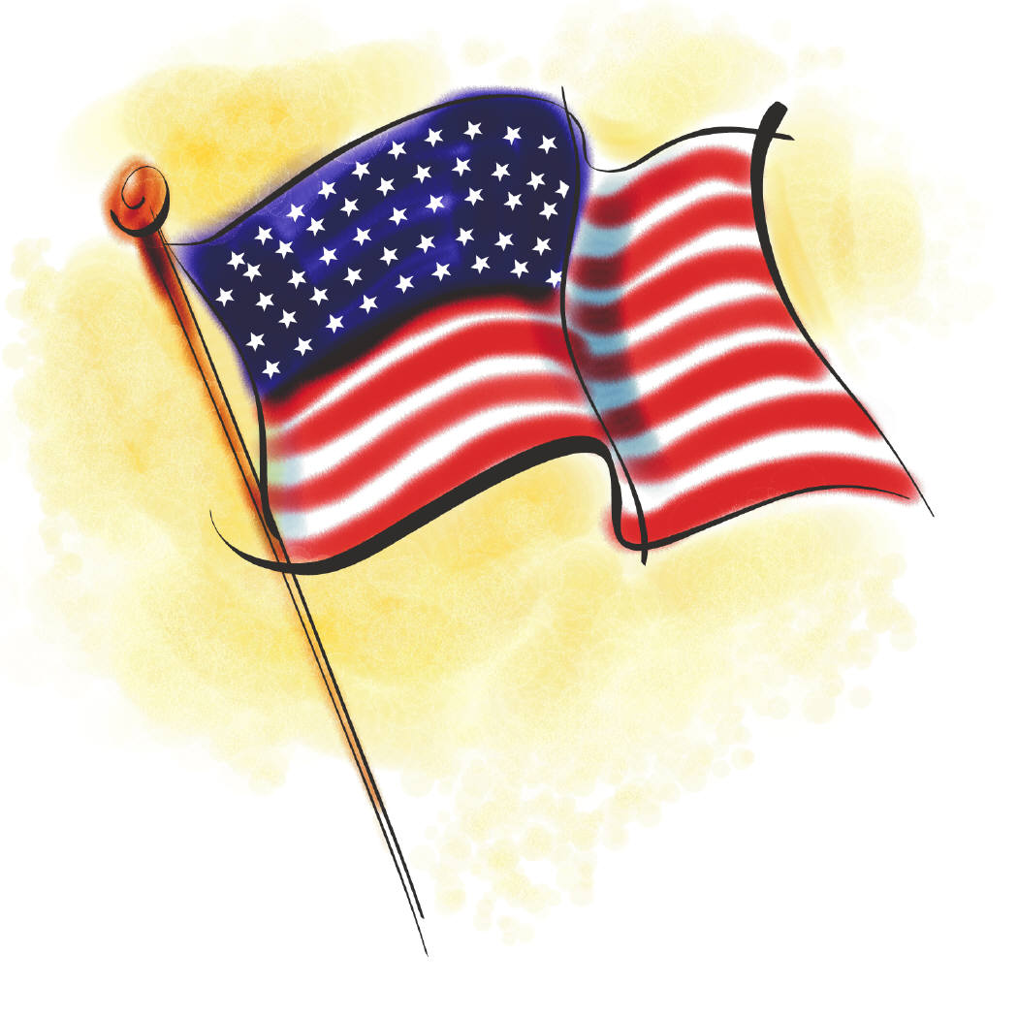
Study Guide: COMMUNITITES
History/Social Science SOLs 2.3, 2.10 and 2.12

Test Date:

Students will need to know the following information for the test. Please help them study.
Thank you, The Second Grade Teachers

- A community is a place where people live, work and play.
- The people who live in a community are called the population.
- Transportation is a way of moving people and things from one place to another.
- Communities change over time and life today is different from the way our grandparents lived when they were young.
- Long ago, people traveled by horses.
- Today, most children go to school during the day.
- New inventions have led to changes in buildings, jobs and transportation.
- People who belong to a nation have duties, rights, and privileges. These people are called citizens.
- A citizen’s special rights are called privileges.
- A responsible citizen would not tell lies.
- A responsible citizen would help others.
- If you found money and tried to find the owner, that would be showing trustworthiness.
- If you voted for your classmate to be president of your class, you would be taking part in the voting process. This would make you a good citizen.
- If someone hit you and you chose to ignore him or her and not hit them back, you are showing self-discipline.
- Self-discipline means to have control over oneself.
- A common principle shared by Americans is to respect and protect the rights and property of others.
- Writing on bathroom walls would not improve our community.
- People contribute to their community by practicing the responsibilities of good citizens.
- Americans are united or joined together by common principles and traditions.
- Americans love freedom. This is a common principle that unites all Americans.
- People who live in the United States have different ideas and traditions.
- Flag Day is always celebrated on June 14th. We honor our nation’s flag.
- Our flag is also called “Old Glory”.
- President’s Day is set aside to honor Presidents Washington and Lincoln.
- The Fourth of July is America’s birthday.
- Each year on November 11th we celebrate Veteran’s Day to honor men and women who have fought to keep our country free.

