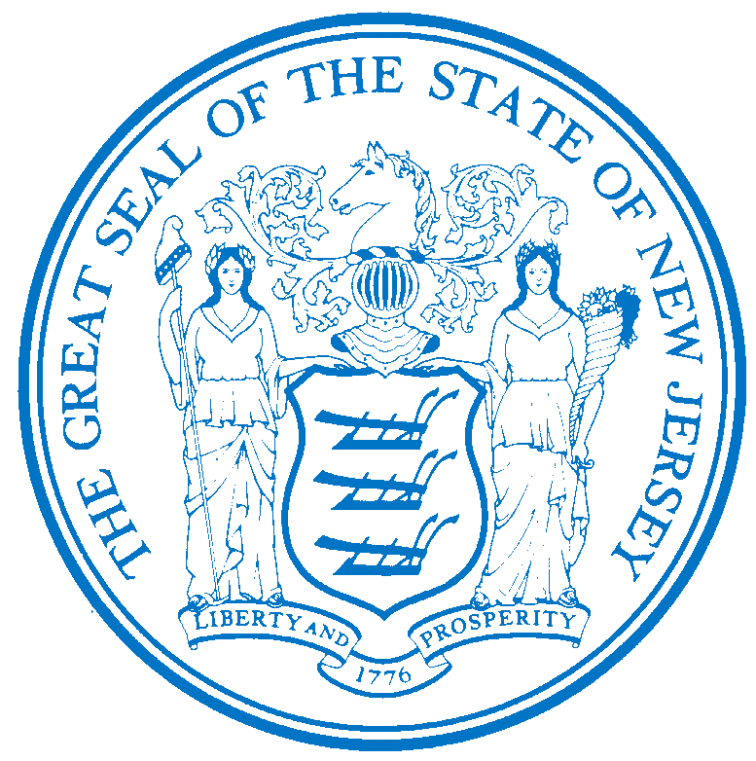


Department of Human Services
OFFICE OF THE ASSISTANT COMMISSIONER FOR
HUMAN RESOURCES
PO Box 700
Trenton, NJ 08625-0700
CHRIS CHRISTIE Elizabeth connolly
Governor Acting Commissioner

KIM GUADAGNO Christina Mongon Lt. Governor Assistant Commissioner
Human Resources

OPEN TO: Permanent State employees as a promotional or lateral opportunity, pending the rescission of applicable promotional and hiring restrictions.

STATE-WIDE DISTRIBUTION
JOB OPPORTUNITY #080-17
DATE: March 16, 2017

TITLE: Program Coordinator, Mental Health

SALARY: $64,677.09 to $92,011.89

LOCATION: Greystone Park Psychiatric Hospital
59 Koch Ave
Morris Plains, NJ 07950

POSITION INFORMATION

DEFINITION: Under the direction of a designated supervisory officer, is responsible for assisting team leaders, and/or may act as a team leader; develops, administers and supervises the coordination, planning, and implementation of specific care, custody, and rehabilitation services for a group of patients and/or unique programs, within a section, unit, level, or department; promotes the concept of level of functioning unified services, normalization and advocacy; does other related duties.

REQUIREMENTS:

EDUCATION: Graduation from an accredited college or university with a Bachelor's degree in social work, social case work, vocational rehabilitation, guidance and counseling, psychology,
nursing, pastoral counseling, special education, art, music, art therapy, music therapy, social science, education, sociology, occupational therapy or recreation.

EXPERIENCE: Three (3) years of experience in mental health in the field of social case work, vocational rehabilitation, guidance and counseling, psychology, nursing, pastoral counseling,
education or other related allied fields.

NOTE: A Master's degree in any educational area specified above may be substituted one (1) year of experience.

LICENSE: Appointee will be required to possess a driver's license valid in New Jersey only if the operation of a vehicle, rather than employee mobility, is necessary to perform the essential duties of the position.

NOTE: APPLICABLE SPECIAL RE-EMPLOYMENT LISTS ESTABLISHED AS A RESULT OF A LAYOFF WILL BE USED BEFORE ANY APPOINTMENTS ARE MADE.

RESUME SUBMITTAL

Interested candidates possessing the requirements listed, should forward resumes with the job opportunity # as indicated below:

SUBMIT TO: Michelle Battle
Personnel Assistant 2
Greystone Park Psychiatric Hospital
59 Koch Ave
Morris Plains, NJ 07950
Email responses to: Mhsgph.resume@dhs.state.nj.us

RESPOND BY: March 30, 2017

DHS-CO REVIEW: DAB 03/16/2017

IMPORTANT NOTICES
(1) RESIDENCY - Effective 9/1/11, NJ PL 70 (NJ First Act), requires all State employees to reside in New Jersey, unless exempted under the law, or current employees who live out-of-state and do not have a break-in service of more than 7 calendar days, as they are “grandfathered.” New employees or current employees who were not grandfathered and who live out-of-state have one year after the date of employment to relocate their residence to New Jersey or request an exemption. Current employees who reside in NJ must retain NJ residency, unless he/she obtains an exemption. Employees who fail to meet the residency requirements or obtain an exemption will be removed from employment.
(2) DRUG SCREENING - If you are a candidate for a position that involves direct client care in one of the Department of Human Services’ hospitals or developmental centers, you may be subject to pre and/or post-employment drug testing/ screening. The cost of any pre-employment testing will be at your expense. Candidates with a positive drug test result or those who refuse to be tested and/or cooperate with the testing requirement will not be hired. You will be advised if the position for which you’re being considered requires drug testing and how to proceed with the testing.

