Heart Dissection Lab
(42 pts.)

- Look carefully at the surface of the heart. How does the heart’s outside surface look like? What are the three layers of the heart from the exterior to the interior? Describe the pericardium membrane? Why is it shiny and slippery? (5 pts.)

Identify the parts of the heart shown in the picture (diagram) below: This is the
ventral side (rounded side). Don’t cut it yet.

Aorta | 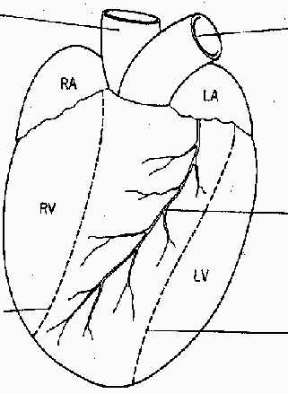 | Pulmonary artery
The two vena cava go into the right atrium on the other side (dorsal side) |  | The pulmonary vein goes into the left atrium on the dorsal side.
 |  | Coronary artery and vein
When you need to see inside the right ventricle, cut here.
When you need to see inside the right ventricle, cut here. |  | When you want to open the left ventricle cut here.
Identify the arteries and veins which come out of the heart. Using the string and ruler, measure the diameter in cm. of the arteries and the thickness of the walls. Describe what the arteries look like (color, shape, texture, etc.) (3 pts.)
Diameter of arteries: _____________________
Description of arteries: __________________________________________________________________
- Looking at the heart, what is difference in the characteristics (color, shape, texture, etc.) of the vena cava, pulmonary trunk and aorta? (3 pts.)
- Can you find any coronary arteries or veins? Where are they found? What is their function? (2 pts.)

- Cut open the left ventricle following the lines on the diagram. What is the valve that separates the left ventricle from the aorta? (2 pts.)

- Cut open the right ventricle following the lines on the diagram. What is the valve that separates the right ventricle from the pulmonary trunk? (2 pts.)

- How is the muscle thickness and volume of the left ventricle different from the muscle thickness and volume of the right ventricle? Using the ruler in cm., measure the muscle thickness of both the right and left ventricle. (5 pts.)
Left Ventricle muscle thickness: ________cm.
Right Ventricle muscle thickness: ________cm.
- Cut into the atria and measure the muscle thickness. Is the muscle wall thicker or thinner than the ventricles? Explain why this is the case. (3 pts.)

- What can you say about the size (volume) of each of the chambers? Are they different sizes, which is the largest? (2 pts.)

- What is the chamber that receives the blood from the vena cava into the heart? (2 pts.)

- Located next to the heart valves and papillary muscles. Look for the chordae tendinae. Describe their characteristics (color, shape, texture, etc.). What is their function? (3 pts.)

- Looking at the heart, how does blood flow from the body tissues to the heart and back to the body tissues? Describe how the oxygen levels change from the body tissue through the heart and back into the body tissue. (5 pts.)

- Conclusion: What did you learn from doing the heart dissection? (5 complete sentences) – 5 pts.

