Physical Science
Course Syllabus
Instructor - Mr. Adam Reinhart
Fall 2013

Information
Location - Room #404
Office hours - Mon – Thur. 7:30-8:15, 3:15pm – 3:45pm
School Phone - (803)-810-8145
Email address - adam.reinhart@clover.k12.sc.us
Class Twitter Account - @MrRPhysicalSci

Description
Welcome To Physical Science. In this course we will be exploring the fields of physics and chemistry. The first 9 weeks will be discussing chemistry topics and the last 9 weeks we will finish up the semester with physics topics. This class is designed to get students ready to take the more difficult science classes at Clover High School. This class is not an EOC course but is still required for students to take at CHS.

Freshmen - Adjusting to High School:
In my experiences working with freshmen, I have found that many are surprised by some of the different academic expectations of high school. Please be prepared to have more of an emphasis on personal responsibility, a strong adherence to deadlines, and an emphasis on ACHIEVEMENT rather than on effort.
This class is designed to get you ready for future high level science classes and will learn information, skills and strategies you will be using throughout you high school career

Schedule
1. Unit 1 Inquiry 6. Unit 6 Energy transformations
2. Unit 2 Atomic Structure 7. Unit 7 Electricity & Magnetism
3. Unit 3 Chemical Reactions 8. Unit 8 Waves
4. Unit 4 Composition of Matter 9. Unit 9 Biology Prep
5. Unit 5 Force and Motion 10. End of year Projects / Finals Prep

Homework Policy
Homework is due the next day after being assigned. Turn it into your class box or emailed to me. Typical homework assignments are vocabulary exercises, worksheets to expand in class learning, and reading from the textbook. All homework assignments will be posted my web page. Reminders will be sent out on the class twitter account. If you forget or choose not do an assignment points will be lost according to the lists below.

Home work / Labs Major Assignments/ Projects
1st day = -5 1st day = -7
2nd day = -10 2nd day= -14
3rd day = 0 points awarded 3rd day= -21

Tardy/Absence Policy/Returning from absence
This class will follow the ninth grade academy tardy/ absence policy. You will have 1 week to turn in any missing work from the day of your absence. This includes making up test and labs. After the 5 day grace period is up, you will begin to lose points just like any other late assignment. If you know you will be going to miss some days of school please let me know so I can plan accordingly and supply you with work to complete before your absence. Assignments may be sent out via email upon request by a student or parent

What you need for this class
One of the major grades in this class is to keep an organized binder/notebook – you must have one no later than August 28th. The binder purpose is to keep you organized and to store all important materials so you have them at the end of the year. The following things you will need every day
- Binder 3. Your textbook
- pencil/pen 4. Internet access (not required but will be used almost daily)

Grading Scale:
A = 100-93 C = 84-77 F = Below 70
B = 92-85 D = 77-70

Communication of grades:
Grade will be posted in the classroom by student id number. Parents and students may also view grades via the parent portal grade book. A paper copy of grades and assignments can be provided upon request.

Lab Safety
Lab participation is a necessary component of this course. My classroom was not designed for lab activities but we will do the best with what we have. Students will participate in lab safety training though out the year and will be required to pass a lab safety quiz. Students who consistently and intentionally misbehave in lab will be dealt with on an administration level or will be assignment alternate assignments instead of participating in the labs. Responsible behavior is a must to insure the safety of all students in the lab

Extra help
Tutoring is available before school starting at 7:30am and after school until 4:00pm. I am the NGA Science tutor and the meeting time is every Wednesday after school until 4:30 pm.

Accommodations
Please see me or email me if you require special accommodations due to learning disabilities, religious practices, physical requirements, medical needs, or any other reasons.

Classroom Rules
All rules for this classroom exist for two primary purposes:
1. Prevent all disruptions of the learning process
2. Insure the safety of all students in the classroom

To achieve the goals set above, students are expected to:

1. Follow all school rules listen in the student handbook
2. NO CELL PHONES
3. Be in assigned seats, working quietly on the warm up, at the bell.
4. Be respectful and respectable at all times.
5. Remain in assigned seats unless otherwise instructed.
6. NO food in the classroom.
7. Refrain from speaking while the teacher is speaking.
8. LISTEN while the teacher is speaking.
9. Use equipment and materials exactly as instructed.
10. Keep independent and group work areas clean.

In the event that classroom rules are broken, the following steps will be taken:
 | Classroom | Lab
First Offense | 1. Verbal Warning | 1. Warning
 | 2. Out-of-Class Discussion for Clarification
Second Offense | 1. Date, Information, Student Initial on Referral to be held | 1. Sit down from lab
 | 2. Phone will be taken away until class is over | 2. Zero for lab grade
Third Offense | 1. Date, Student Initial on Referral to be held | 1. Removal from lab for one unit
 | 2. Lunch Detention to Discuss Conflict
 | 3. Call to Parent
 | 4. Notification to Administrator
Fourth Offense | 1. Call To Parent | 1. Removal from lab for the rest of year
 | 2. Referral sent to Administrator

Physical, verbal, and sexual abuse will not be tolerated in the classroom. If this happens you will be removed from the classroom

My record for any classroom disabling problem

Name of Student | 1st Offense | 2nd Offense | 3rd Offense | 4th Offense
 | Warning Issued | Lunch Detention | Lunch Detention | Signed Referral
 | Met with Student | Signed Referral | Signed Referral | Sent to Administrator
 | Signed Referral | Lunch Detention | Called Parent | Call parent
 |  |  | Notified Administrator

The best discipline plan is a PROACTIVE plan! If you are feeling at all frustrated with your work or your instructor, please discuss the situation with your teacher as soon as possible

Please sign the following and return this Page to the teacher.

I have read and agree with the discipline plan described above:

Student Name______________________________________ Date______________

Parent Name_______________________________________ Date______________
Name: ___________________________ Period: _______

Directions: Read the questions carefully and answer to the best of your abilities

- How many meters are in a kilometer?

- What does a microscope do?

3. What scientist famous equation is E=mc²

- What is the smallest thing that takes up space?

- Why can we not see air?

- What is a good conductor?

- What is a microwave? (not what you heat up a hot pocket with)

- What is a magnet attracted to?

- How many planets are in our solar system?

- What is the difference between your mass and weight

11. What are two ways to accelerate an object?

Name: _______________________ Period: _____

Directions: Follow the bulleted points below to describe yourself to me. Use the bulleted points to draw a picture of a face on the back of this page. You are not graded on artistic ability but please be truthful. If the bulleted point has nothing to do with you then skip it. This should only take about 20 minutes

- If you are male draw a large rectangle, if you are female draw a large circle
- With the best of your ability draw your hair style
- If you have blond hair draw a pointy nose, brown- round nose, black- long nose, red hair – square nose
- Tell me your age by the number of freckles on your forehead
- If you are over 6 feet tall draw large eyes, under 6 feet tall- small eyes
- If you live with 1 parent draw square eyes, 2 parents – circle eyes, other – triangle eyes
- If you have at least one brother or sister draw a large mouth, only child- small mouth
- If you were born in Clover draw large ears, born somewhere else draw small ears
- If you plan on going to college draw an earning in the left ear, if not give yourself a nose ring
- If you like science draw a full set of teeth, if you dislike it have some missing
- Draw a chain on your neck with the year you will graduate
- If you enjoy labs or out of desk activities draw a tongue sticking out
- If you do not like taking notes draw a sun in the background
- In the sky about your face draw… birds if you like multiple choice questions, planes if you like true and false, and pigs if you like essays
- If you do homework at home draw some clouds above you face, if you get it done at school draw some lightning bolts
- If you own a pet draw it next to you
- On the bottom of the page draw a picture of the school activities you plan on participate in

Here is an example of my face if I was a student
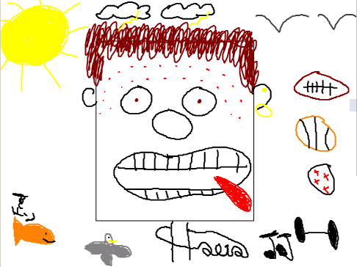

Draw your face here
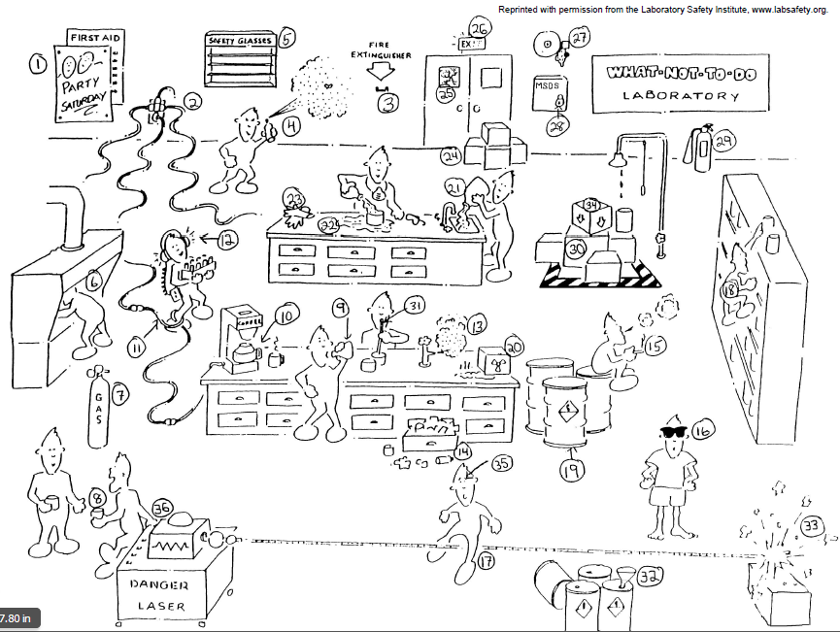
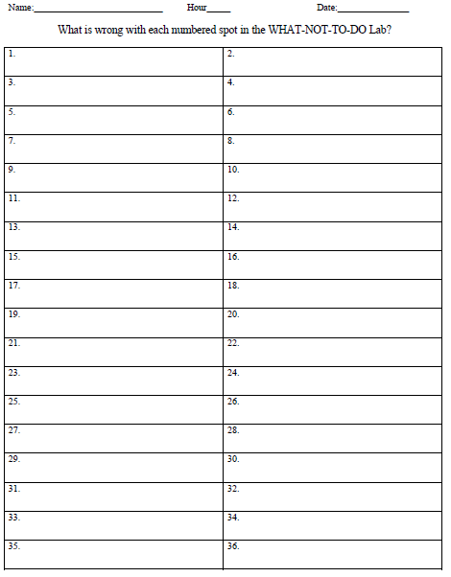
Introduction to laboratory Safety Video - Fill in the blanks as you watch the video
I. Lab is a _______________________
II. Be ________________________ for lab
Including 1.
2.
3.
4.
5.
6.

III. Act _______________________________
No __________________________________
No _____________________________ or _______________________________
Actions should be ___________________________ and _____________________________

IV. _____________________________ lab instructions
If unsure what to do _____________________________________________
Never 1. _____________________________________
2. _____________________________________
3. _____________________________________

V. Important ___________________ equipment
Personal Equipment Classroom Equipment
1. 1.
2. 2.
3. 3.
4.
How long should you wash your eyes with the eyewash station ______
With fire extinguisher remember pass
P ________ A________ S________ S________
In all emergency situations you should ___________________________________________

VI. Handle substances _____________________________________
Always read labels _________________________________
Describe the correct way to smell a chemical _____________________________________
Acids and Bases are _____________________________________
Make sure all _____________________________________ are away when using a flame or heating device
Use _____________________________________ hands when carrying chemicals
Never dispose of any materials without _____________________________________
Handle _________________________ and _____________________ ______________________
Always ne alert for __________________________ if you see some ____________________________

VII. Use _____________________________________ carefully
Steps to lighting a Bunsen burner
1.
2.
3.
4.
How do you know you have a good flame?
1.
2.
When heating a test tube, make sure the mouth is _____________________________________
Hot and cold glassware _____________________________________

VIII. A __________________________________ class is a _________________________________ class

