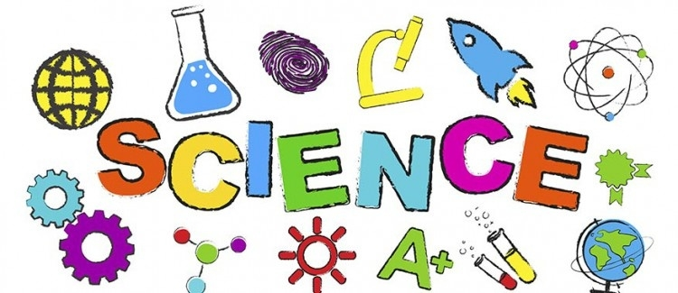
7th Grade – General Science Mrs.Bidelspach – Room C303
Shamokin Area School District 2020-2021
Rbidelspach@indians.k12.pa.us

Course Description:
General Science 7 is a full-year course designed to introduce students to the structure and function of organisms and how those organisms interact with the environment. The course will include studies on the following topics: Cells, Cell Processes and Energy, Genetics, Modern Genetics, Classification, Evolution, Human Biology, Populations and Communities, Ecosystems and Biomes, and Living Resources.

Required Materials:
- Pen or Pencil
- Chromebook, Tablet, or Laptop
- Folder (for in class students)

Assignments and Homework:
All assignments and homework will be posted daily in Google Classroom. Assignments are due according to the directions for each assignment. We will be going as paperless as possible in the classroom. However, in-class students will need a folder to keep class outlines organized. Cyber students may be taking notes on paper from home as directed in Google Classroom.

Google Classroom Procedures:
All students will log in to Google classroom and complete the daily Bell Ringer and return it back to me. Completing the Bell Ringer will be used as a “sign-in” for class for students at home. Cyber students should complete that day’s assignments in the order that they are posted. In-class students will wait for further instruction after the Bell Ringer has been completed.

Synchronous and Asynchronous Learning for Cyber Students:
Students working from home have the option to complete their assignments during their assigned class period (synchronously) and may log-in to Google Meet. Or they may complete the assignments on their own time, but on the same school day (asynchronously). Assignments are still due on dates as directed in Google Classroom whether working synchronously or asynchronously.
Using Google Meet:
Turn off your video and audio when logging into Google Meet. If you are logging in live during your assigned class period please read my messages in the chat. It may take a few minutes to meet with you because of the need to sanitize desks and be in the hall during the passing of classes. Please be patient. If you do not have any questions you do not need to log-in to Google Meet.

Grading:
Final grades will be calculated from scores earned on tests, quizzes, classwork, and completed Bell Ringers. I will return assignments in Google Classroom. Some will have grades and comments and others will just be returned as confirmation that I received your assignment. Please do not use Google Classroom to determine your overall grade. To see current grades, progress and report card grades please log into your student or parent portal.

Mask or Face Covering Policy:
Face coverings must be worn at all times in the classroom regardless if we are able to social distance or not. There will be a designated “mask relief area” in the back of the room if and when a student needs a break from wearing his/her mask. Students will not be dismissed at the close of class until they are wearing their masks.

Cell Phone Policy:
Cell phones are not permitted to be used during class. Cell phones are not an approved device for Google Classroom. This is school policy. Phones must be off and out of sight.

