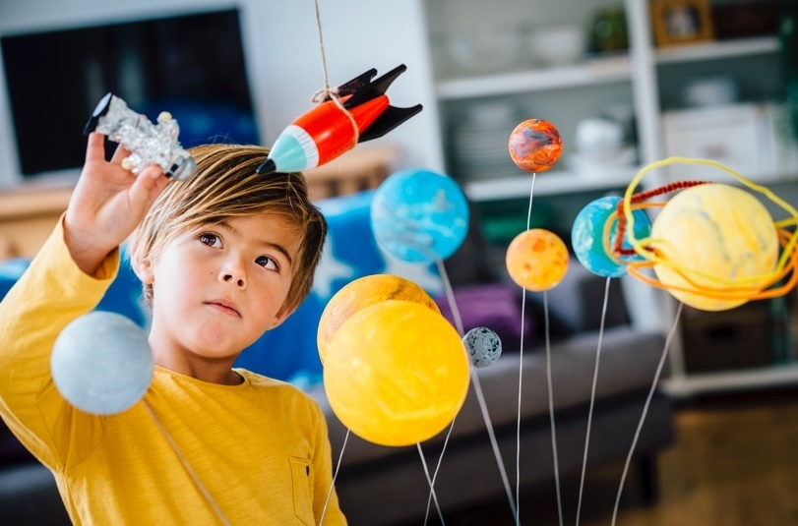

Calling All Scientists!

Join Us for the DPS Science Fair!
Date: Thursday, March 23rd
Time: 5:30 PM
Location: Danville Primary School

SCIENCE FAIR PROJECT IDEAS
 | Experiments  How does it work?  How is it made?  What happens when I…?  Chemistry, Physics, Engineering, Electronics & more! |  | Research Reports  Health & Nutrition  Favorite Animals  Exciting Places  Astronomy, Biology, Zoology & more! |  | Collections  Insects  Plants  Gems & Coins  Earth Stones  Earth Science, Life Science & more! | 

Trifold boards will be provided for all scientists by the Danville Primary Home in School Association.

Participant Timeline:
Return Registration Form to Homeroom Teacher: February 23rd.
Trifold Board Sent Home with Student Scientists: Week of March 6th.
Science Fair Set Up: 4:30-5:30 on March 23rd, Bring all project materials anytime during this hour.
Science Fair Presentations: 5:30 on March 23rd.
________________________________________________________________________________________________
Registration Form
Student’s Name: _______________________________
Grade: ________________________________________ Homeroom Teacher: __________________________

I, ______________________ (parent/guardian), grant permission for my student to participate in the Danville Primary School Science Fair on Thursday, March 23rd.

