Grade Level/Subject/Topic: Fifth Grade/Science Oceans

Created by: Samantha Sigmon
Campbell Court Elementary

Standards Addressed:
SOL 5.6
The student will investigate and understand characteristics of the ocean environment. Key concepts include
- geological characteristics (continental shelf, slope, rise);
- physical characteristics (depth, salinity, major currents); and
- biological characteristics (ecosystems).

Pre-Assessment:
Pretest on Interactive Achievement

Defining the Learning Goals: What the student will:

Know (Facts/Vocabulary):
Continental shelf depth coral reef
Continental slope salinity food chains
Continental rise temperature human impact on ocean environment
Abyssal plain animal and plant life
Trench salt marsh

Understand (Big Ideas):
- An ocean’s composition (salinity, density, temperature, etc.) varies depending on the geographic location, which has implications for the ecosystem (salt marsh, estuaries, and coral reefs).
- Natural and human forces can cause changes in ocean environments.

Do (Specific Skills student is able to do after the lesson):
- Explain key terminology related to the ocean environment.
- Draw a picture of the ocean floor and label and describe each of the major features.
- Describe the variation in depths associated with ocean features, including the continental shelf, slope, rise, the abyssal plain, and ocean trenches.

Materials/Supplies:
Oceans Menu
Appropriate copies
“The Mighty Ocean” book or any book about oceans

Procedures/Activities

***This lesson is designed to review concepts learned during the oceans unit. All material has been covered previous to this lesson. They have been pre-assessed at the beginning of the unit.

Day 1: Students will complete oceans MENU.

Day 2: Finish Menu activities and review for test using CPS system.

Day 3: Students will complete post assessment on Interactive Achievement.

(If) Differentiated Instruction:
What? content process product

How? readiness interest learning profile

Why (What prompted you to differentiate in this way)?

Anchor Activities:
Labeling the Ocean Floor on the Smartboard
Oceans sort
AR books

Post-Assessment:
Interactive Achievement

Closure:
Review what has been learned using the CPS system.

Teacher Reflection:
(What went well? What would you do differently? Why?)

Exploring Oceans Menu

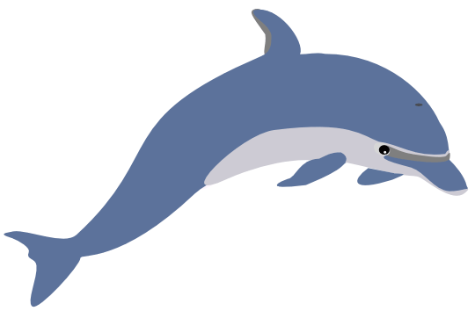

Main Dish—All students must draw and label the ocean floor on the drawing paper provided and write a brief statement explaining each part.

Side Dishes—You must choose 2 of the following assignments.
- Draw a picture of a specific part of the ocean and the animals that would be in that part. Label it and explain that part, including the temperature, density, salinity, depth and animal and plant life.
- Draw a Venn diagram to compare and contrast 2 different parts of the ocean. Make sure to list at least 4 similarities and differences.
- Draw a Venn diagram comparing and contrasting a salt marsh to the coral reef. You must list at least 4 similarities and differences.
- Draw an ocean food chain and explain each step in words by writing a paragraph below the drawing.
- Read “The Mighty Ocean” and complete the study page.

Dessert—You must choose at least 1 of these assignments.
- Make a poster showing the negative impacts that humans have on the ocean environment and explain how we can keep our oceans clean.
- Choose a book on ocean animals and write a book report on the information you discover.
- Create a matching game to help study the parts of the ocean floor. (Use index cards provided.)

Name______________________________________

Title of Book_______________________________________________________

Author____________________________________

List 5 things you learned from reading this book.

1.______________________________________________________________________

2.______________________________________________________________________

3.______________________________________________________________________

4.______________________________________________________________________

5.______________________________________________________________________

What was your favorite thing about the book?___________________________________

________________________________________________________________________

________________________________________________________________________

What is something that could have made the book more interesting?_________________

________________________________________________________________________

________________________________________________________________________

Ocean Food Chains

Directions: Draw an ocean food chain and explain on the lines below.

______________________________________________________

______________________________________________________

______________________________________________________

______________________________________________________

______________________________________________________

______________________________________________________

______________________________________________________

Dive into the ocean!

Directions: Draw a part of the ocean below and explain the temperature, density, salinity, depth, and animal and plant life on the lines below.

______________________________________________________

______________________________________________________

______________________________________________________

______________________________________________________

______________________________________________________

______________________________________________________

______________________________________________________

Compare and Contrast
Salt Marsh vs. Coral Reef

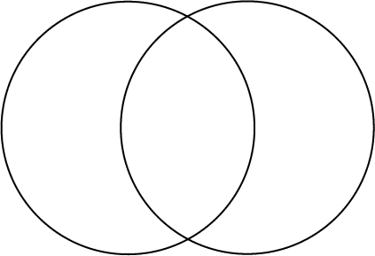

Compare and Contrast
Two parts of the Ocean

