AP Environmental Science
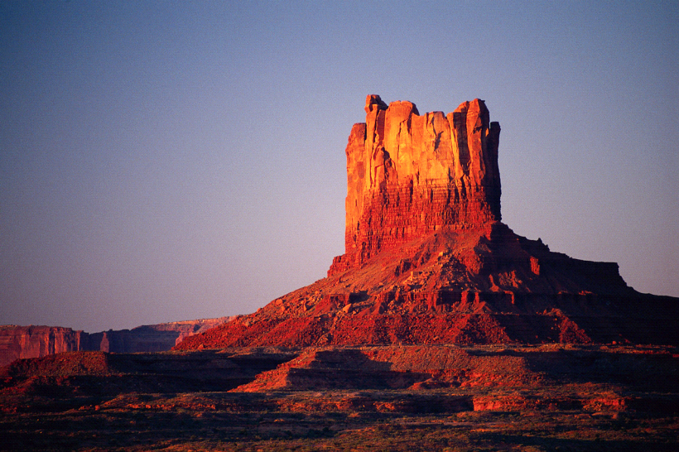
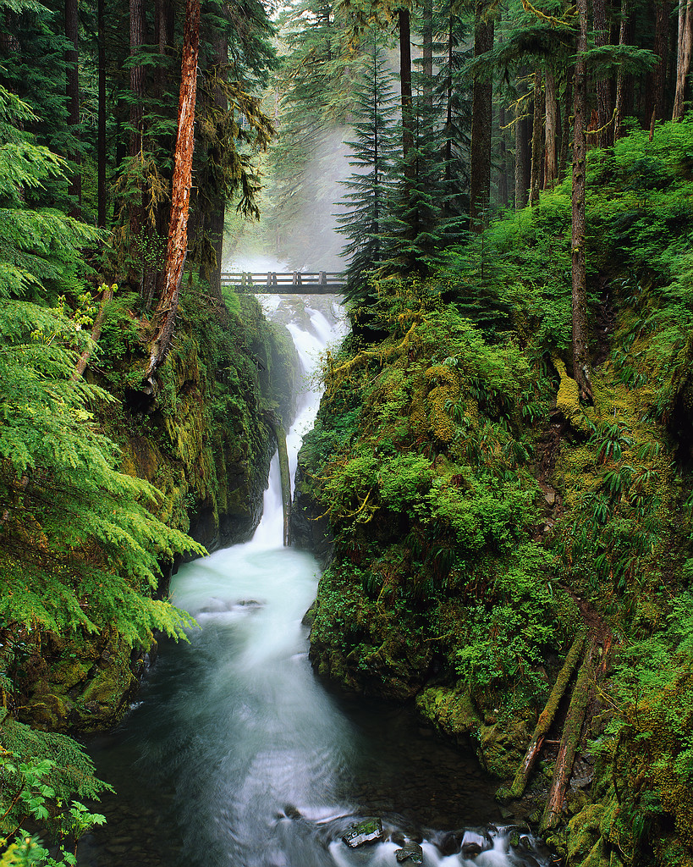
National Park Project

Objective:
Design a booklet or power point about your National Park.

Procedure:
1. Go to www.np s.gov
2. Click on visit your parks
3. Select your park to find information

Requirements:

1. A map of the park. Include hiking trails and facilities found in the park, campgrounds, hotels, stores and other facilities. 5 points

2. How would I get there from Owenton, KY. 5 points

3. Detailed descriptions of the biomes found in the park. Include pictures 15 points

4. Explain ecological balances within the park. Look at the food chains, limiting factors, ranges of tolerance and succession. 10 points

5. What should a visitor expect to see in terms of biotic and abiotic factors?
What species of animals and plants live in the park and what is the geology of the park?
What endangered species live in the park that are protected and what is the NPS doing for these species?
Include any other interesting information on the organisms or geology on the park.
Include pictures 25 points

6. Include a chart showing high temperatures and low temperatures for each month and precipitation for each month. 5 points

7. Include a history of the park; both geological and human history. 10 points

8. If a person had only 2 days to spend in the park, what should they do?
If a person had a week to spend in the park, what should they do? 20 points

9. Contact the park and interview a ranger. What do they do in a typical week? 5 points

THIS PROJECT SHOULD BE NEAT AND CREATIVE!
