Earth Science Laboratory Performance Test

-A portion of your regents grade will be based on Part D of the performance test which is to be administered in class on the date provided by your teacher.

-The Laboratory Performance Test will be broken up into 3 different stations. You will be allotted 9 minutes to complete each station.

While we cannot review what is exactly is on the Performance test you are allowed to know what is on it and practice “parallel tasks”.

Disclaimer: The SED memo of 9/14/2007 states:
"Students should be familiar with the content, concepts, and process skills assessed on the performance tasks and should have performed similar tasks during the normal course of instruction. However, practice of any of the individual stations before this performance component is administered is strictly prohibited".

Station 1 – Mineral and Rock Identification

Mineral Identification
You will need to know how to identify the characteristics of different minerals

Luster – Metallic or Nonmetallic
(Metallic looks like metal, nonmetallic does not.)

Cleavage or Fracture
Cleavage breaks in flat plains. Fracture breaks irregularly or roughly.

Streak – Color or Colorless/White

Hardness – Hard or Soft
Is it able to scratch glass? (Make sure you rub the area to be sure it’s a scratch and not just a streak)

Rock Identification
You will need to know how to identify the three different types of rocks using one or more of the following characteristics

Igneous Characteristics | Sedimentary Characteristics | Metamorphic Characteristics
Intergrown Crystals/Grains  Glassy Texture  Vesicular-(Air Pockets) | Mixed Sediments/Grains  Layering  Fossils | Foliation -(Wavy Layers)  Banding-(Different Colored Layers)

Station 2 – Locating an Epicenter

To find the epicenter of an earthquake, you will need to use data from three different stations.

You need to know how to use a seismograph to find the difference between P and S wave arrival times and use those times to draw a circle of the distance from the epicenter.

Using the P-wave and S-wave chart and a piece of scrap paper you will find out how far a Station is from the Epicenter.

- Find the time difference from the arrival of the P-wave and S-wave
- Line up a piece of scrap paper with the Y-axis of the graph and make two ticks at the time difference you calculated
- Move the scrap paper until the two ticks match up with how far apart the P-wave and S-wave lines are.
- Follow the line down to find the distance from the epicenter (10^3=1000km)
- Draw a circle from the distance from the Station using your Compass.
- Where the three circles meet is where the Epicenter is located.

Move compass apart as far as the distance given.
1 2 3 4 5 6
0

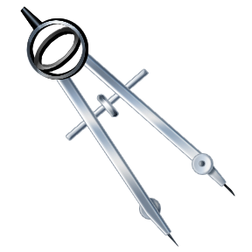

Remember to carefully subtract the times. (THERE ARE 60 SECONDS IN A MINUTE NOT 100!!)

Station 3 Constructing and Analyzing an Asteroids Elliptical Orbit

Just like in the ellipse lab in class you will have to construct an ellipse using two tacks and a loop of string to construct an ellipse.

Be sure to hold down the tacks securely as you carefully pull the string tight and draw an ellipse with your pencil.

You will need to measure the distance between the foci (tack holes) and the length of the Major Axis (the entire length of the orbit) and plug the values into the formula:

Eccentricity=Distance between the foci
Length of the major axis

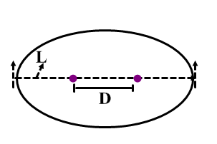
Remember: THE ANSWER HAS TO BE A DECIMAL!!! (between 0-1)

Remember 0 – Less Eccentric
1 – More Eccentric

