FYI
Some great info here…☺

From: Scientific Principals [mailto:pleasedonotreply2@minime.nsta.mmsend.com] On Behalf Of Scientific Principals
Sent: Wednesday, February 16, 2011 11:36 AM
To: shaynes@perry.k12.ny.us
Subject: February 2011: Reading and Writing in Science

If you are unable to view this version, please click here to view the online version.
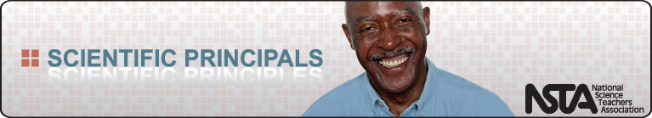
NSTA Home I Member Benefits I Conferences I Member Journals I Science Store I Learning Center
Sponsored by:    February 2011: Reading and Writing in Science  With so much emphasis on reading and writing skills, it can prove difficult to fit science into the curriculum; however, we've found lots of great ways to combine the two and create a rewarding experience for students. Read below for time-saving ideas that will inspire you to make science a pivotal part of your elementary school.  Enhance Your Content Knowledge—How Is Reading Science Books Different from Reading Other Kinds of Books? Science reading can be a slow process, as compared to other types of reading. You read science texts to understand specific concepts, and just about every word can be significant for understanding the concept at hand. This article includes research findings and strategies for incorporating this type of reading into your plans.  Get Parents Involved—Would you like to recommend books to parents, but need some help? The yearly list of Outstanding Science Trade Books is available online and offers families the opportunity to solve mysteries, face manatees, and hike dinosaur mountain! Have some Spanish speakers in your school? We have the perfect list for you: Libros de Ciencias en Español.  What Does Good Science Look Like?—Teachers are pressured to teach more and more content and meet higher and higher standards, and writing in the content areas can provide an authentic way to teach writing skills. This Editor's Note from a past field editor of Science and Children focuses on incorporating writing into the science curriculum.  Teaching Through Trade Books—Discover Reading: We often gloss over the history of science—forgetting to highlight the women and men who have advanced scientific discovery. These notable individuals are the backbone of our field, and this article honors them by encouraging children to read about their stories and make their own discoveries.  Websites We've Vetted: Click the following keywords for links to websites full of information on this month's theme. NSTA's team of webwatchers has tried them all: Reading and Writing in Science and Writing for Science.  Favorites, Finds, and Freebies—Elementary Science and Writing Tips: Children's author and science aficionado Lisa Westberg Peters has compiled an array of resources that encourage K–5 students to create and explore connections between science and writing. Visitors can listen to Peters read her geology-inspired poems, access a bibliography of science and nature poetry books for kids, and find classroom activities.  Coming next month... Forensic Science
  Sponsored by:
  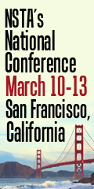
  
  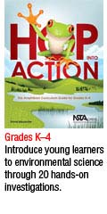
  
  Would you like to send Scientific Principals to a colleague? If so, please click here to sign up.
  Please tell us what you think of this newsletter. Click here to send us your feedback.
Forward this message to a colleague
Scientific Principals is a monthly e-mail newsletter for elementary school principals. Based on typical themes found in elementary science curricula, each issue of Scientific Principals offers a science toolbox full of new ideas and practical applications.
This e-newsletter is brought to you by the National Science Teachers Association
1840 Wilson Boulevard • Arlington, VA 22201-3000 • Phone: 703-243-7100
http://www.nsta.org
If you do not want to receive this e-newsletter, please follow this link:
http://ecommerce.nsta.org/optout/default.asp?source=principals

