Excited about science
Created on Thursday, 06 February 2014 00:00 | Written by Kate Hoots |

Students at Rosemont Ridge Middle School kick off science fair season

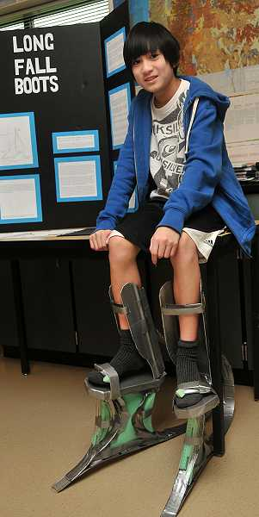
by: TIDINGS PHOTO: VERN UYETAKE - Ben Chan demonstrates the long fall boots he designed to protect workers from large falls.
Science fair season is in full swing in the West Linn-Wilsonville School District. While students from primary schools are just starting their projects, students at the high school level already are busy collecting and analyzing data.
Students at Rosemont Ridge Middle School are leading the way. Their school’s science expo was held Jan. 15 at the school. Participants from the seventh and eighth grades spent the first semester taking a science extension class as their elective. All sixth-graders created science projects as part of their science curriculum this year.
“We believe it’s good for kids. Kids benefit from the whole process of science, from taking a project and following through,” sixth-grade science teacher Jen Owens said. “We’re having all sixth-grade kids do it. They’re just building their science skills.”
Steve Davala, a seventh-grade science teacher, was teaching two science extension classes with 30 seventh- and eighth-graders in each.
“We’re excited, all these things coming together,” Davala said, “because we love science.”
Rosemont’s science expo followed International Science and Engineering Fair (ISEF) rules, including interviews with students and formal judging.
“It’s part of the communication piece, communicating science,” Owens said.
This year’s event marks the first time the school has held a science fair during the school day.
“In the past, seventh grade has done evening events. This is the first time a day has been focused entirely on science and engineering,” eighth-grade science teacher Jessamyn Van Hook said.
The students in Theresa Ellis’ eighth-grade science classroom were entirely focused on science and engineering during the science fair. The classroom was buzzing and students took turns explaining their projects to one another as well as to the adults serving as science fair judges.
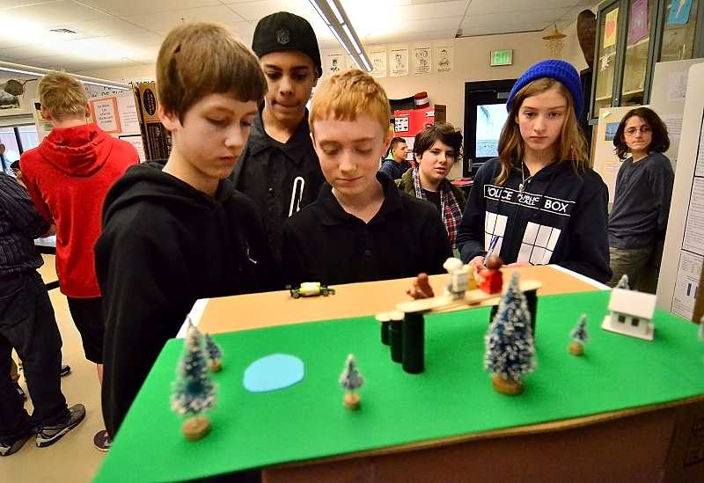
by: TIDINGS PHOTO: VERN UYETAKE - Ian Walsh, center, shows fellow Rosemont students how his magnetic car works. From left are Nic Nemec, David Gravely and Alexis Mooney.
One of those students, Ian Walsh, designed a project around the theory behind magnetic cars. He had designed a short section of road from cardboard and used magnets under the “roadway” to power a toy car. Using magnets to power cars is more green, he said, and could be faster too. The cost of the magnets is the major obstacle to implementation, he said.
“If you can’t get past cost, there’s really no high potential,” Ian said.
Other projects focused on more practical matters. Saralun Ondee created a study around people’s eating habits and how learning about vegetarianism might influence their habits. Her hypothesis was that most people would change their habits after receiving information about the benefits of a vegetarian diet. That hypothesis proved true, as most of her subjects reported being willing to eat less meat after participating in the experiment.
Although Saralun said she was interested in learning new things, this was her first time participating in a science fair. Now, she is interested in designing a project when she is a freshman for the Intel ISEF held each year at the high school.
“It made me want to do other things that relate to health and research,” she said.
The eighth-graders’ projects ran the gamut of interests, investigating personal concerns as well as more general topics.
Nathalia Colbert, for example, studied the effect of straightening hair with an iron. For her experiment, she applied a straightening iron one or more times a day to samples of human hair. Damage was visible on many of the samples.
“I learned it’s harmful and flattens follicles and weakens hair,” she said. “I’m going to start using heat protection.”
Alyssa Betts studied the effectiveness of various substances at blocking ultraviolet rays. Her project involved growing yeast under various screens, including vitamin E, olive oil, zinc oxide and commercial sunscreens.
“I haven’t been able to get conclusions yet,” Alyssa said. “It looks like I used the wrong kind of UV light.”
Far from being discouraged by the wrong turn she had taken, Alyssa was excited to move ahead.
“I will try again,” she said. “I’m going to get a different kind of light, to hopefully kill yeast cells correctly.”
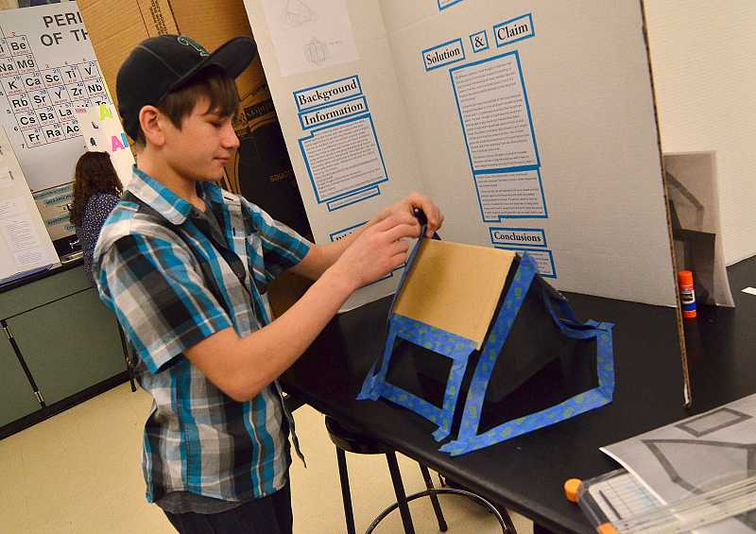
by: TIDINGS PHOTO: VERN UYETAKE - Kevin Bodi puts the finishing touches on his hurricane net display.
That’s just the kind of inquiry the science expo’s organizers were hoping to inspire.
“It’s helping kids get excited about science,” Davala said.
Judges like Barbara Porche, a Rosemont parent, were impressed by what they saw at the expo.
“I don’t remember this thorough of projects when I was growing up,” she said.

