
Name ____________________Period__________ Lab Group #________
From Fusion to the Beach: Convection Current Lab

Purpose: To measure and observe the motion of energy through materials

Materials: Lab sheet, ringstand, ring and mesh netting, beaker, heating pad, dye crystals, stop watch, 3 thermometers, 2 test tube holders, 1 beaker thermometer clip.

Role Assignments:
Project Manager-
Begin experiment per the procedure. Responsible for lab completion and Excel spreadsheet and graph.
Physical Scientist-
Record observations for lab. Responsible for completed lab sheet.
Astrophysicist-
Measure time duration. Responsible for careful measurements.
Engineer-
Operate the lab. Responsible for lab safety and correct performance of lab.

Procedures:
- Set up your ring stand and burner as demonstrated in class and the picture below.
- Fill a large beaker with water and let stand so all turbulence is dissipated (the water settles down and stops moving).
- Use the test tube holder to attach a thermometer between the heating pad and the bottom of the beaker. Call this thermometer 1.
- Attach another thermometer (#2) inside the water (about half way) using the beaker-thermometer clip.
- Use a test tube holder to attach another thermometer (#3) above the beaker. After one minute, record the temperature of each thermometer.
- Drop several (2-4) dye crystals near the edge of the beaker.
- Turn on the heating pad.
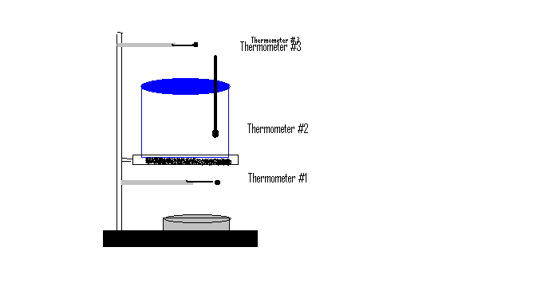
Describe the appearance and behavior of the dye below.
Draw arrows showing dye movement.
- Get your stopwatch ready. Start the watch and apply the heating pad slightly under the dye crystals. Observe how the crystals dissolve and move.

- Every MINUTE, record the temperature of each thermometer in the chart.

Minute | Temperature #1 | Temperature #2 | Temperature #3
Start Temp.
1
2
3
4
5
6
7
8

Analysis:
- Create an Excel lab spreadsheet and line chart of your data.
- Which thermometer (1, 2, or 3) had the greatest change in temperature? Explain how you know this is the biggest change.
- Which thermometer got the hottest?
- Which thermometer stabilized after a few minutes (started changing less)?
- Which thermometer changed the least over time?

Conclusions:
- Relate the set-up of the lab to the structure of the sun (from core to corona). Write a sentence about each section of the lab set up and the layer of the sun that it represents. Which area gets the hottest? Why? How does convection help get energy out of the sun and toward Earth?
- Explain how energy moves from the core of the star to the surface and into the atmosphere.

