Information for Applicants to the
National Youth Science Camp®

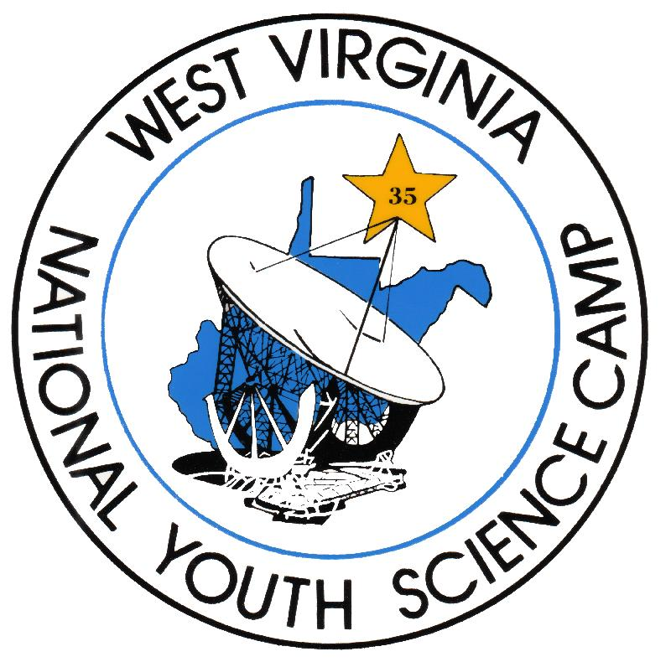
2003 National Youth Science Camp®
June 26 – July 21, 2003
Operated by the
National Youth Science Foundation®
Post Office Box 3387
Charleston, WV 25333
www.nysc.org
(304) 342-3326 Voice • (304) 342-8856 Fax
----------
Andrew N. Blackwood, Ed.D., Director
director@sciencecamp.org

Answers to Frequently Asked Questions
What is the National Youth Science Camp®?
The National Youth Science Camp® (NYSC®) is one of the nation's premier programs in secondary science education. Since its inception in 1963 as part of West Virginia's Centennial Celebration, the four-week summer program has offered educational forums and recreational activities that encourage the development of thoughtful scientific leadership.

How are the delegates selected?
Two students are chosen to represent each state as delegates to the National Youth Science Camp®. Delegates are graduating high school seniors who have demonstrated exceptional academic achievement, leadership in school and community activities, and a genuine interest in the sciences. The governor of each state appoints a selection coordinator who initiates a competitive process to choose two delegates and two alternates.

Who are the state selection coordinators?
State selection coordinators are usually appointed in December with most state selection deadlines in late-February. Contact the National Youth Science Camp® to identify the selection coordinator for your state.

How much does it cost to attend?
Delegates attend the National Youth Science Camp® at no expense, transportation included. This has been true throughout the history of the camp so that delegates can attend regardless of their financial status.

What are the goals of the NYSC®?
The National Youth Science Camp® honors, rewards, and encourages excellence in science. It creates an environment where young scientists of diverse backgrounds and interests may reap maximum benefits from interaction with one another and with visiting scientists. It strives to broaden horizons, to inspire confidence and creativity, and to encourage a sense of thoughtful scientific leadership among future scientists, engineers, mathematicians, and health care professionals.

How does the NYSC® accomplish its goals?
The National Youth Science Camp® offers hands-on small-group learning experiences, a provocative lecture series, and a challenging outdoor program. The hands-on experiences and lectures expose delegates to current work across the spectrum of scientific disciplines. Visiting scientists are invited based on their reputation as leaders in their fields and on their ability to share up-to-date research with the delegates. The atmosphere at the NYSC® is engaging and supportive. Guests, staff, and delegates have time to relax and discuss ideas over meals or while on the hiking trail. Recent guest speakers at the NYSC® include Dr. Francis Collins, Director of the National Human Genome Project, Dr. Ken Ono of the University of Wisconsin-Madison, Dr. "Zoon" Nguyen of Northern Minnesota Radiation Oncology, and Dr. Margaret Lowman of the Selby Botanical Gardens.

Where is it held?
The National Youth Science Camp® is held at a rustic camp near Bartow in the eastern mountains of West Virginia's Potomac Highlands, close to the National Radio Astronomy Observatory at Green Bank and within the unique wilderness areas of the Monongahela National Forest. Because of the camp's location, delegates have the opportunity to visit the National Radio Astronomy Observatory’s new Green Bank Telescope as well as such West Virginia landmarks as the Spruce Knob-Seneca Rocks National Recreation Area, the Dolly Sods Wilderness Area, and several other destinations.
What happens on a typical program day at the NYSC®?
A typical day begins with a morning lecture from a guest scientist. After this, some groups of students leave to go on outdoor trips while the rest break up into small groups for their hands-on, small group directed studies facilitated by guest scientists or NYSC® staff members. The afternoon is reserved for free-time activities such as optional seminars, athletic and recreational activities, art, and music. All NYSC® program areas are open--Natural Sciences, Physical Sciences, Applied Arts, Music, and the computer lab. While free time seminar topics can be scientific, they often depart from science and encompass the personal interests of delegates, staff, and guests. All activities challenge delegates to approach problems with creativity or to try something new. Activities range from fishing to philosophy, ballroom dancing to biological technologies. The atmosphere is purposefully informal. An evening science lecture follows dinner.

Answers to Frequently Asked Questions

What is the NYSC® Outdoor program?
To reinforce and encourage well-rounded development, a fun and challenging outdoor program supplements the NYSC®’s scientific program. Three times during camp, all delegates go on overnight outdoor trips, which may include backpacking, rock climbing, caving, kayaking, mountain biking, or science field experiences. Many of these activities are also offered on "day trips", making it possible for most delegates to try several different offerings.
Why do delegates travel to Washington DC?
Because the National Youth Science Camp® is only five hours from the nation's capital, delegates are able to take advantage of the area's extensive scientific and cultural offerings during a three-day trip. Each year, Senator Robert C. Byrd of West Virginia honors the delegates with a luncheon to which he invites his Senate colleagues. Recent keynote speakers include Dan Goldin, administrator of NASA and Bill Richardson, Secretary of the Energy. The National Zoo, The National Institutes of Health, The Smithsonian Institution National Zoological Parks Conservation and Research Center, the National Academy of Science, and NASA/Goddard Space Flight Center all have provided special tours and speakers for the NYSC® delegates. Delegates also may spend some time in the capital's many museums, historic buildings, and monuments during the trip.

Who should apply to the NYSC®?
Eligible applicants:
- Must be candidates for high school graduation in the spring of 2003;
- Must be available to participate in the entire NYSC® program (June 26 to July 21, 2003);
- Should intend to pursue a profession oriented toward science, mathematics, engineering, or medicine;
- Must demonstrate superior academic proficiency, including recognition in mathematics and/or the sciences;
- Must demonstrate an application of leadership abilities and social maturity through involvement in both school and community activities;
- Must demonstrate skills and achievements outside the realm of science and outside the realm of academic pursuits; and
- Must demonstrate a curiosity and an eagerness to explore many and varied topics.

How can I find out more about the NYSC®?
For more information and some color images of the National Youth Science Camp®, see the NYSC® web page at www.nysc.org, or contact the Director, Andrew N. Blackwood, Ed.D., at director@sciencecamp.org.
How is the NYSC® funded?
The NYSC® was totally supported by the State of West Virginia from its first session in 1963 through its twentieth session in 1982, and is now funded through contributions to the National Youth Science Foundation®, Inc., a 501(c) (3) foundation registered with the Internal Revenue Service. While a generous portion of the funding still comes from the State, support increases each year from the private and corporate sectors. Along with numerous individual contributors, including NYSF® Trustees and NYSC® alumni, other contributors in recent years include: Allegheny Energy, American Electric Power*, Ashland Foundation, Carpenter Foundation, The Charleston Gazette, Daywood Foundation, ECA Foundation*, Dickinson Properties Limited Partnership, Dow Chemical Company Foundation, DuPont Corporation, ECA Foundation, Entrust Inc., Federated Coal Company, Fidelity Foundation*, Guest Services Inc., Jamey Harless Foundation, Herscher Foundation, Hewlett-Packard, International Industries Inc., Jackson & Kelly LLC, Bernard H. & Blanche E. Jacobson Foundation, Charles T. & Mary Ellen Jones Fund, Lockheed Martin, McJunkin Corporation, Millipore Foundation, National Radio Astronomy Observatory, Nortel Networks, Oracle Corporation, Pfizer Foundation, Sidney Stern Memorial Trust, Struers America, and the Verizon Foundation.
The NYSC® is also made possible through in-kind contributions from many sources, including Cass Scenic Railroad, The Greenbrier, The Scottish Rite Bodies of the Valley of Charleston, Dow USA, West Virginia University Institute of Technology, West Virginia Department of Natural Resources, and West Virginia Wildwater Association.
*Indicates support for organizational development work

General Information and Instructions
National Youth Science Camp® | The National Youth Science Camp® is a four-week long program that honors and challenges the two most promising high school science students from each state. Scientists from across the nation who work on some of the most provocative topics in science today present lectures and hands-on science seminars and linger to interact informally with student delegates. Delegates are challenged to explore new areas in the biological and physical sciences, art, and music with resident staff members. They also may present seminars covering their own areas of interest and research. The delegates visit Washington D.C. to take advantage of some of the nation’s premier scientific, governmental, and cultural facilities. The four-week experience includes three overnight expeditions into the Monongahela National Forest featuring backpacking, rock-climbing, caving, mountain biking, or kayaking opportunities. Delegates are required to participate in the camp program for its entirety as the fast-paced activities in the remote location make coming and going very difficult.
Location of the Camp | The camp will be held in the Monongahela National Forest near Bartow in the eastern mountains of West Virginia.
Dates of the Camp | Delegates MUST be able to attend the entire NYSC® program. They will arrive in Charleston, West Virginia, on Thursday, June 26, 2003, and will depart on Monday, July 21, 2003.
Cost | The National Youth Science Foundation® funds the National Youth Science Camp®. It is offered at NO COST to its participants, so that selected delegates may attend regardless of their financial status. Educational and recreational programming, as well as meals, lodging, and round-trip air passage on scheduled airlines are provided free of charge to the delegates.
Eligible Applicants | - Must be candidates for high school graduation in the spring of 2003;  - Should intend to pursue a profession oriented toward science, mathematics, engineering, or medicine;  - Must demonstrate superior academic proficiency, including recognition in mathematics and/or the sciences;  - Must demonstrate an application of leadership abilities and social maturity through involvement in both school and community activities;  - Must demonstrate skills and achievements outside the realm of science and outside the realm of academic pursuits; and  - Must demonstrate a curiosity and an eagerness to explore many and varied topics.
Application Criteria | A complete application consists of an original and one copy of the following:  - Delegate Application Cover Sheet (please print or type),  - A letter detailing your qualifications and reasons for applying (must be typed),  - A resume,  - A recent academic transcript (including standardized test scores when possible), and  - A signed letter of support from a teacher or research mentor.
Submission Instructions | - Staple items 1 - 5, described above, together with one staple in the upper left corner. Do not otherwise bind your application nor place it in a folder.  - Mail your complete application to your state selection coordinator using United States Postal Service first class mail so that it is received no later than February 28, 2003. The mailing address for your state’s selection coordinator can be found online at www.nysc.org.
Questions | For answers to questions about the application and delegate selection process, please contact your state’s selection coordinator. For answers to questions about the NYSC®, please contact the camp’s director, Andrew N. Blackwood, Ed.D., at director@sciencecamp.org.

Delegate Application Cover Sheet

Print or Type

Name:
 | Last | First | Middle
Gender: | Male Female
Street Address:
City, State Zip:
Home Telephone:
E-mail Address:
Parents’/Legal Guardians’
Full Names:
School Name:
School Address:
City, State Zip:
School Telephone:
Principal’s Signature of Support:
Applicant Certification: | I certify by signature below, that I am in the 12th grade, and to the best of my knowledge and belief, all of the information on and attached to this application is true, correct, complete and made in good faith. If selected, I will be available to participate during the entire period of the National Youth Science Camp®, from June 26 through July 21, 2003.
Applicant’s Signature:
Date Signed:

