PHYSICAL SCIENCE: CHEMISTRY REVIEW

OBJECTIVE: Student will describes the basic structure of the atom as protons, neutrons, and electrons in specific arrangements. Describes the fundamental parts of the atom. Protons Neutrons Electrons
Atomic Theory Models: John Dalton (Chemical elements are made up of atoms. The atoms of an element are identical in their masses, found to be false after isotopes were discovered. Atoms of different elements have different masses. Atoms only combine in small, whole number ratios such as 1:1,1:2,2:3 etc.
JJ Thomson (Plum pudding model, with protons and imbedded electrons.)
Ernest Rutherford (Gold foil experiment. The atom is mainly empty space with a dense positively charged center.)
Neil Bohr (Shows how electrons are arranged in energy levels.)
Electron Cloud Model (Probability Model) Like a fan spinning so fast you cannot see the blades turning.

SUBATOMIC PARTICLES
Nucleus is the center of the atom, contains 99.9% of the mass of the atom, holds neutrons and protons
- Proton, p+: has a positive charge, all are identical, no matter which element, mass is one amu, the number of protons determines which element you have
- Neutron, n°: has a neutral (no charge), all are identical, regardless of the element, mass is one amu, the number of neutrons of an element can be determined by: Atomic Mass – Atomic Number
Electron Cloud is the area surrounding the nucleus, mostly empty space, holds the electron
- Electron, e-: has a negative charge, the mass is 1/1840 amu, in a neutral atom, the number of electrons equals the number of protons

Objective: Student will describes the basic structure of the atom as protons, neutrons, and electrons in specific arrangements. Describes the fundamental parts of the atom.

ATOMIC NUMBER, Z: Equals the number of Protons, determines the identity of the element, if you change the number of protons, you change the element
MASS NUMBER, A: The number of protons and neutrons combined, different for each isotope of an element
ATOMIC MASS: All masses of the isotopes of the element averaged together. It is never a whole number.

THE FIRST TWENTY ELEMENTS (Information obtained from Periodic Table)

Atomic # Name Symbol Mass # Atomic mass Period Group Valence e- Electron Config.
1 Hydrogen H 1 1.01 1 1 1 1
2 Helium He 4 4.00 1 18 2 2
3 Lithium Li 7 6.94 2 1 1 2,1
4 Beryllium Be 9 9.01 2 2 2 2,2
5 Boron B 11 10.81 2 13 3 2,3
6 Carbon C 12 12.01 2 14 4 2,4
7 Nitrogen N 14 14.01 2 15 5 2,5
8 Oxygen O 16 16.00 2 16 6 2,6
9 Fluorine F 19 19.00 2 17 7 2,7
10 Neon Ne 20 20.18 2 18 8 2,8
11 Sodium Na 23 22.99 3 1 1 2,8,1
12 Magnesium Mg 24 24.31 3 2 2 2,8,2
13 Aluminum Al 27 26.98 3 13 3 2,8,3
14 Silicon Si 28 28.09 3 14 4 2,8,4
15 Phosphorus P 31 30.97 3 15 5 2,8,5
16 Sulfur S 32 32.07 3 16 6 2,8,6
17 Chlorine Cl 35 35.45 3 17 7 2,8,7
18 Argon Ar 40 39.95 3 18 8 2,8,8
19 Potassium K 39 39.10 4 1 1 2,8,8,1
20 Calcium Ca 40 40.08 4 2 2 2,8,8,2

The periodic table is organized by increasing atomic number and is read from left to right. Each vertical column is called a group or family. The family that starts with hydrogen and lithium is called the Alkali Metals. The next family, which starts with beryllium, is called the Alkali Earth Metals. Elements in the first two columns are reactive metals and form compounds easily. The family starting with fluorine is called the Halogens. These nonmetals are also very reactive. The last column, with the nonmetals helium, neon, argon, krypton, xenon, and radon, are called noble gases and are very UNREACTIVE.

ISOTOPES
An isotope is when you have atoms of the same element that differ in atomic mass. These atoms have the same number of protons but a different number of neutrons. Mass numbers are the way you distinguish one isotope from another. Any sample of elements in nature will contain a mixture of isotopes.

Example: CARBON carbon-12 6 protons 6 neutrons
carbon-14 6 protons 8 neutrons

Carbon-14 is not as stable an atom as carbon-12 and easily breaks down.

If an isotope has too many or two few neutrons compared to the number of protons, it is unstable and will undergo radioactive decay. These radioactive isotopes become different elements in an effort to become more stable.
Each radioactive element breaks down after a certain amount of time. This time is measured in “half-life”. The time required for one half of the substance to break down is referred to as its half-life. The half-life for a substance does not change. Some examples are carbon-14 (half-life of 5730 years) and uranium-238 (half-life of 4.5 billion years).

RADIATION
Some elements are unstable and tend to break down spontaneously. They do not have enough “binding energy” in their nuclei to hold the protons and neutrons together. These elements are said to be radioactive. Radioactivity is where rays are spontaneously produced by the nucleus of an unstable atom. It can be particles, energy, or a mixture of both. Most radioactive nuclei have too many neutrons compared to their protons.

Types of Radioactive Decay:

Alpha Particle, α: Has a +2 charge; the particle is composed of two protons and two neutrons; Is stopped by skin, tissue paper. These particles are not very energetic. The atomic number drops by two.
Example: When uranium (atomic number 92) undergoes radioactive decay, it gives off an alpha particle. The atomic number drops by two and it becomes the element, thorium, with an atomic number of 90.

Beta Particle, β: Has a –1 charge; comes from a neutron being given off – the neutron gives off a beta particle (negative) and a proton (positive); the beta particle leaves and the proton stays in the nucleus. Metal foil stops this particle.
Example: When bismuth (atomic number 83) undergoes radioactive decay, it gives off a beta particle. The atomic number increases by one and it becomes the element polonium, with an atomic number of 84.

Gamma Ray, γ: Has no mass or charge because it is energy. It is high-powered electromagnetic radiation and it is stopped by lead, concrete.

Uses of Radioactivity
- Medicine: Radiation is used as a form of therapy for cancer. X-rays and gamma rays produced by cobalt-60 or cesium-137. Radioactive elements can be used as tracers that can follow certain chemical reactions inside living organisms.
- Industry: Food may be exposed to gamma rays in an effort to kill bacteria and other parasites in the food in hopes to limit the number of food poisoning cases.
- Radiochemical Dating: Radioactive isotopes are used to measure fossils and other artifacts. While an organism is alive, it takes in isotopes. Once the organism dies, the isotopes do not enter the body anymore. Scientists can estimate how much of the radioactive isotope was present in the body to begin with and then determine how much is currently left. Carbon-14 is a common isotope measured.
- Too much radiation can be lethal. You are exposed to radiation every day by watching television, standing in the sun, and even standing in your basement. The goal is to not get exposed to too much radiation. Too much radiation can result in cancer or other diseases. This happens when the radioactive substance causes damage to your DNA and chromosomes. This in turn causes changes in your cells.
- Fuel/Electrical Source: The energy produced in nuclear reactions can be used as a fuel source. Fusion is the result of nuclei combining and giving off huge amounts of energy. This occurs in the sun. Fission is the splitting of an atom into two and releasing energy at the same time.
- Compare and contrast the processes of fission and fusion
- Describe various means of dealing with nuclear waste over time.

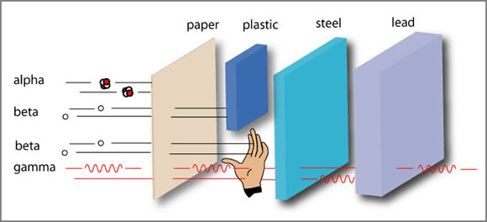

OBJECTIVE: Recognize that all matter is composed of molecules, ions, or atoms. Compare and contrast the terms, atoms, molecules, and ions and provide examples of each.

MOLECULES, IONS, AND ATOMS
Matter is made of atoms. Atoms combine to form molecules or ions. A molecule is a particle of matter that is made up of two or more atoms. A molecule is the smallest particle of a compound that still retains the property of the compound. These atoms are held together (bonded) by sharing their electrons. Molecules form covalent compounds. Water, sugar, and carbon dioxide are all formed from molecules.
Atoms also form ions. Ions are charged particles that are formed when an atom or group of atoms lose or gain electrons. A positive ion, called a cation, has lost one or more electrons. A negative ion, called an anion, has gained one or more electrons. Ions form ionic compounds. Ions dissolved in water are good conductors of electricity. They are called electrolytes. Table salt is an example of a compound that forms ions.

BONDING
Ionic bonds are very strong. The negative charged ion and the positive charged ion are attracted to each other and are brought together. This force of attraction is enough to hold them together. Compounds with strong ionic bonds have high melting points and high boiling points. These compounds are usually solids at room temperature. Metal and Nonmetal makes up an ionic compound.
Sharing electrons to create a more stable outer electron structure form covalent bonds. Atoms are more stable with their valence electrons or outer energy levels are full. The first energy level is full when it holds two electrons. The second energy level is full when it holds eight electrons. When two or more atoms bond covalently, they form a molecule. Covalent bonds are weaker bonds and have lower melting points and boiling points. They are usually gases and liquids are room temperature. Covalent compounds are made from Nonmetals and Nonmetals.

OBJECTIVE: Student will compare and contrast matter and its characteristics related to its state (solid, liquid, and gas).
Students will identify chemical or physical changes conceptually in a laboratory setting.

STATES OF MATTER
Matter can be classified into four states of matter – solids, liquids, gases, and plasma.
Solids have definite shape and definite volume. For the most part, solids can be carried around without the help of a special container. The molecules or atoms in a solid are densely pack together and vibrate back and forth in their own space. The atoms cannot change positions. Examples: rock, paper.
Liquids have no definite shape and a definite volume. They take on the shape of the container that they are in. The molecules or atoms in a liquid are packed together, but not as densely as a solid. They can slide around each other but cannot break apart. Examples: water, mercury.
Gases have no definite shape and no definite volume. They expand to take on the shape and volume of the container they are in. A gas’ molecules or atoms have more energy that a solid or liquid and they can go anywhere within their container. Examples: helium, air.
Plasma has no definite shape and no definite volume. It is composed of electrically charge particles which are usually associated with a large amount of energy. Example: sun.

PHASE CHANGES
Each of the three main states of matter can change into another state by going through a phase change. Phase changes are physical changes where the properties of the substance change, but the substance remains the same kind of matter. Substances are made to change phases by adding or taking away heat energy. There are five phase changes.
Melting solid becomes liquid absorbs heat
Vaporization (boiling) liquid becomes gas absorbs heat
Sublimation solid becomes gas absorbs heat
Freezing liquid becomes solid loses heat
Condensation gas becomes liquid loses heat
Deposition gas becomes solid loses heat

PHYSICAL PROPERTIES AND CHANGES
Matter is anything that has mass and volume. Mass and volume are physical properties. A physical property is one that can be observed without changing the substance that you are observing. Physical properties include color, hardness, crystalline shape, mass, volume, density, weight, temperature, and length.
- Mass: the amount of matter in an object; measure with a balance and the unit is grams
- Volume: the amount of space an object takes up; measure with a graduated cylinder or a metric ruler and the unit is liters (liquid, gas) or cubic centimeters (solid, gas).
- Weight: measure of the force of gravity between two objects; measure with a spring scale and the unit is Newton.
- Length: straight-line distance from point A to B; measure with a metric ruler and the unit is meters.
- Temperature: the measure of the average kinetic energy of the particles that make up the sample; measure with a thermometer and the unit is Celsius.
- Density: mass per unit of volume; measure the same way you measure mass and volume and you use the units for mass and volume (example: g/cm³)

Physical changes do not produce a new substance. They produce the same substance with new physical properties. For instance, water may change from a solid to a liquid. Its volume and density will change, but it is still water. Examples of physical changes include melting, freezing, condensation, vaporization, sublimation, cutting, breaking, mixing, and dissolving.

CHEMICAL PROPERTIES AND CHANGES
Chemical properties cannot be observed unless the substance you are observing becomes something new. The particles of one substance undergo a chemical change and become something new. Chemical properties include such properties as flammability. You cannot observe this in paper unless the paper burns. Then, it is no longer paper.
There are several evidences of chemical changes. These are:
- Formation of a new substance (solid precipitate, gas bubbles)
- The production of energy (heat or light)
- The absorption of energy
- Appearance of a new color or odor

Examples of chemical changes include combustion (burning), fermentation, metabolism, electrolysis, rusting metals, striking a match – anything that involves a chemical reaction.

MATTER

Heterogeneous Homogeneous
(parts are different) (uniform throughout)

MIXTURES: settle out upon standing; all parts are NOT identical, Not chemically combined; parts of mixture keep individual identities; parts are not in fixed amounts. Examples include chocolate chip cookie, pizza, and muddy water.
SOLUTION: will not settle out upon standing; all parts are identical; NOT chemically combined; parts are not in fixed amounts. Examples include tea, coffee, and sterling silver. Solute + Solvent
ELEMENT: simplest pure substance; cannot be broken down by heat or chemical means; all parts are identical; will not settle out upon standing. Examples include any element from the periodic table.
COMPOUND: pure substance; can be broken by heat and chemical means; all parts are identical; will NOT settle out upon standing; components are in fixed amounts; components lost their identities and take on a new one. Examples include salt (NaCl), sugar (C₆H₁₂O₆), and baking soda (NaHCO₃).

Chemical Reactions ( Know the reactants and products. Also be able to balance the equations.)
Synthesis Reaction H₂ + 0₂ → H₂0

Decomposition Reaction H₂O₂ → H₂O + O₂

Single Replacement Reaction HCl + Zn →ZnCl₂ + H₂

Double Replacement Reaction AgNO₃ + NaCl → AgCl + NaNO₃
Know the subsymbols for the (g), (l), (s),(aq)

Acids and Bases (Usually an acid begins with an H and a base ends with OH)

Litmus Paper (pink turns blue in a base) (blue turns pink in an acid)
pH (scale that assist in knowing if the material is an acid or base)

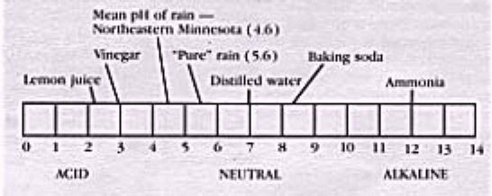

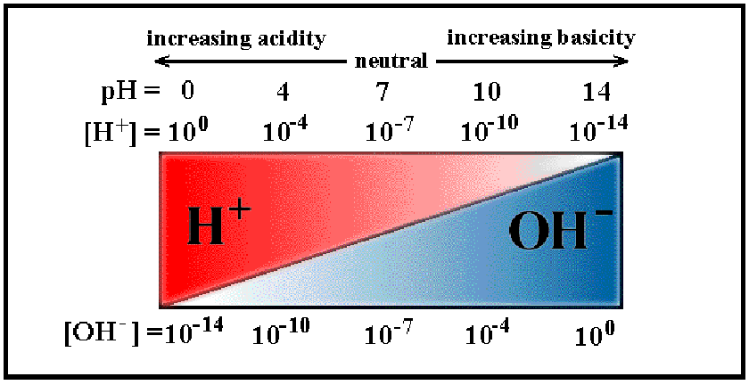
Concentration

Neutralization (Acid + Base yields a salt and water)

Electrical Conductors (electrolytes) Ionic Compounds dissolved in water, acids or bases
(Allows a light bulb to light up, intensity of bulb shows strength of electrolytes)

Solubilty Curve ( A graph that shows the amount of a compound that can dissolve in a given volume of water)

Solutions contain solutes and solvents. The solute is always the smaller of the two . To speed up the dissolving of a solution you can stir the solution, heat the solution, or change the surface area(crush it) , also the concentration affects the solution. Unsaturated solution can hold more solute, saturated solutions can not hold anymore solute and supersaturated solutions have more than normal amounts of solute at that temperature. Change the temperature and the amounts can change.

Alloys are two or more metals blended together: 24K gold = pure gold
18K gold = 18 parts gold and 6 parts silver

Polar (Like goes with Like) (Oil will not mix with water because oil is a organic compound and water is an inorganic compound)

Locate on the periodic table: alkali metals, alkaline earth metals, transition metals, halogens, noble gases, metals, nonmetals nonmetals, oxidation numbers for the family groups.

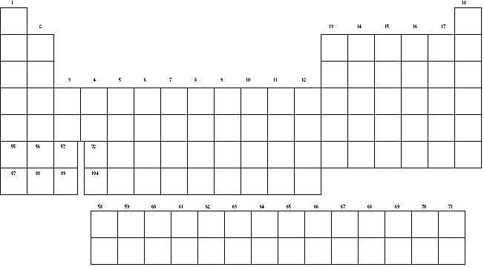

Using the above Periodic Table: Analyze the periodic trend for atomic radius. Describe what happens going left to right and top to bottom on the periodic table. Also describe what happens to density, electronegativity,
Ionization energy, melting points

Trends of the Periodic Table
Note: These are general periodic trends of elements. There are many exceptions to these general rules.

Review
Period - a row of elements on the periodic table. Remember that sentences are written in rows and end with a period.
Group - a column of elements on the periodic table. Remember that group is spelled group and groups go up and down.
Atomic Radius - Atomic radius is simply the radius of the atom, an indication of the atom's volume.
Period - atomic radius decreases as you go from left to right across a period.
Why? Stronger attractive forces in atoms (as you go from left to right) between the opposite charges in the nucleus and electron cloud cause the atom to be 'sucked' together a little tighter.
Group - atomic radius increases as you go down a group.
Why? There is a significant jump in the size of the nucleus (protons + neutrons) each time you move from period to period down a group. Additionally, new energy levels of elections clouds are added to the atom as you move from period to period down a group, making the each atom significantly more massive, both is mass and volume.
Electronegativity - Electronegativity is an atom's 'desire' to grab another atom's electrons.
Period - electronegativity increases as you go from left to right across a period.
Why? Elements on the left of the period table have 1 -2 valence electrons and would rather give those few valence electrons away (to achieve the octet in a lower energy level) than grab another atom's electrons. As a result, they have low electronegativity. Elements on the right side of the period table only need a few electrons to complete the octet, so they have strong desire to grab another atom's electrons.
Group - electronegativity decreases as you go down a group.
Why? Elements near the top of the period table have few electrons to begin with; every electron is a big deal. They have a stronger desire to acquire more electrons. Elements near the bottom of the chart have so many electrons that loosing or acquiring an electron is not as big a deal. This is due to the shielding affect where electrons in lower energy levels shield the positive charge of the nucleus from outer electrons resulting in those outer electrons not being as tightly bound to the atom.
Ionization Energy - Ionization energy is the amount of energy required to remove the outmost electron. It is closely related to electronegativity.
Period - ionization energy increases as you go from left to right across a period.
Why? Elements on the right of the chart want to take others atom's electron (not given them up) because they are close to achieving the octet. The means it will require more energy to remove the outer most electron. Elements on the left of the chart would prefer to give up their electrons so it is easy to remove them, requiring less energy (low ionization energy).
Group - ionization energy decreases as you go down a group.
Why? The shielding affect makes it easier to remove the outer most electrons from those atoms that have many electrons (those near the bottom of the chart).
Reactivity - Reactivity refers to how likely or vigorously an atom is to react with other substances. This is usually determined by how easily electrons can be removed (ionization energy) and how badly they want to take other atom's electrons (electronegativity) because it is the transfer/interaction of electrons that is the basis of chemical reactions.
Metals
Period - reactivity decreases as you go from left to right across a period.
Group - reactivity increases as you go down a group
Why? The farther to the left and down the periodic chart you go, the easier it is for electrons to be given or taken away, resulting in higher reactivity.
Non-metals
Period - reactivity increases as you go from the left to the right across a period.
Group - reactivity decreases as you go down the group.
Why? The farther right and up you go on the periodic table, the higher the electronegativity, resulting in a more vigorous exchange of electron.
Ionic Radius vs. Atomic Radius
Metals - the atomic radius of a metal is generally larger than the ionic radius of the same element.
Why? Generally, metals loose electrons to achieve the octet. This creates a larger positive charge in the nucleus than the negative charge in the electron cloud, causing the electron cloud to be drawn a little closer to the nucleus as an ion.
Non-metals - the atomic radius of a non-metal is generally smaller than the ionic radius of the same element.
Why? Generally, non-metals loose electrons to achieve the octet. This creates a larger negative charge in the electron cloud than positive charge in the nucleus, causing the electron cloud to 'puff out' a little bit as an ion.
Melting Point
Metals - the melting point for metals generally decreases as you go down a group.
Non-metals - the melting point for non-metals generally increases as you go down a group.

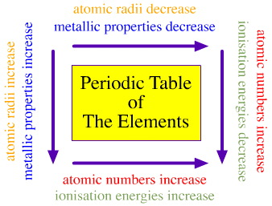

Trends in Density

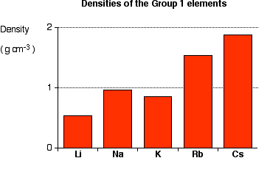
Notice that these are all light metals - and that the first three in the Group are less dense than water (less than 1 g cm⁻³). That means that the first three will float on water, while the other two sink.
The density tends to increase as you go down the Group (apart from the fluctuation at potassium).
Explaining the trend in density
It is quite difficult to come up with a simple explanation for this, because the density depends on two factors, both of which are changing as you go down the Group.
All of these metals have their atoms packed in the same way, so all you have to consider is how many atoms you can pack in a given volume, and what the mass of the individual atoms is. How many you can pack depends, of course, on their volume - and their volume, in turn, depends on their atomic radius.
As you go down the Group, the atomic radius increases, and so the volume of the atoms increases as well. That means that you can't pack as many sodium atoms into a given volume as you can lithium atoms.
However, as you go down the Group, the mass of the atoms increases. That means that a particular number of sodium atoms will weigh more than the same number of lithium atoms.

Know and be able to use a Bohr Model of an atom to tell what the atom is if not given the symbol.

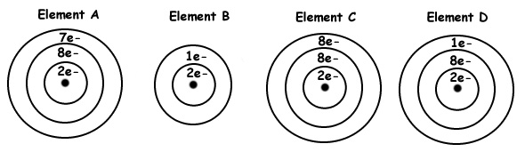

Know and be able to use an E-dot model to describe the atom.

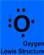

Be able to name and write formulas for compounds.

(NH₄)₂CO₃ Ammonium carbonate Use the Periodic Table and or the Polyatomic Ion Chart

K₂O Potassium oxide

Fe(III)(CO₃)₃ Iron (III) carbonate

(Remember the Criss Cross Method for writing chemical formulas)

Study the Solubilty Curve

Study the oxidation PT

Know the 4 types of Chemical Reactions
