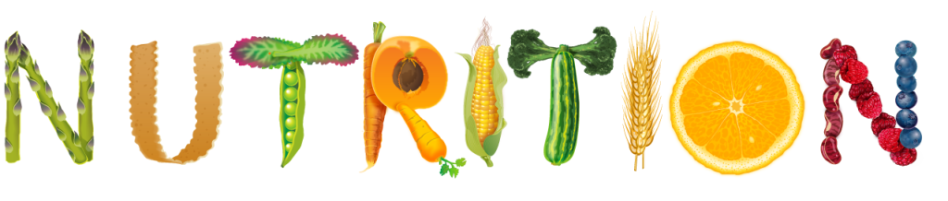
BILL NYE: THE SCIENCE GUY

NAME - __________________________________________ DATE - _____________________

DIRECTIONS: WATCH THE VIDEO TO COMPLETE THE WORKSHEET. QUESTIONS GO IN ORDER.

1) Food is where the human body gets _______________________________.

2) What are the three kinds of foods humans need to eat to stay healthy?

1 - ________________________________________________

2 - ________________________________________________

3 - ________________________________________________

3) NIFTY HOME EXPERIMENT What is the goal of this experiment?

__________________________________________________________________________

__________________________________________________________________________
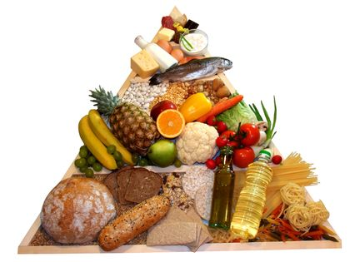
4) CONSIDER THE FOLLOWING What term is a measure of heat energy?

________________________________________________

COMPLETE THE SCIENCE FORMULA

1 LITER OF ____________________ + 1 DEGREE OF ___________________ = 1 ____________________

5) How many daily calories does the typical adult human need every day? ___________________
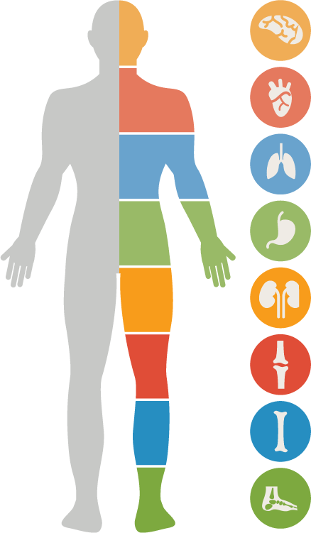
6) What two body parts does the mineral iron help improve?

1 - ___________________________ 2 - _____________________________

7) WAY COOL SCIENTIST
What job is the focus of this segment? __________________________________________

Explain two digestion facts that are covered in this section.

1 - _______________________________________________________________________

2 - ______________________________________________________________________
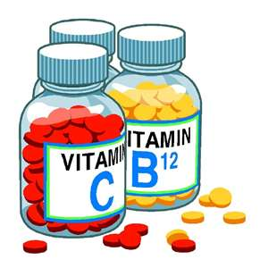
8) What are four types of foods that contain carbohydrates?

1 - _________________________ 3 - _________________________

2 - _________________________ 4 - _________________________

9) What are two parts of the human body that are built of proteins?

1 - _________________________ 2 - _________________________

10) What percentage of our brain is made of fat? _____________________

11) TRUE FALSE The human body can digest fiber.

12) BILL NYE’S SCIENCE SONG

“You need the kind of ____________________ that’s _______________ for you.”

“_____________________________ give you __________________________________.”

“I live for __________________________! No time for _________________________!”

FOLLOW-UP VOCABULARY PUZZLE
13) Find these NUTRITION VOCABULARY TERMS in the wordsearch.
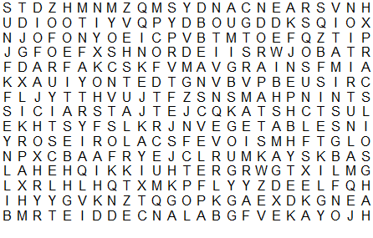

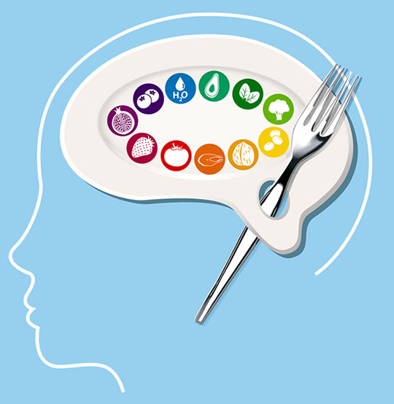
balanced diet
beans
calories
energy
fiber
fish
fruits
grains
healthy foods
minerals
nutrients
oils
vegetables
vitamins
