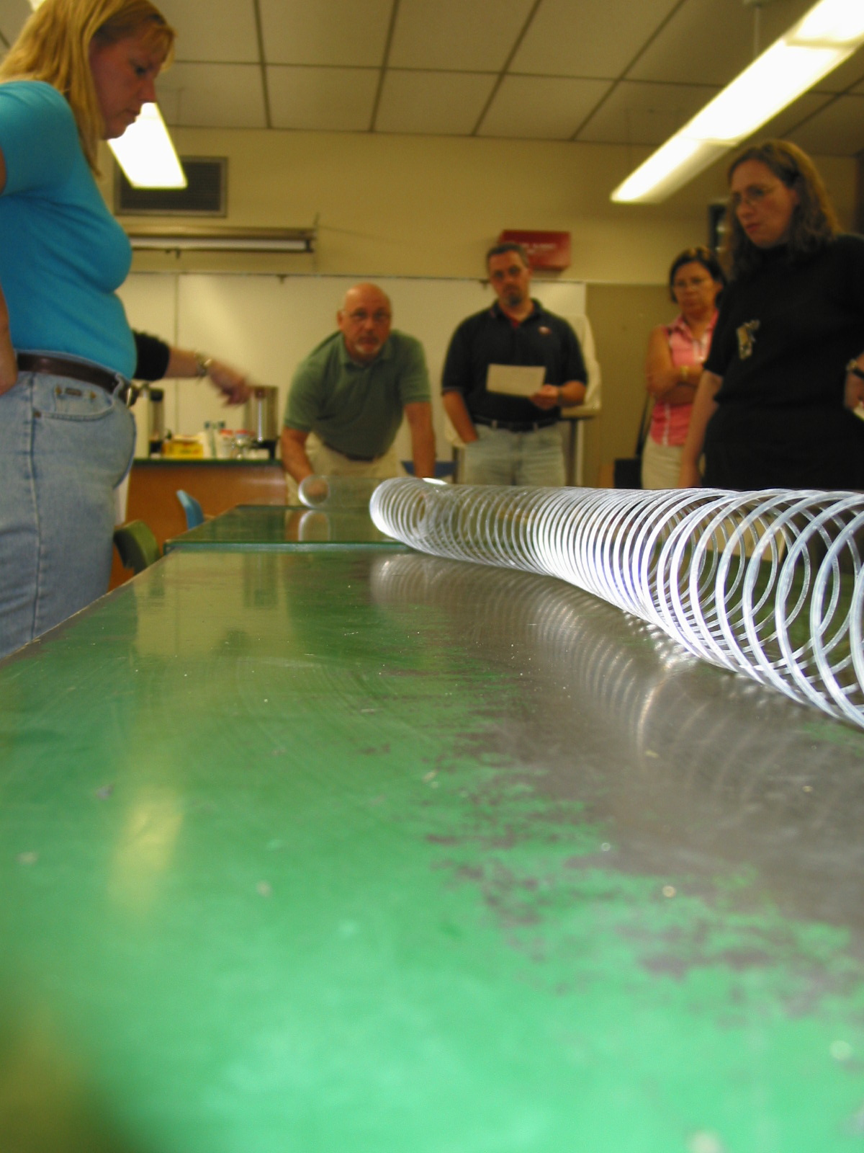
Instructor: Frank Bencivengo (2002 Science Teacher Workshop participant)
School District: Hamilton Township, Mercer County, NJ
Title: Measuring wave length and frequency
Subjects: Radiation, Energy Spectrum
Grade: 8
Overview:
The abstract concept of wave length and frequency can be demonstrated with the popular toy, The Slinky. By generating waves of various lengths with the slinky, estimating their length and counting the number of waves passing a fixed point the student can discover the relationship between wavelength and frequency. Inferences about energy and potential harm can then be made.
Objectives:
- The student will discover the relationship between wavelength and frequency
- The student will visualize the change in energy as wavelength decreases.
Materials:
- Metal slinky
- Tape or marker
- Meter stick
- Second timer ( optional)

Procedures:
  - Lay out an area on the floor or table tops at least 6 meters in length.
  - In the center of the area place a mark or a piece of tape to act as the stationary point.
  - Straddle the slinky on either side of the mark.
  - Stretch the slinky along the entire length of the demonstration area and anchor with a student at one end. The instructor will hold the other end.
  - Generate a wave along the floor or table top by moving the end of the slinky from side to side. Note: The size of the wave will be proportionate to the energy used to generate the wave.
  - Have a student stand facing the fixed point. As the wave passes ask the student to estimate the size of the wave by comparing it to the markings on the meter stick. Do several practice runs before the final measurement or average the measurements. Record the results in data table.
  - Using a stopwatch or just counting 1001, 1002 etc. have student or students count the number of waves that pass the fixed point in 5 seconds. Divide the count by five and record the number of waves that passed per second.
  - Repeat steps 5,6 and 7 using waves of shorter length. Repeat as many times as practical.
Data Table

Wave Length | Number of waves | Frequency / waves per sec.

Analysis:

- What did the instructor do to generate a wave?

- How did the instructor make the waves change in size?

- What is the relationship between wavelength and frequency?

- What relationship exists between wavelength and energy of the wave; between frequency and the energy of the wave?

Conclusions:

(references: http://imagine.gsfc.nasa.gov/docs/science/know_l1/emspectrum.html
http://imagine.gsfc.nasa.gov/docs/science/know_l2/emspectrum.html )

