School Age Documentation
Anecdotal Notes, Photos, and Work Samples

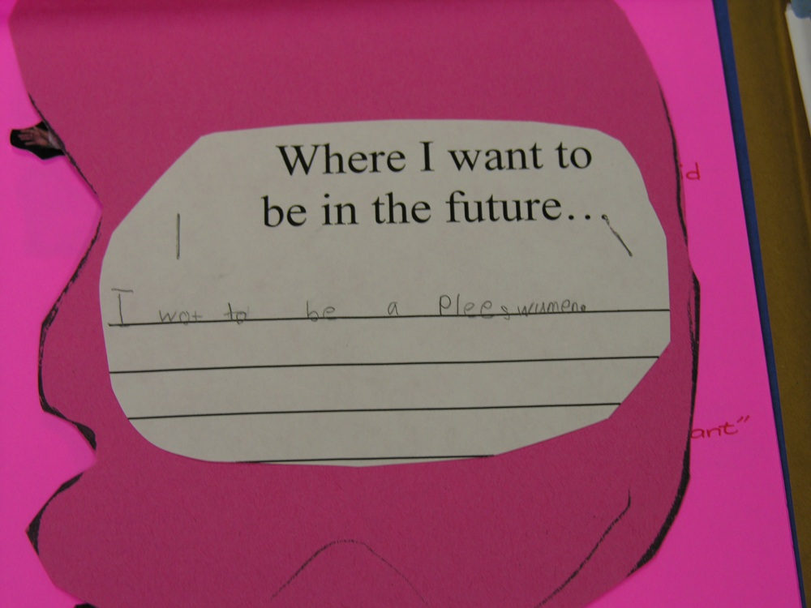

Work Sample and Anecdotal
Delfina 6 yrs old 9/16
After a week of activities based on career choices for the future, D wrote what she wanted to be a grownup. She said, “I want to be a policewoman. They drive police cars with sirens and put bad people in jail.” She spoke each word aloud as she wrote down the letters and invented the spellings of the words she recorded.

Marra – 9 yrs old 10/23 Anecdotal Observation
M said,”I like math.” She asked me to give her some math problems. Said, “I’m good doing math problems.” She pulled a math exercise sheet from her backpack and shared it with me and Katie. She said, “See I got all of these right!” She displayed a big smile.

Measures: 1, 2, 7

Systems for Taking Observation Notes

One program uses sticky-backed blank observation notes to encourage staff to jot down observations and then organize them into the child’s portfolio pages by Desired Result and Indicator.

Staff:
• Add the child’s name, date and time.

• Note the measure number.

• Write objective descriptions of what you see and hear as children go through their daily routines.

Child Date Time
Measure#
OBSERVATION:

Another program uses rings of blank ANECDOTAL NOTE sheets in various locations in the classroom with an attached pencil. Staff members are trained to take a blank note sheet, record observations, and then tack them to a wall chart in the staff work area under the domain.

At a later time, the staff review and reflect on what these notes document, and file them into the children’s portfolios with a brief summary.

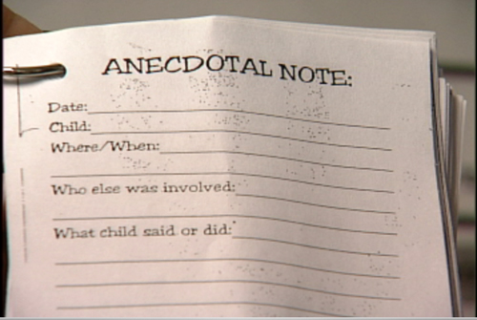
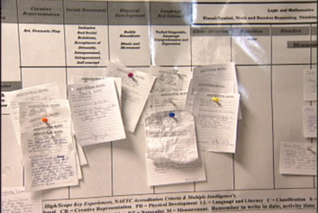

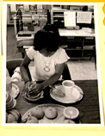
4/10 A. 7 yrs. old

A. said, “I squeezed the oranges and like I had to put juice in the cup. Juice is good for you!”
Measure 11 Understanding healthy lifestyles

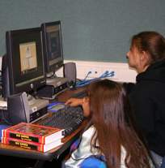

Macie, 11 yrs. old
and Kim, 6 yrs. old 11/31

M asked a group of girls to play a computer game. K said that she wanted to play one. M said, “OK.” They pulled chairs together at the computer and started the game. They worked separately for about a minute then M asked, “What do you want to do? I’m gonna make a castle.” K said, “I don’t know how to make a castle.” M, “I can make one for you.” K smiled and said, “We can make it together.” They played at the computer for about 30 minutes.
Measure #’ 8 - Friendships

Portfolio Documentation – Photo and Anecdotal

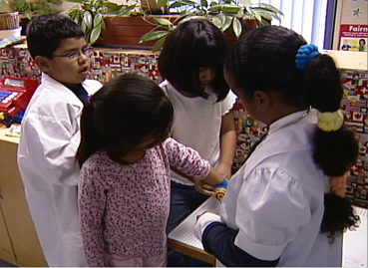

Luis 9 yrs old 2/16

During dramatic play with the doctor’s office materials, L told the other kids, “There are too many kids in this DR’s office. Someone might get hurt. We need to make some rules.” Others in the area continued as before.

L spoke a little louder and said, “We need to move the “patients” to that side of the office. If we put chairs there, they will have a place to sit. The “doctors” can practice here so no one will run into them and make them drop their medicine and tools.” Two children moved to bring chairs to the suggested areas and directed the “patients” to sit for their appointments.

Measures: 5 and 8

